Better applying european criminal law
Legal and Language Training for Court Staff Across Europe

…….. National seminar

Speaker(s)  Name  position  Name  Position | Key topics  - Mutual Legal Assistance  - European Arrest Warrant  - European Investigation Order  - Mutual recognition  - Freezing and confiscation  Language  ………...  Event number  321SDT20  Organiser  ……….
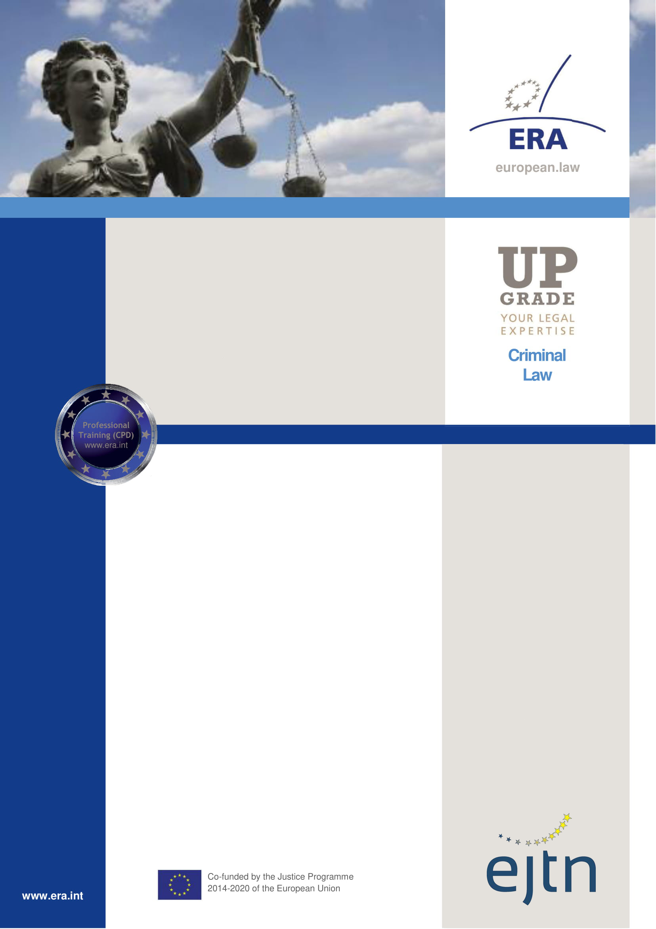
Better Applying European Criminal Law
………. , …………. (Weekday, Date of the first day)  I. Mutual Legal Assistance (MLA)  09:00 Introduction to the training and presentation on the MLA  09:30 Solving the introductory scenarios  10:00 Break  10:15 Solving the case scenario  12:35 Questions, discussion  12:55 Lunch break  II. The European Investigation order (EIO)  13:55 Presentation on the EIO  14:15 Solving case scenario 1  14:35 Solving the exercises  14:50 Break  15:05 Solving case scenario 2  17:05 Questions, discussion  17:25 End of the first day  ………. , …………. (Weekday, Date of the second day)  III. Freezing and confiscation  09:00 Presentation on freezing and confiscation  09:20 Solving case scenario 1  11:00 Break  11:15 Solving the exercises and case scenario 2  12:15 Questions, discussion  12:35 End of the seminar | Objective  The seminar aims to enhance the knowledge of selected court staff concerning some frequently overlooked topics of European criminal law.  Who should attend?  Selected court staff who often encounter the topics covered in the training during their work.  Methodology  The training consists of multiple modules, each covering a specific European criminal law topic.  Each module starts with a short presentation on the topic by the trainer, followed by case studies and exercises.  While solving the exercises, the participants will familiarize themselves with the legal sources and online tools relevant to the topic.

