Mutual Legal Assistance in Criminal Matters
Set of Case Studies – Guide for Trainers

Written by:
Daniel Constantin Motoi
Judge,
Court of First Instance, 4th District, Bucharest Tribunal, Bucharest

Table of contents

A. Scenarios 1
I. Introductory scenarios 1
II. Case scenario; Questions 2

B. Additional notes for the trainers regarding the cases 4

C. Methodological approach 5
I. General idea and core topics 5
II. Working groups and structure of the seminar 6
III. Additional material 7

D. Solutions 8

Mutual Legal Assistance in Criminal Matters
A. I. Introductory scenarios:
1. A Spanish judicial authority wants to hear a witness who is Denmark, via videoconference.
Which legal instrument should it use?
2. A Bulgarian judicial authority wants to hear a witness who is Ireland, via telephone conference.
Which legal instruments should it use?
3. A German judicial authority wants to hear an expert who is in Greece, via videoconference.
Which legal instruments should it use?
4. A French judicial authority wants to hear an expert who is Romania, via telephone conference.
Which legal instruments should it use?
5. A Croatian judicial authority wants to summon an accused person in Denmark.
Which legal instrument should it use?
6. An Irish judicial authority wants to summon a witness in Greece.
Which legal instrument should it use?
7. A Romanian judicial authority wants to hear by videoconference a witness in Georgia.
Which legal instrument should it use?
8. A Bulgarian judicial authority wants to summon a witness in Norway.
Which legal instrument should it use?
9. A German judicial authority wants to hear a witness in Switzerland via videoconference.
Which legal instrument should it use?

A. II. Case scenario:
The Prosecutor’s Office attached to the Court of First Instance Arad is investigating 3 thefts committed between 20.12.2019 and 24.02.2020 in the Western part of the country (case file no. 5440/P/2019). The thefts were committed in different parking stops on the highway A3 and merchandise was stolen from trucks during the night by 2 suspects. During the investigation, the Romanian prosecutor identified a truck driver from Denmark who was witness to one theft. Also, based on the recordings taken from two parking stops, the Romanian authorities have managed to identify the two suspects. One of the suspects is an Irish citizen and based on the information received by the police authorities he is living in Ireland. The other suspect is C.C., a Romanian citizen (born on 23.12.1978), living at 9 May Street, Arad, Arad county.
Now the Romanian prosecutor needs to hear, via videoconference, the witness A.B. (born on 14.01.1960) who is currently living in Langelandsgade Street, Aarhus, Denmark and doesn’t want to come to Romania to be heard. After this, the Romanian prosecutor will hear, via videoconference, the Irish suspect, J.H. (born on 15.10.1966) living on Henry Street, Dublin, Ireland who refuses to appear in its territory in person to be heard.
Questions:
- Which is the legal instrument applicable in order to hear the witness A.B. by videoconference? If is not possible to hear the witness by videoconference, can the witness be heard by telephone conference?
- Is it possible to hear the suspect J.H. by videoconference?
- Identify the requested competent authorities in Denmark and Ireland and the channels of transmission that need to be used.
- Which form for the LoR is to be used by the requesting judicial authority when asking for the hearing by videoconference or by telephone conference?
- Fill in the LoRs necessary for hearing the witness and the suspect.
- Are there any time limits for the execution of the MLAs by the requested competent authorities?
- Which rules and requirements will apply to the hearing the witness or suspect?

Part B. Additional notes for the trainers regarding the cases
A. II. Case scenario:
- The requesting competent authority will be changed and replaced by a competent authority from the MS where the seminar is taking place, except for Greece, Denmark and Ireland.
- A city from the country where the seminar is taking place will be chosen after changing. Also, the suspect C.C. will be a citizen of the same country where the seminar is taken place (an address from this country will be chosen).
Part C. Methodology
- General idea and core topics
The idea of this training material is to make the court staff from the Member States familiar with the legal instruments for judicial cooperation available at European level with a view to gathering evidence from abroad.
Very often, court staff find themselves in difficulty trying to identify and use the appropriate legal instrument for judicial cooperation in criminal matters.
After identifying the legal instrument applicable, court staff are involved in administrative tasks ranging from filling in the form requested by the legal instrument, identifying the competent authority to send it to, translation of the form, requesting or sending additional information regarding judicial cooperation.
For these reasons, the following main aspects will be covered within the seminars:
- The key features of the MLA process with focus on the hearing by videoconference and telephone conference of witnesses and suspects.
- The relationship between the Convention on Mutual Assistance in Criminal Matters between the Member States of the European Union and its protocol, the 1959 European Convention on Mutual Assistance in Criminal Matters and its protocols and Directive/41/EU regarding the gathering of evidence from abroad.
- Familiarisation with the content of an LoR and learning how to complete one.

- Familiarisation with the rules and requirements applicable to the hearing of witnesses and suspects by videoconference and telephone conference as provided for in the different relevant legal instruments.
- Different administrative details such as how should an issuing authority proceed in a particular situation, where an issuing authority can find an electronic LoR, where the issuing authority can find the competent authority from the executing Member State where the request needs to be addressed to fulfil everything demanded to be properly addressed.
- Working groups and structure of the seminar
The seminar will start with a presentation .ppt (15 – 20 minutes) in which the trainer will explain some key features of the mutual legal assistance process (relationship between MLA and mutual recognition legal instruments, how to identify the legal instruments, transmission channels, forms, execution, time limits) briefly pointing out the provisions regarding hearings by videoconference and telephone conference from the Convention on Mutual Assistance in Criminal Matters between the Member States of the European Union and the Second Additional Protocol to the 1959 European Convention on Mutual Assistance in Criminal Matters.
The seminar will continue with the introductory scenarios, which are the opportunity for the participants to identify different instruments for judicial cooperation in order to gather evidence with the cooperation of another Member State.
The participants will be divided into 4-6 groups of 5-8 people and each group will have a laptop/computer with an Internet connection.
The introductory scenarios will help participants better understand the relationship between the legal instruments for judicial cooperation in criminal matters, as sometimes this may look complicated.
The trainer will guide the participants to recognise the relationship between Directive/41 of the European Parliament and of the Council of 3 April 2014 regarding the European Investigation Order in criminal matters, the Convention on Mutual Assistance in Criminal Matters between the Member States of the European Union and the 1959 European Convention on Mutual Assistance in Criminal Matters and its protocols.
Solving the introductory scenarios should take around 30 minutes. A 10-minute break will be taken at this point.
The case scenario is the opportunity to go deeper into understanding the MLA system and the difference to mutual recognition legal instruments, applying provisions from the Convention on Mutual Assistance in Criminal Matters between the Member States of the European Union and the 1959 European Convention on Mutual Assistance in Criminal Matters and its protocols.
By answering the questions, the participants will be able to identify the competent authorities involved in the MLA process, understand the channels for transmission of the LoR, applicability of time limits, and the rules and requirements applicable for the hearing of witnesses and suspects by videoconference.
The participants will also fill in LoRs for hearing a witness and/or a suspect by MLA. For this, 2-3 groups will fill in the LoR for hearing the suspect and the other 2-3 groups will fill in the LoR for hearing the witness.
The participants will access the EJN’s website in the section Compendium. Here the participants will be able to fill in an LoR online and then save and print them. The completed LoRs will later be checked with the trainer.
Solving the case scenario should take around 2 hours and 20 minutes.
Any remaining questions should be discussed in plenary (approx. 5-10 minutes).
The organisers should try to form groups of participants with a similar level of experience in working with the MLA legal instruments.
- Additional requirements
Participants will have access to the European Convention of 20 April 1959 on mutual assistance in criminal matters and its protocols (The Treaty Office from the CoE’s website), the Convention of 29 May 2000 on mutual assistance in criminal matters between the Member States of the European Union and Directive/41/EU of 3 April 2014 regarding the European Investigation Order in criminal matters (EJN’s website).

Part D. Solutions
A. I. Introductory scenarios:
Obtaining evidence in criminal matters in the ambit of the EU can be done in two ways: using the legal instruments based on the principle of mutual assistance or the legal instruments based on the principle of mutual recognition.
In this, the most important task for the judicial authority is identifying the legal instrument applicable to the two MS involved in the future judicial cooperation process. Doing this, it will allow the requesting judicial authority to observe the requirements provided in it to achieve a good outcome for its request.
Identifying the legal instrument applicable by the issuing judicial authority is not a question of choosing one particular legal instrument. The applicable legal instrument will be the one in force at the moment when the judicial authority asks for the judicial assistance from an authority within another MS.
For this, the issuing authority will have to pay particular attention to the sequence of the legal instruments, as they replace or supplement other legal instruments in relation to MS (the relation with other legal instruments is usually mentioned at the beginning or in the final provisions of the legal instrument in question – e.g. Article 34 of Directive/41/EU regarding the EIO, Article 1 of the Convention on Mutual Assistance in Criminal Matters between the Member States of the European Union).
- For example, if the Directive on the European Investigation Order is applicable, the issuing judicial authority will have to fill in an EIO and follow the procedure mentioned in Directive 2014/41/EU of the European Parliament and of the Council of 3 April 2014 regarding the European Investigation Order in criminal matters.
- If Directive 2014/41/EU is not applicable to an MS, then the issuing judicial authority will have to recourse to the conventional mutual legal assistance contained in legal instruments such as: the European Convention on Mutual Assistance in Criminal Matters of the Council of Europe of 20 April 1959, as well as its two additional protocols, and the bilateral agreements concluded pursuant to Article 26 thereof, the Convention implementing the Schengen Agreement and the Convention on Mutual Assistance in Criminal Matters between the Member States of the European Union and its protocol.
Before identifying the solutions to our scenarios, it must be recalled that Directive/41/EU regarding the European Investigation Order in criminal matters is the legal instrument in force after 22 May 2017 within the European Union with some exceptions (some MS are not taking part and are not bound by this legal instrument).
As provided in the Recitals (44) and (45) of Directive 2014/41/EU regarding the European Investigation Order, in accordance with Articles 1 and 2 and Article 4a(1) of Protocol No 21 on the position of the United Kingdom and Ireland in respect of the area of Freedom, Security and Justice annexed to the TFEU and the TFEU, and without prejudice to Article 4 of that Protocol, Ireland is not taking part in the adoption of this Directive and is not bound by it or subject to its application. Also, in accordance with Articles 1 and 2 of Protocol No 22 on the Position of Denmark annexed to the TEU and the TFEU, Denmark is not taking part in the adoption of this Directive and is not bound by it or subject to its application.
As mentioned in Article 34 para 1 of Directive 2014/41/EU, the European Investigation Order in criminal matters replaced conventional mutual legal assistance with a cooperation mechanism based on mutual recognition as regards, in particular, obtaining evidence. In this way the MS shall apply the Directive regarding EIO to the detriment of the other legal instruments available regarding the gathering of evidence, and this is not a question of option for the issuing judicial authority.
Although, according to Article 34 para 3 of the Directive regarding EIO, Member States may conclude or continue to apply bilateral or multilateral agreements or arrangements with other Member States after 22 May 2017, this can be done only insofar as these make it possible to further strengthen the aims of the Directive and contribute to simplifying or further facilitating the procedures for gathering evidence and provided that the level of safeguards set out in this Directive is respected.
Hearings by videoconference or other audiovisual transmission and hearings by telephone conference are provided for in different legal instruments such as:
- Article 24 and 25 of Directive 2014/41/EU regarding the European Investigation Order in criminal matters,
- Article 10 and 11 of the Convention of 29 May 2000 on Mutual Assistance in Criminal Matters among the Member States of the European Union,
- Article 9 and 10 of the Second Additional Protocol to the European Convention on Mutual Assistance in Criminal Matters (1959 Convention).
Provisions on summonings we encounter in the 2000 Convention (Article 5) but also in the 1959 Convention (Article 7)

Identifying the legal instrument applicable for points a-i) will determine the rules, forms and requirements to be followed by both MS involved in the judicial cooperation.
- A Spanish judicial authority wants to hear, by videoconference, a witness who is Denmark. Which legal instrument should it use?

Spain has transposed Directive 2014/41 regarding EIO but Denmark has not taking part and is not bound by this legal instrument according to Recital (45) of the same Directive.
The status of implementation of Directive 2014/41/EU regarding EIO can be found on the EJN’s website – www.ejn-crimjust.europa.eu in the section EU Legal Instruments for Judicial Cooperation. Further in the table, there is the section Status of implementation of the Directive where we could verify if a country had transposed the Directive regarding EIO.

This means that we need to identify an instrument on mutual legal assistance applicable to both MS. In our case for Denmark and Spain the Convention of 29 May 2000 on Mutual Assistance in Criminal Matters between the Member States of the European Union is applicable (the hearing of videoconference of a witness is provided in Article 10 of the 2000 Convention) because it has been signed, ratified and is in force in both countries.

The table of the ratification details of Convention of 29 May 2000 on Mutual Assistance in Criminal Matters between the Member States of the European Union is available on the EJN’s website.

Still, the Spanish judicial authority needs to verify the Declaration made by Denmark in relation to the application of some of the provisions from the 2000 Convention. As seen below, the declaration made by Denmark only concerns the non-application of Article 10 to the hearing by videoconference of the accused person, which is not our case. So, the 2000 Convention is applicable for let. a).

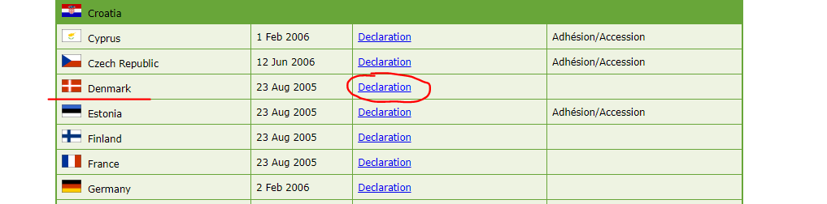

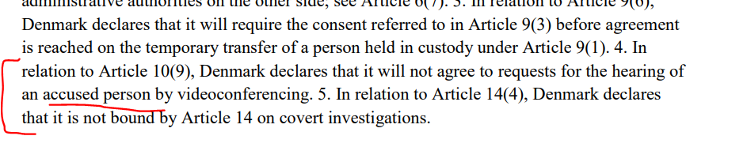
2. Bulgarian judicial authority wants to hear by telephone conference a witness who is in Ireland. Which legal instrument should it use?

Checking again the status of implementation we see that Bulgaria has transposed Directive 2014/41 regarding EIO but Ireland is not taking part and is not bound by this legal instrument according to Recital (44) of the same Directive.

This means that we need to identify an instrument on mutual legal assistance applicable to both MS. In our case for Bulgaria and Ireland, the Convention of 29 May 2000 on Mutual Assistance in Criminal Matters between the Member States of the European Union is applicable (the hearing of videoconference of a witness is provided in Article 10 of the 2000 Convention) because it has been signed, ratified and it is in force in both countries. The 2000 Convention is in force in Ireland as of 23 August 2020.
Still, the Bulgarian judicial authority needs to verify the Declaration made by Ireland in relation to the application of some of the provisions from the 2000 Convention. Verifying the declarations made by Ireland we note that none of them concerns the application of Article 10 of the 2000 Convention. So again, the 2000 Convention is applicable for let. b).

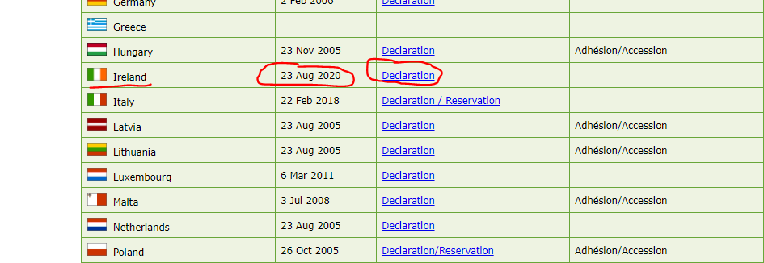

3. The German judicial authority wants to hear, by videoconference, an expert who is in Greece. Which legal instrument should it use?

Checking the status of the implementation of Directive 2014/41 on EIO indicated above we note that both Germany and Greece have transposed the Directive which means that this legal instrument is applicable between the two MS and in particular the provisions from Article 24 of the Directive.
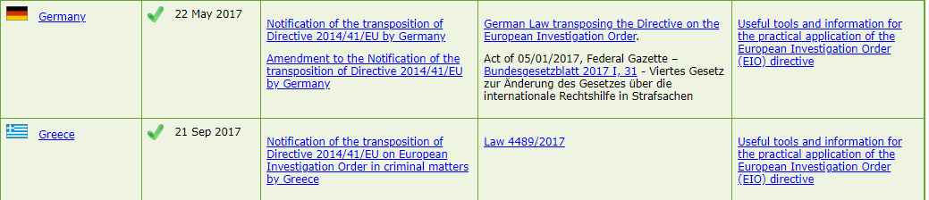

4. The French judicial authority wants to hear, by telephone conference, an expert who is Romania. Which legal instrument should it use?

Checking again the status of implementation of Directive 2014/41 on EIO indicated above we note that both France and Romania have transposed the Directive which means that this legal instrument is applicable between the two MS and in particular the provisions from Article 24 of the Directive.
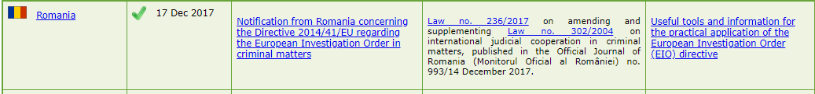

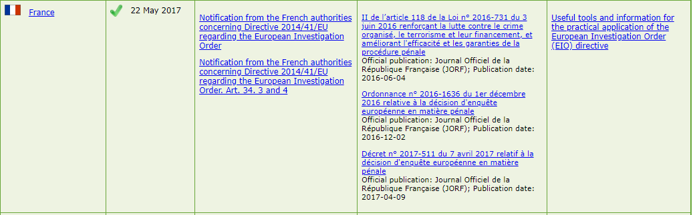

5. The Croatian judicial authority wants to summon an accused person in Denmark. Which legal instrument should it use?

The first thing to notice here is that this not an investigative measure requested by the Croatian judicial authority, which means that it is outside the scope of application of Directive 2014/41 on EIO. So, we do not need to check the status of implementation of the Directive.
We need to identify an instrument on mutual legal assistance applicable to both MS. As members of the European Union we check first if the 2000 Convention (Article 5 provides the sending and service of procedural documents) is in force in both MS. For this we check the table of ratifications indicated above for the 2000 Convention. We see that for Denmark the 2000 Convention is in force but that this is not the case for Croatia.
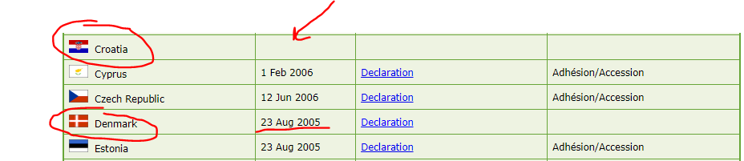

We need to identify other instrument on mutual legal assistance that could apply to both MS. Article 7 of the European Convention on Mutual Assistance in Criminal Matters (1959 Convention) provides for the service of writs and records of judicial verdicts – Appearance of witnesses, experts and prosecuted persons. We need to verify whether this legal instrument is in force in both MS.
For this we go to the Treaty Office of the Council of Europe’s website and check for the signatures and ratifications of the 1959 Convention. The list of the signature countries is available here.

We see below that the 1959 Convention is in force in both MS. Still, the Croatian judicial authority needs to verify the Reservations (R) and Declarations (D) made by Denmark in relation to the application of some of the provisions of the 1959 Convention.
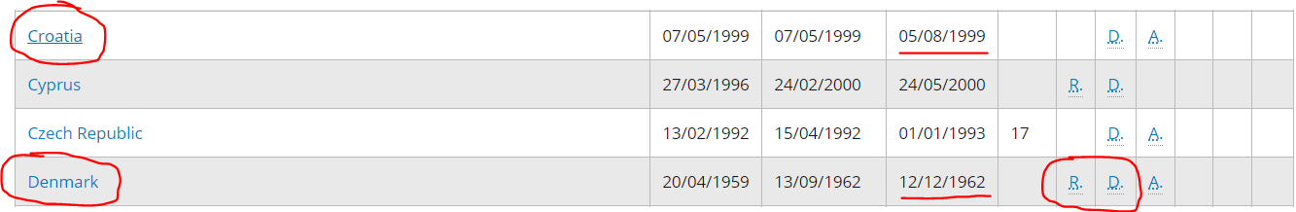

Below are the reservations and declarations made by Denmark on how the Article 7 of the 1959 Convention will apply (in which manner, deadline).
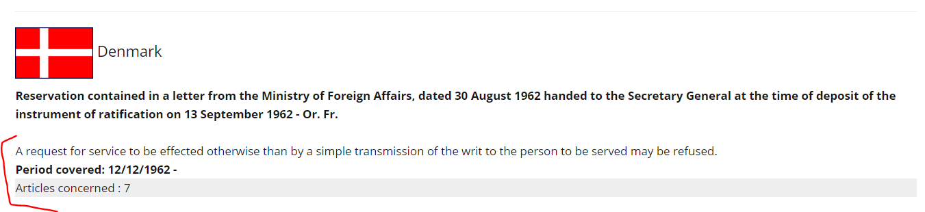
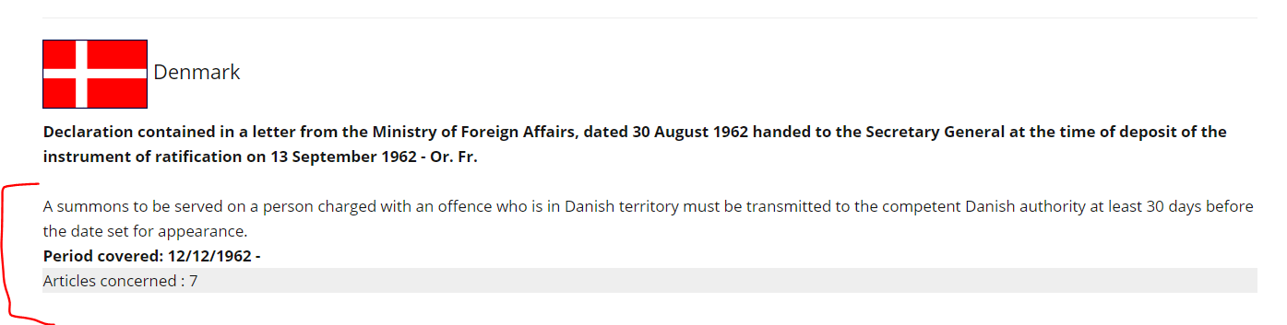

6. An Irish judicial authority wants to summon a witness in Greece. Which legal instrument should it use?

Again, this not an investigative measure requested by the Irish judicial authority, which means that it is outside the scope of application of Directive 2014/41 on EIO. So, we do not need to check the status of implementation of the Directive (also, Ireland is not bound by the Directive).
This means that we need to identify an instrument on mutual legal assistance applicable to both MS. As members of the European Union we check first if the 2000 Convention (Article 5 provides the sending and service of procedural documents) is in force in both MS. For this we check the table of ratifications indicated above. We see that for Ireland the 2000 Convention is in force which is not the case for Greece.
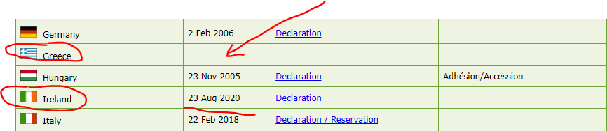

This means that we need to identify another instrument on mutual legal assistance that could apply to both MS. Article 7 of the European Convention on Mutual Assistance in Criminal Matters (1959 Convention) provides for the service of writs and records of judicial verdicts – Appearance of witnesses, experts and prosecuted persons. We need to verify whether this legal instrument is in force in both MS.
As mentioned at let. e) we go to the Treaty Office of the Council of Europe’s website and check for the signatures and ratifications of the 1959 Convention.
We see below that the 1959 Convention is in force in both MS. Still, the Irish judicial authority needs to verify the Reservations (R) made by Greece in relation to the application of some of the provisions of the 1959 Convention. Checking the Reservations made by Greece we note that none of them concerns the application of Article 7 of the 1959 Convention.
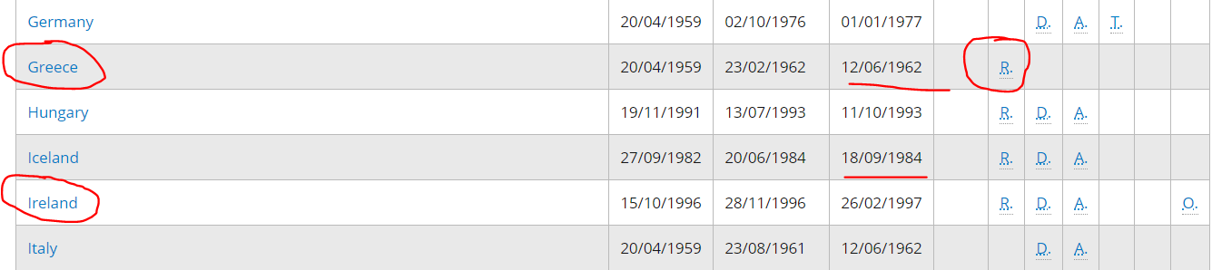

- Romanian judicial authority wants to hear by videoconference a witness in Georgia. Which legal instrument shall it use?

An investigative measure Directive/41 is not applicable, because Georgia is not a member of the European Union. So, we need to draw our attention again to the Treaty Office – Council of Europe’s website.
Hearing by videoconference of a witness is provided in Article 9 of the Second Additional Protocol to the 1959 Convention (Treaty no. 182 - Strasbourg, 08/11/2001). We see that this Second Additional Protocol is in force both in Romania and Georgia, so this protocol is the legal instrument for the MLA between the two countries.
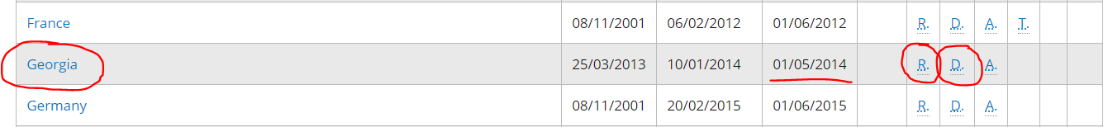

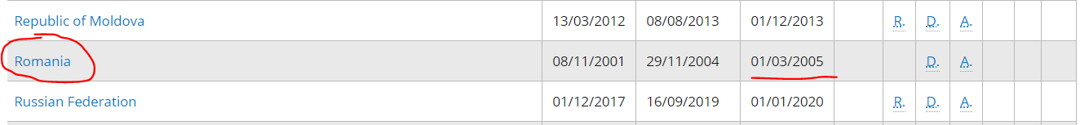

Now, the Romanian judicial authority needs to verify the Reservations (R) and Declarations (D) made by Georgia in relation to the application of some of the provisions from the Second Additional Protocol to the 1959 Convention. Checking them we note that none concerns the application of Article 9 of the Second Additional Protocol to the 1959 Convention.

8. The Bulgarian judicial authority wants to summon a witness in Norway. Which legal instrument should it use?

The first thing to see is that Directive 2014/41 on EIO is not applicable for this particular case.
Next, although Norway is not a member of the European Union, some provisions from the 2000 Convention are still applicable in relation to Norway and Iceland with the EU according to the Agreement between the European Union and the Republic of Iceland and the Kingdom of Norway on the application of certain provisions of the Convention of 29 May 2000 on Mutual Assistance in Criminal Matters between the Member States of the European Union and the 2001 Protocol thereto.
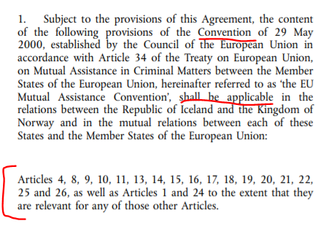
We note that Article 5 concerning the sending of procedural documents is not mentioned in Article 1 para 2 of the Agreement abovementioned, which means that the 2000 Convention will not be the legal instrument for MLA between the two countries.
We recall that Article 7 of the 1959 Convention is concerned with the sending of procedural documents so we will turn our attention to it. We see that the 1959 Convention is in force in both countries. Now, the Bulgarian judicial authority needs to verify the Reservations (R) and Declarations (D) made by Norway in relation to the application of some of the provisions of the 1959 Convention.

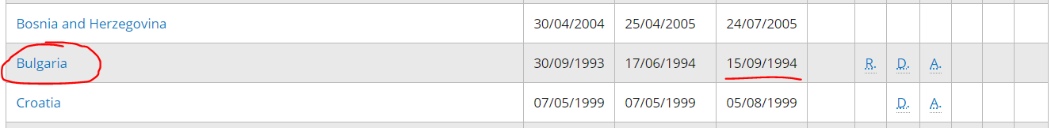

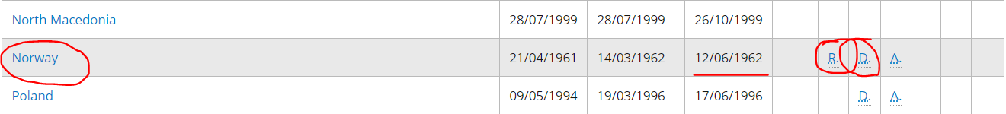

Below are the Reservations and Declarations made by Norway to the 1959 Convention concerning the application of Article 7.
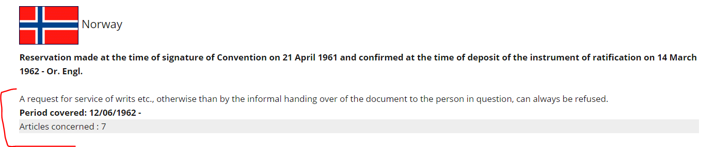
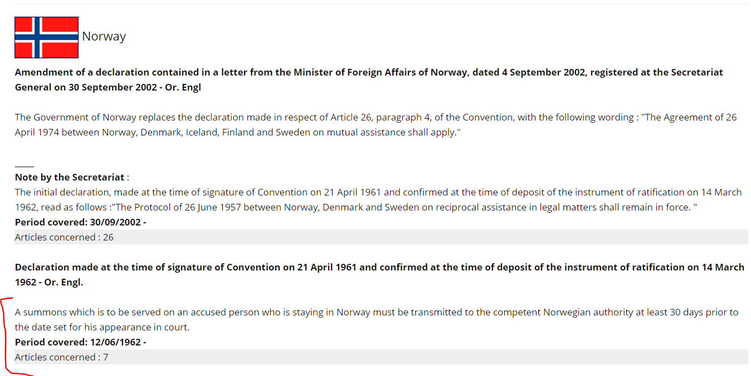

9. The German judicial authority wants to hear, by videoconference, a witness in Switzerland. Which legal instrument should it use?

Again, the first thing to see is that Directive 2014/41 on EIO is not applicable for this case.
Secondly the 2000 Convention is not also applicable.
Hearing a witness by videoconference is provided for in Article 9 of the Second Additional Protocol to the 1959 Convention (Treaty no. 182 - Strasbourg, 08/11/2001). The link is provided below:
https://www.coe.int/en/web/conventions/full-list/-/conventions/treaty/182
We see that this Protocol is in force both in Germany and Switzerland, so this protocol is the legal instrument for the MLA between the two countries.
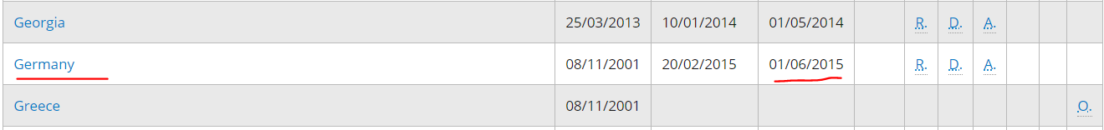

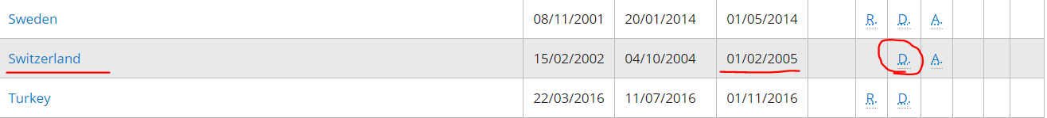
Now, the German judicial authority needs to verify the Declarations (D) made by Switzerland in relation to the application of some of the provisions from the Second Additional Protocol to the 1959 Convention. Checking them we note that none concerns the application of Article 9 of the Second Additional Protocol to the 1959 Convention.
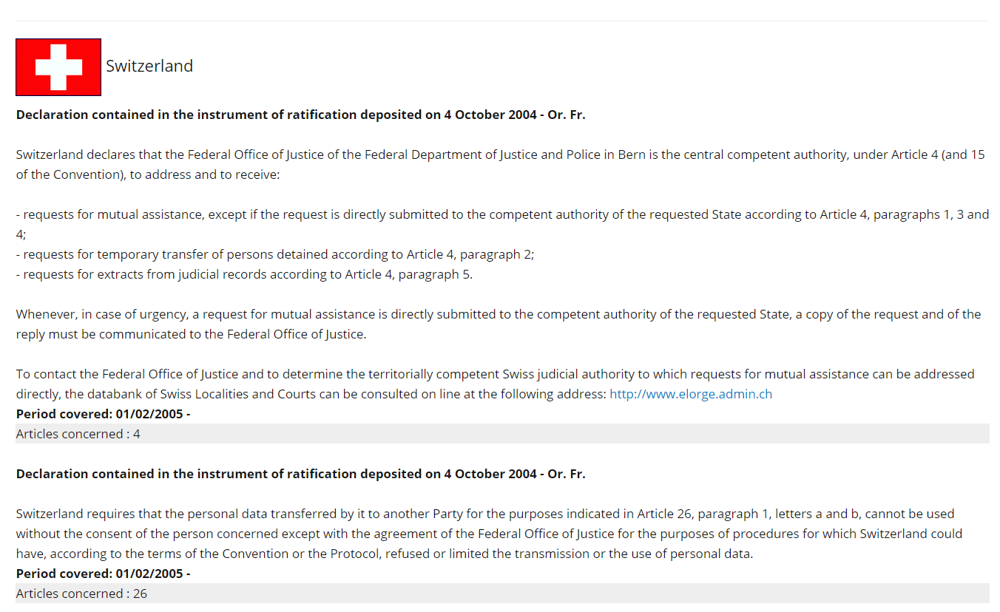

Key points to remember when identifying the legal instrument applicable in the judicial cooperation process:

- Always look for a legal instrument for judicial cooperation in criminal matters in force in the two countries involved in the MLA process.
- Always check the countries that signed a Convention (or the Protocols) and also check the possible reservations and declarations made by that requested State.
- Check the status of implementation for Council Framework Decisions or Directives for the MS of the European Union (see EJN’s website).
- An issuing authority will not use a legal instrument replaced by another one just because it thinks that the old one was working faster or the process of cooperation was smoother. For example, an issuing authority can’t use the Convention of 29 May 2000 on mutual assistance in criminal matters between the Member States of the European Union instead of Directive 2014/41/EU of 3 April 2014 regarding the European Investigation Order, in order to gather evidence in a particular situation included by the Directive and by the 2000 Convention (for example - hearing a witness by videoconference).
- In this case, according to Article 34 para 1 of the Directive, the Directive is the legal instrument applicable as it replaces, as from 22 May 2017, the corresponding provisions of 2000 Convention in order to gather evidence (so, in our example abovementioned, Article 10 of the 2000 Convention has been replaced by the Article 24 of Directive 2014/41 on EIO). The 2000 Convention can’t be seen as a multilateral agreement or arrangement, mentioned in Article 34 para 3 of the Directive, since the objective of the Directive was to replace it by a simpler and more effective system (see case C-296/08 - Goicoechea – para 54 and 55 applicable mutatis mutandis.
- Denmark and Ireland are not bound by Directive 2014/41on EIO.
- The 2000 Convention is not in force in Greece and Croatia.

A. II. Case scenario:
Solutions:
Q1. Which legal instrument is applicable in order to hear the witness A.B. by videoconference? If it is not possible to hear the witness by videoconference, can the witness be heard by telephone conference?
As explained in the introductory case, we see that Romania has transposed the Directive regarding EIO and that Denmark is not taking part and is not bound by this legal instrument according to Recital (45) of the same Directive. This means that the Convention of 29 May 2000 on Mutual Assistance in Criminal Matters between the Member States of the European Union is applicable as it is in force in both MS.
The requirements for hearing a witness by videoconference are provided in Article 10 para 1-8 of the 2000 Convention unfortunately Denmark hasn’t made any declarations regarding the hearing by videoconference of the witnesses yet (see the declarations made by each state in the link provided below).
The declarations made by each MS regarding some of the provisions of the 2000 Convention can be accessed on the EJN’s website.

The declarations made by Denmark regarding provisions of the 2000 Convention can be accessed here.

If, for different reasons, it is not possible to hear the witness by videoconference, the hearing can be done by telephone conference according to the requirements in Article 11 of the 2000 Convention.
- If the requesting competent authority is from Croatia, then Article 9 para 1-7 of the Second Additional Protocol to the 1959 European Convention on Mutual Assistance in Criminal Matters (Strasbourg, 08/11/2001) will be applicable for the hearing of witness by video conference or by telephone conference, as Croatia has not signed the Convention of 29 May 2000 on Mutual Assistance in Criminal Matters between the Member States of the European Union and Denmark is not bound by Directive 2014/41 on EIO.

Q2. Is it possible to hear the suspect J.H. by videoconference?
As explained in the introductory case, Romania has transposed Directive 2014/41/EU regarding EIO, but Ireland is not taking part and is not bound by this legal instrument according to Recital (44) of the same Directive.
Both Romania and Ireland have signed and ratified the 2000 Convention, and the Convention is in force as of 23.08.2020 for Ireland. This means that the Convention of 29 May 2000 on Mutual Assistance in Criminal Matters between the Member States of the European Union is applicable as both MS have signed and ratified it.
The requirements for hearing of a suspect by videoconference are provided in Article 10 para 9 of the 2000 Convention unfortunately Ireland hasn’t made any declarations regarding the hearing of the witnesses by videoconference yet (see the declarations made by each state in the link provided below).

The declarations made by each MS regarding some of the provisions of the 2000 Convention can be accessed on the EJN’s website.

The declarations made by Ireland regarding provisions of the 2000 Convention can be accessed here.

If the requesting competent authority is from Croatia, then Article 9 para 8 of the Second Additional Protocol to the 1959 European Convention on Mutual Assistance in Criminal Matters (Strasbourg, 08/11/2001) will be applicable for the hearing of a suspect by video conference or by telephone conference, as Croatia has not signed the Convention of 29 May 2000 on Mutual Assistance in Criminal Matters between the Member States of the European Union and Ireland is not bound by Directive 2014/41 on EIO.

Q3. Identify the requested competent authorities in Denmark and Ireland and the channels of transmission that need to be used.
LoR => Romania (or other MS with the exception of Croatia and Greece) – Denmark
According to Article 6 para 1 of the 2000 Convention, requests for mutual assistance shall be made in writing, or by any means capable of producing a written record under conditions allowing the receiving Member State to establish authenticity, and sent directly between judicial authorities with territorial competence for initiating and executing them, and shall be returned through the same channels unless otherwise specified.
The requested competent authority can be identify using the Atlas from the EJN’s website. We select the country – Denmark, the investigative measure needed – 703. Hearing witnesses: by video conference, then select all other matters (it is not the case for serious economic infractions, money laundering), the legal instrument applicable – the 2000 Convention, and adding the city – Aarhus – should give us the competent authority where the LoR should be send directly (see the steps below).

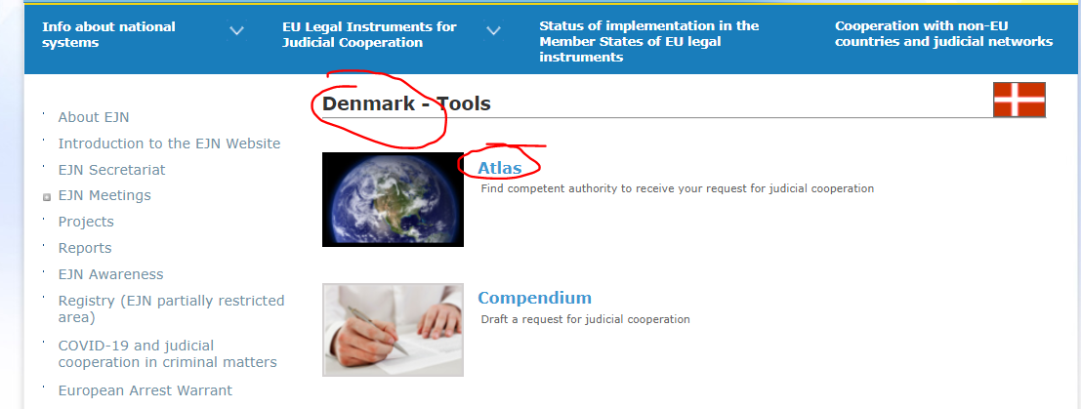

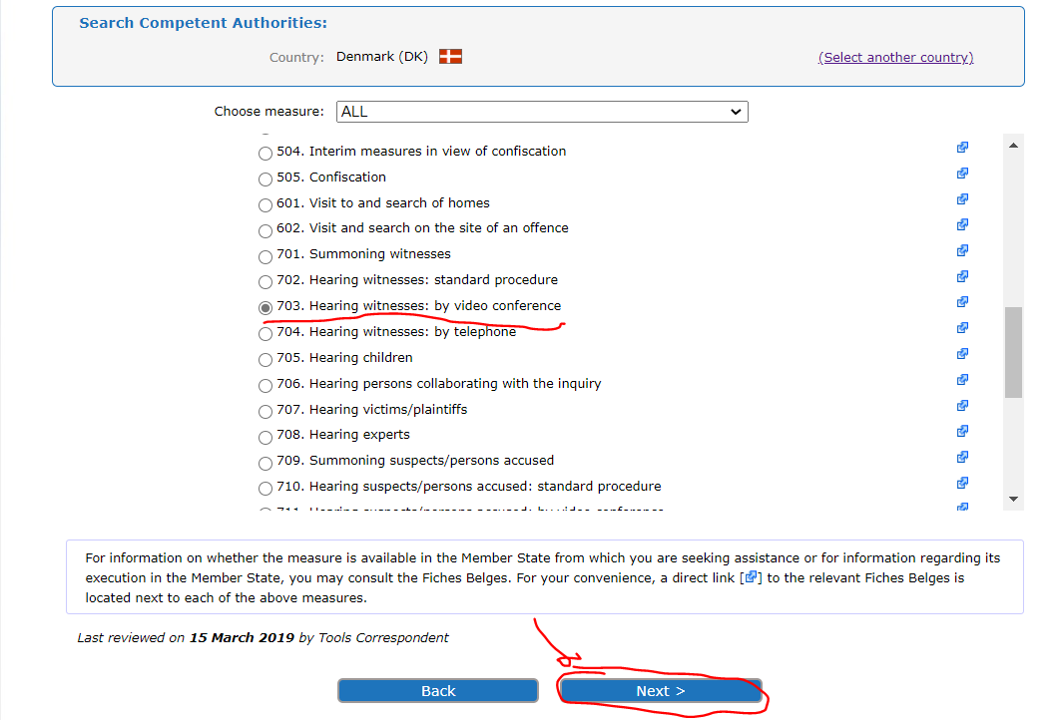
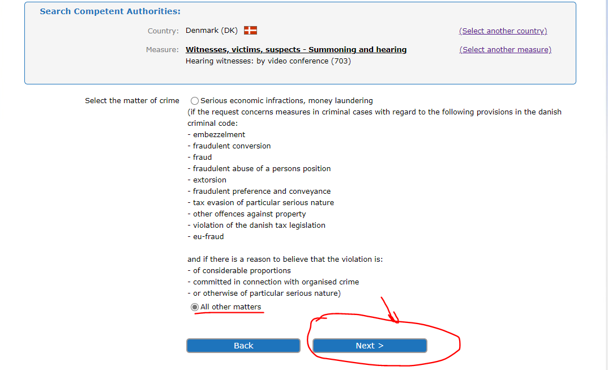

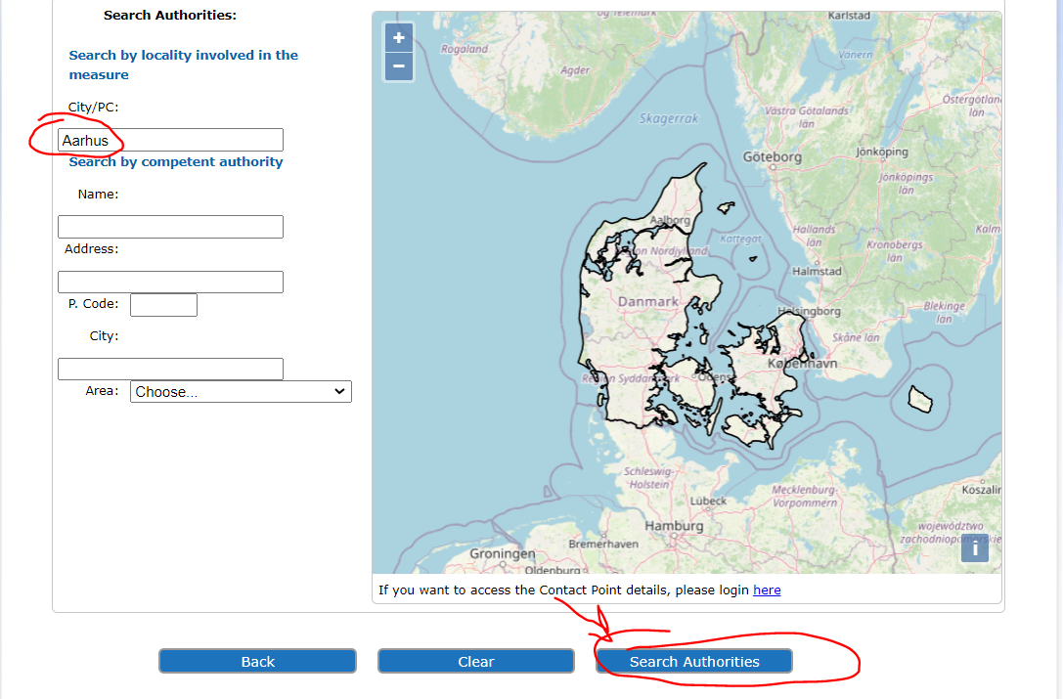

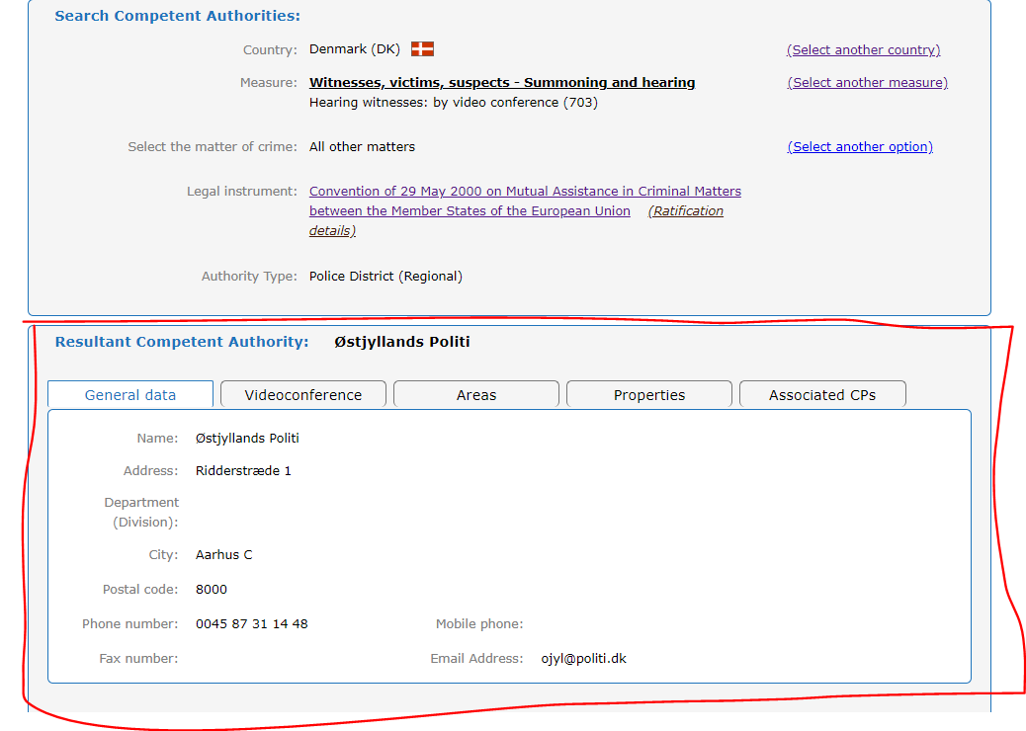

After sending the LoR to this competent authority, the requesting and requested authority will enter into contact in order to arrange all the technical details for this hearing.
In the case of Croatia Article 4 of the Second Additional Protocol to the 1959 European Convention on Mutual Assistance in Criminal Matters will be applicable, of course, if a more favorable bilateral agreement between the two countries doesn’t exist (MoJ to MoJ channel).
LoR => Romania (or other MS with the exception of Greece and Croatia) – Ireland
According to Article 6 para 1 of the 2000 Convention, requests for mutual assistance shall be made in writing, or by any means capable of producing a written record under conditions allowing the receiving Member State to establish authenticity and sent directly between judicial authorities with territorial competence for initiating and executing them, and shall be returned through the same channels unless otherwise specified.
Notwithstanding paragraph 1, the United Kingdom and Ireland, respectively, may, when giving the notification provided for in Article 27(2), declare that requests and communications to it, as specified in the declaration, must be sent via its central authority. These Member States and the UK and Ireland may at any time by a further declaration limit the scope of such a declaration for the purpose of giving greater effect to paragraph 1. They shall do so when the provisions on mutual assistance of the Schengen Implementation Convention are put into effect for them (Article 6 para 3 of the 2000 Convention).
Ireland made a declaration to this Article and so, all incoming requests shall be sent to the Minister for Justice and Equality as the Central Authority (see below).

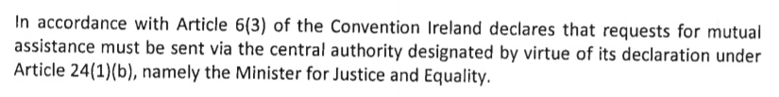
For this reason, the request for mutual assistance shall be addressed in writing by the Ministry of Justice of Romania (requesting authority) to the Ministry of Justice and Equality Ireland (as requested Central authority) and shall be returned through the same channels.

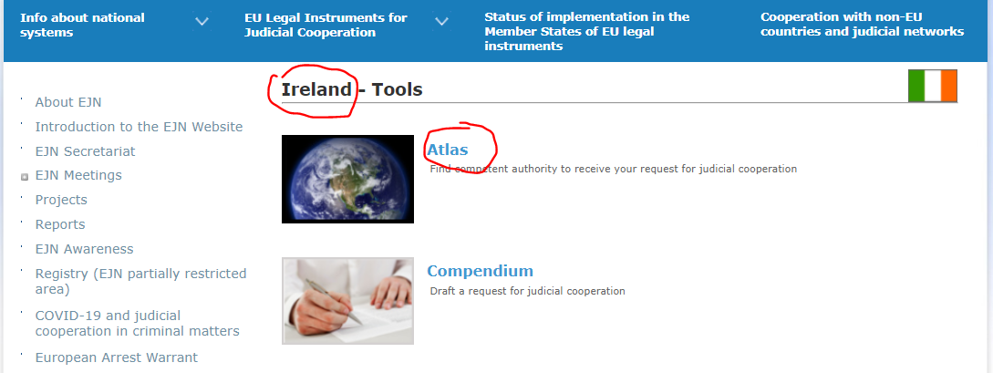

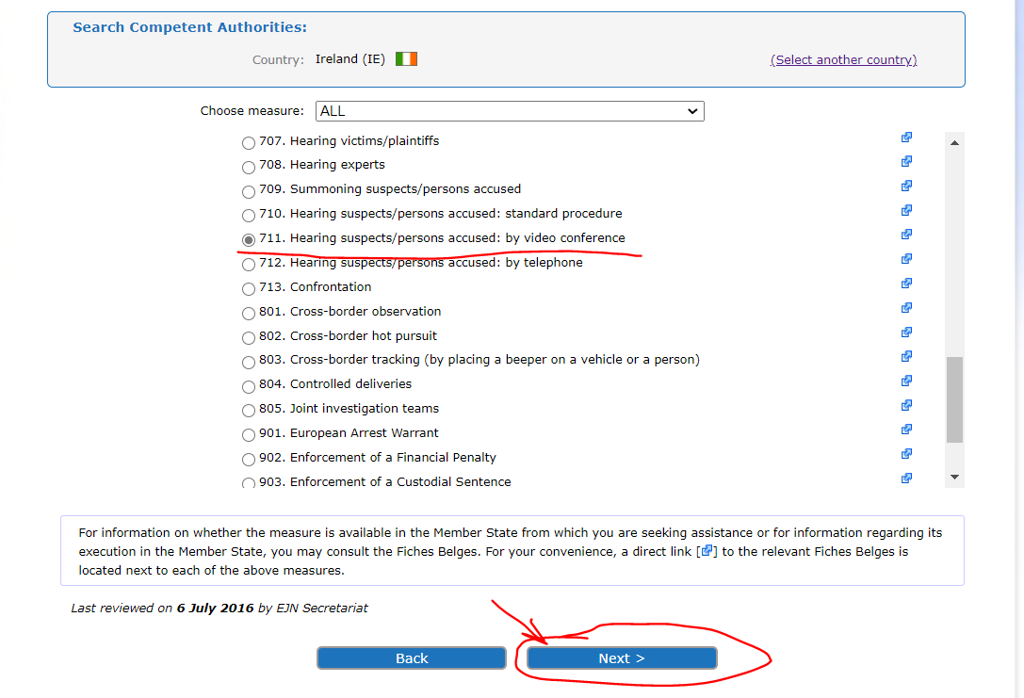

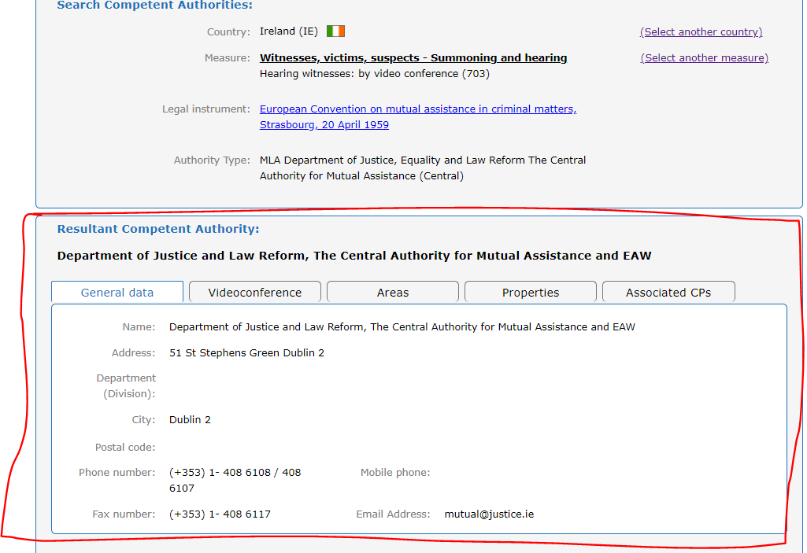

Q4. Which form for the LoR is to be used by the requesting judicial authority when asking for the hearing by videoconference or by telephone conference?
There is no specific form for the LoR which is to be send by the requesting authority to the requested authority neither in the 2000 Convention nor in the 1959 Convention and its additional protocols.
Requesting authority have struggled to draft different forms of an LoR to be sent to the requested authority. And this is not an easy task!
For this reason, on the EJN website in the Section – Compendium –there is the possibility to draft an LoR depending on whether the requested authority is located in an EU Member State, Norway or a non-EU Member State.

A Compendium User Manual is available on the same webpage.

Q5. Fill in the LoRs necessary for hearing the witness and the suspect.
The participants will have to fill in an LoR in order to hear a witness and/or a suspect by MLA.
Notes when filling in the LoRs for the hearing of witness and suspect:
- When filling in the request for mutual legal assistance in the section – Requesting authority - introduce all the details of a national judicial authority competent to investigate the offences provided in the case scenario from the country where the seminar is taken place (!!! the requesting authority will only remain the same as in the case scenario if the seminar is taken place in Romania).
- Section – Requested authority – will be filled in with the information from question c).
- Section – Requested measure – 703. Hearing witnesses: by video conference or 711. Hearing suspects/persons accused: by video conference depending on the LoR.
- Section – Persons concerned – please insert the details of the two suspects and witness (person 1, 2 and 3). Please add random details when missing from the ones provided in the case scenario.
- Section - Urgency / Confidentiality – fill in Yes or No depending on your national provision. In case you put Yes for either of the two boxes – the participants will indicate if there is a procedural deadline and the reasons for the urgency or confidentiality.
- Section – Legal basis of the request – depending on the LoR:
- for the LoR - hearing the witness by video conference is the 2000 Convention (with the exception of Croatia where the legal basis is the Second Additional Protocol to the European Convention on Mutual Assistance in Criminal Matters, Strasbourg, 08 November 2001),
- for the LoR – hearing the suspect by videoconference is the 2000 Convention.
If there is a bilateral/multilateral treaty between your country and the requested country from the case scenario, the participants will indicate the treaty/convention/agreement or any other international instrument existing between the two countries.
- When filling the section - Facts and qualification – the participants will introduce the national provisions applicable for the facts described in the case scenario.
- When filling the section - Special formalities required under the law of the requesting state – the participants will introduce the formalities provided by the national law in relation to hearing the witnesses or the suspects (if applicable).
- In the section - Other authorities involved – the participants will fill in the authority/authorities provided by the national law (if applicable). The participants will specify the role of these authorities or if they request to assist to the execution of the request.
- In the section - Specific information needed in case of request for hearings by videoconference – the participants will fill in any information regarding their judicial authority or any fictional information (if not known) for the requesting authority and random information for the requested authority and pre-meeting information not known from the case provided.
- In the section Annexes – if filled in please mention the name of the annex.
- For the section - Signature / Official stamp – the participants will fill in a random name and position.
Q6. Are there any time limits for the execution of the MLAs by the requested competent authorities?
Different from Directive 2014/41/EU regarding the European Investigation Order in criminal matters where express time limits for recognition or execution (see Article 12) have been introduced, neither the 2000 Convention nor the Second Additional Protocol to the European Convention on Mutual Assistance in Criminal Matters provide such time limits for execution of an LoR.
As a general rule, the requests shall be executed as soon as possible and if possible, within the deadlines indicated by the issuing authority.

- Convention on Mutual Assistance in Criminal Matters between the Member States of the European Union (2000 Convention)
Article 4 para 2 provides that the requested Member State shall execute the request for assistance as soon as possible, taking as full account as possible of the procedural deadlines and other deadlines indicated by the requesting Member State.
If it is foreseeable that the deadline set by the requesting Member State for executing its request cannot be met the authorities of the requested Member State shall promptly indicate the estimated time needed for execution of the request. The authorities of the requesting Member State shall promptly indicate whether the request is to be upheld, nonetheless. The authorities of the requesting and requested Member States may subsequently agree on further action to be taken concerning the request (Article 4 para 4).
- Second Additional Protocol to the European Convention on Mutual Assistance in Criminal Matters
There are no time limits provided for the execution of an LoR in the Convention, which means that the requests are to be executed as soon as possible and, if possible, within the deadlines indicated by the issuing authority.
Q7. Which rules and requirements will apply to the hearing the witness or suspect?
In order to ensure the admissibility of the evidence obtained, the authorities of the requested State shall comply with the formalities and procedures indicated by the authorities of the requesting State provided that they are not contrary to fundamental principles of law in the requested State.
- Hearing by videoconference of the witness => Article 10 of the 2000 Convention
Conditions, rules and requirements applicable:
- The witness is in one Member State’s territory and has to be heard by the judicial authorities of another Member State.
- It is not desirable or possible for the person to be heard to appear in the territory of the requesting MS in person.
- The requested Member State shall agree to the hearing by videoconference provided that the use of the videoconference is not contrary to fundamental principles of its law.
- The judicial authority of the requested Member State shall summon the person concerned to appear in accordance with the forms laid down by its law.
- A judicial authority of the requested Member State shall be present during the hearing, where necessary assisted by an interpreter, and shall also be responsible for ensuring both the identification of the person to be heard and respect for the fundamental principles of the law of the requested Member State.
- If the judicial authority of the requested Member State is of the view that during the hearing the fundamental principles of the law of the requested Member State are being infringed, it shall immediately take the necessary measures to ensure that the hearing continues in accordance with the said principles.
- Measures for the protection of the person to be heard shall be agreed, where necessary, between the competent authorities of the requesting and the requested Member States.
- The hearing shall be conducted directly by, or under the direction of, the judicial authority of the requesting Member State in accordance with its own laws.
- At the request of the requesting Member State or the person to be heard the requested Member State shall ensure that the person to be heard is assisted by an interpreter, if necessary.
- The person to be heard may claim the right not to testify which would accrue to him or her under the law of either the requested or the requesting Member State.
- The judicial authority of the requested Member State shall on the conclusion of the hearing draw up minutes indicating the date and place of the hearing, the identity of the person heard, the identities and functions of all other persons in the requested Member State participating in the hearing, any oaths taken and the technical conditions under which the hearing took place.
- The document shall be forwarded by the competent authority of the requested Member State to the competent authority of the requesting Member State.
- The cost of establishing the video link, costs related to the servicing of the video link in the requested Member State, the remuneration of interpreters provided by it and allowances to witnesses and experts and their travelling expenses in the requested Member State shall be refunded by the requesting Member State to the requested Member State, unless the latter waives the refunding of all or some of these expenses.
- Hearing by videoconference of the witness => Article 9 para 1-7 of the Second Additional Protocol to the European Convention on Mutual Assistance in Criminal Matters
Conditions, rules and requirements applicable:
- The witness is in one Member State’s territory and has to be heard by the judicial authorities of another Member State.
- It is not desirable or possible for the person to be heard to appear in the territory of the requesting MS in person.
- The requested Member State shall agree to the hearing by videoconference provided that the use of the videoconference is not contrary to fundamental principles of its law.
- Requests for a hearing by video conference shall contain the reason why it is not desirable or possible for the witness or expert to attend in person, the name of the judicial authority and of the persons who will be conducting the hearing.
- The judicial authority of the requested Party shall summon the person concerned to appear in accordance with the forms laid down by its law.
- A judicial authority of the requested Party shall be present during the hearing, where necessary assisted by an interpreter, and shall also be responsible for ensuring both the identification of the person to be heard and respect for the fundamental principles of the law of the requested Party.
- If the judicial authority of the requested Party is of the view that during the hearing the fundamental principles of the law of the requested Party are being infringed, it shall immediately take the necessary measures to ensure that the hearing continues in accordance with the said principles;
- Measures for the protection of the person to be heard shall be agreed, where necessary, between the competent authorities of the requesting and the requested Parties
- The hearing shall be conducted directly by, or under the direction of, the judicial authority of the requesting Party in accordance with its own laws.
- The judicial authority of the requested Party shall on the conclusion of the hearing draw up minutes indicating the date and place of the hearing, the identity of the person heard, the identities and functions of all other persons in the requested Party participating in the hearing, any oaths taken and the technical conditions under which the hearing took place.
- The document shall be forwarded by the competent authority of the requested Party to the competent authority of the requesting Party.
- Hearing by videoconference of the suspect => Article 10 para 9 of the 2000 Convention
Member States may at their discretion also apply the provisions of Article 10 of the 2000 Convention, where appropriate and with the agreement of their competent judicial authorities, to hearings by videoconference involving an accused person. In this case, the decision to hold the videoconference, and the manner in which the videoconference shall be carried out, shall be subject to agreement between the Member States concerned, in accordance with their national law and relevant international instruments, including the 1950 European Convention for the Protection of Human Rights and Fundamental Freedoms.
Any Member State may, when giving its notification pursuant to Article 27(2), declare that it will not apply the first subparagraph. Such a declaration may be withdrawn at any time. Hearings shall only be carried out with the consent of the accused person. Such rules as may prove to be necessary, with a view to the protection of the rights of accused persons, shall be adopted by the Council in a legally binding instrument.
Conditions, rules and requirements:
- The suspect is in one Member State’s territory and has to be heard by the judicial authorities of another Member State.
- It is not desirable or possible for the person to be heard to appear in the territory of the requesting MS in person.
- The requested MS considers the hearing appropriate and has the agreement of its competent judicial authorities for the hearing.
- It must exist an agreement between the competent judicial authorities involved with regard to holding the videoconference.
- An agreement on the manner in which the videoconference shall be carried out should be reached by the Parties concerned.
- The consent of the suspect.

Strasbourg, 8.XI.2001
OJ L 130, 1.5.2014, p. 1–36
2000/C 197/01
Strasbourg, 20.IV.1959

