The European Investigation Order
Directive 2014/41/EU of the European Parliament and of the Council of 3 April 2014 regarding the European Investigation Order in criminal matters
Set of Case Studies – Guide for Trainers

Written by:
Daniel Constantin Motoi
Judge,
Court of First Instance, 4th District, Bucharest Tribunal, Bucharest

Table of contents

A. Case studies 1
I. Case scenario 1; Questions 1
II. Exercises 2
III. Case scenario 2; Questions 3

B. Additional notes for the trainers regarding the cases 5

C. Methodological approach 6
I. General idea and core topics 6
II. Working groups and structure of the seminar 7
III. Additional material 8

D. Solutions 9

Annex Step-by-step solutions 23

The European Investigation Order

A. I. Case scenario 1:
In order to gather evidence in a criminal investigation, a Romanian prosecutor needs to:
- hear, by videoconference, a witness who is currently living in Bulgaria,
- order a house search of a suspect living in Austria and,
- obtain information on a Polish bank account of the same suspect.

Questions:
- Which is the legal instrument for judicial cooperation available for the Romanian prosecutor in order to gather evidence from abroad?
- What if the witness lives in Denmark or in Ireland? Does it make any difference for the legal instrument applicable in the case?
- What if the prosecutor wants to summon the witness in Bulgaria in order to be heard in Romania? Will Directive 2014/41/EU still be applicable?
- How many EIOs should the Romanian prosecutor issue for this case? Indicate the reasons for your answer.

A. II. Exercises:
Find the following executing competent authorities for an EIO (general criminal cases):
1. A German competent issuing authority wants a house search of a suspect, located in Brussels, Belgium.
Competent authority:
Language:
2. A French competent issuing authority wants to hear by videoconference a witness residing in Vigo, Spain.
Competent authority:
Language:
3. A Spanish competent issuing authority wants to hear an expert living in Athens, Greece.
Competent authority:
Language:
4. A Romanian competent issuing authority wants to intercept the telecommunication of a suspect located in France without technical assistance.
Competent authority:
Language:

A. III. Case scenario 2:
In March 2020, an investigation was opened in Romania against the offenders A.W. (a German citizen), J.P. and J.L. (Romanian citizens) for allegedly committing two thefts from ATMs located in Constanta, Romania (file no. 1200/P/2020). The Romanian judicial authorities have established that on the night of 27.02.2020, at around 02.00 a.m. and on the night of 09.03.2020, at around 03.20 a.m., A. W. (German citizen, born in Stuttgart, Germany, on 06.06.1955), J.P. (Romanian citizen, born on 25.03.1977) and J.L. (Romanian citizen, born on the 24.06.1978), using proper tools and wearing masks on their faces, committed two thefts from ATMs located in Bulevardul Republicii, Constanta, Romania, managing to steal around 478 000 lei RON (around 100 000 euros).
J.P. and J.L. have been identified and caught by the police but A.W. managed to flee to Germany on 10.03.2020 by personal car with destination Stuttgart, Germany. The stolen money has not yet been found by the police and the investigators assume that it could have been taken by A.W.
J.P. and J.L. were accused of committing the two abovementioned thefts and placed under provisional arrest for 30 days by a decision of the Court of First Instance Constanta on 11.03.2020. They also recognised committing the offences and want to reach an agreement with the prosecutor.
The Prosecutor’s Office attached to the Court of First Instance Constanta who has the jurisdiction in investigating these crimes has established that A. W. is a German citizen and lives in Stuttgart, Siemensstrasse, postal code 70469, Germany.
Also, the Prosecutor’s Office attached to the Court of First Instance Constanta managed to identify the witness T. J., an Austrian citizen who presently lives in Vienna, Gerhard-Bronner Strasse, postal code 1100, Austria (the witness was on vacation in Romania in that period and saw all three offenders on the night of 27.02.2020 near the ATM in Bulevardul Republicii, Constanta, just minutes before committing the theft without masks on near a car with German number plates).
After gathering all the evidence in Romania, on 15.03.2020 the Prosecutor’s Office attached to the Court of First Instance Constanta requested from the Court of First Instance Constanta the authorisation for the A.W.’s house search in Stuttgart. The request that was granted on the same day by the competent judge through decision 111/UP/P/15.03.2020.
Also, the prosecutor in charge of the case wants to hear, by videoconference, T.J. as a witness in the case.

Questions:
- Find the German competent authority the Romanian judicial authority needs to address for A.W.’s house search.
- Find the Austrian competent authority that will help the Romanian judicial authority to hear the witness by videoconference.
- In which languages will the EIOs be sent by the issuing authority to the two competent executing authorities?
- Fill in the EIO regarding the house search in Germany and the EIO regarding the hearing by videoconference in Austria.
- What will the competent executing authority do after receiving an EIO from the issuing authority? What are its obligations?
Part B. Additional notes for the trainers regarding the cases
A. I. Case scenario 1:
The issuing competent authority will be changed and replaced by a competent judicial authority from the MS where the seminar is taking place with the exception Denmark and Ireland. If one of the executing MS is the country where the seminar is taking place, it will be replaced by Romania as the executing MS accordingly.
A. III. Case scenario 2:
- The issuing competent judicial authority will be changed and replaced by a competent judicial authority from the MS where the seminar is taking place with the exception of Denmark and Ireland.
- As a consequence, the case details will be adapted accordingly, with details given from the country where the seminar is taking place (the places where the offences where committed, a number case file, a national competent judicial authority to take the provisional arrest of the suspects J.P. and J.L. and to grant a house search according to the national law).
- If changed for other MS with the exception of Germany and Austria, A.W. will remain a German citizen and T.J. an Austrian citizen, while J.P. and J.L. will be national citizens of the country where the seminar is taking place.
- In the case of Germany, as issuing judicial authority, A.W. will be a Romanian citizen, living in Bucharest, Regina Elisabeta Boulevard, postal code 050013, Romania and J.P. and J.L. will be German citizens).
- In the case of Austria, as issuing authority, A.W. will remain as in the case scenario (a German citizen) and J.P. and J.L. will be Austrian citizens. The witness T.J. will be a Romanian citizen living in Bucharest, Unirii Boulevard, postal code 040090, Romania.
- As a consequence, the authorities mentioned at questions 1, 2 and 4 will be replaced accordingly.
Part C. Methodological approach
- General idea and core topics
The idea of this training material is to make the court staff from the Member States familiar with the legal instruments for judicial cooperation available at the European level with a view to gather evidence from abroad.
Very often, court staff find themselves in difficulty when trying to identify and then use the appropriate legal instrument for judicial cooperation.
After identifying the legal instrument applicable, court staff are involved in administrative tasks ranging from filling in the form requested by the legal instrument, identifying the competent authority to send it to, translation of the form, requesting or sending additional information regarding judicial cooperation. For these reasons, the following main aspects will be covered within the seminars:
1. Scope of application of Directive 2014/41/EU of the European Parliament and of the Council of 3 April 2014 regarding the European Investigation Order in criminal matters.
2. Familiarisation with the general structure of Directive 2014/41/EU.
3. Relationship between Directive 2014/41/EU and other legal instruments for judicial cooperation available at European level with a view to gathering evidence from abroad.
4. Familiarisation with the content of the EIO and learning how to fill in an EIO.
5. Making the participants aware of further developments at European level with regard to Directive 2014/41/EU (availability of guidelines, joint notes, reports especially on the EJN’s website).
6. Administrative details: How should an issuing authority proceed in a particular situation? Where can an issuing authority find the electronic version of the forms provided by the Directive? Which language is to be used? Where can the issuing authority find the competent authority from the executing Member State where the request needs to be addressed to?
- Working groups and structure of the seminar
The seminar will start with a brief presentation (Power point) highlighting the important features of Directive 2014/41/EU regarding EIO – relationship with other legal instruments (especially MLA instruments on gathering of evidence), definitions, scope, transmission of the EIO, recognition and execution, grounds for refusing, alternative measures, time limits, legal remedies, postponement, obligation to inform, relation with other legal instruments (approx. 20 min).
During the presentation, the trainer will make the participants aware of the documents: Competent authorities, languages accepted, urgent matters and scope of the EIO Directive (Updated 07 August 2019) - and Guidelines on the European Investigation Order forms - both available on the EJN’s website.
Case scenario 1 is the opportunity to apply Directive 2014/41/EU of the European Parliament and of the Council of 3 April 2014 regarding the European Investigation Order in criminal matters as an instrument for gathering of evidence from abroad and its relationship with other legal instruments for judicial cooperation available at the European level.
In order to solve the practical cases 4-6, laptops with Internet connection will be needed.
The participants will be divided into small groups of 5-8 people and will solve the questions using the EJN’s website and Council of Europe’s Treaty Office website.
The trainer will guide the participants in finding each of the legal instruments applicable in each case, using the EJN’s website and Council of Europe’s Treaty Office website.
Solving the case scenario 1 should take approx. 20 minutes.
Solving the exercises from point II should take around 15 minutes as they are meant to help the participants in understanding the mechanism for finding a competent executing authority from another MS which will execute the EIO.
In order to solve the Case scenario 2 the participants will remain divided into 4-6 groups of max. 5-8 participants each, and each group needs to have access to a laptop connected to Internet and to the .doc form of EIO, available on the EJN website (as much as possible the groups should have the same level of expertise).
After solving questions 1-3, some of the groups (2-3 groups) will fill in the EIO as required in question 4 (will fill in the EIO regarding the house search) and the other groups (2-3 groups) will fill in the EIO as required in the question 4 (will fill in the EIO regarding the hearing by videoconference).
The participants will fill in a .doc of the EIO, save it on the computer, print it and send it to a group that filled in a different EIO (a group filling in the EIO regarding the house search will send it to the group that filled in the EIO regarding the videoconference and vice versa).
After exchanging the forms, each group will designate a representative which will present the group’s finding whether the EIO received complies with the requirements (approx. 10 min for the discussions).
Solving case scenario 2 (including the filling in of the EIOs) should take approx. 2 hours.
Any remaining questions should finally be discussed in plenary (for approx. 5-10 minutes).
- Additional material
All participants will be provided with a copy of Directive 2014/41/EU of the European Parliament and of the Council of 3 April 2014 regarding the European Investigation Order in criminal matters and of an EIO form. The participants will bring or have access to the national provisions implementing Directive 2014/41/EU. Also, each of the groups will have a .doc of the EIO printed out.

Part. D. Solutions
A. I. Case scenario 1
Q1: Which is the legal instrument for judicial cooperation available for the Romanian prosecutor in order to gather evidence from abroad?
In our case the legal instrument applicable is Directive 2014/41/EU of the European Parliament and of the Council of 3 April 2014 regarding the European Investigation Order in criminal matters (Directive regarding EIO hereinafter), which had the deadline for transposition 22 May 2017.
According to Article 1 para 1 of the abovementioned Directive, a European Investigation Order (EIO) is a judicial decision which has been issued or validated by a judicial authority of a Member State (‘the issuing State’) to have one or several specific investigative measure(s) carried out in another Member State (‘the executing State’) to obtain evidence in accordance with this Directive.
In order to be sure that this judicial cooperation instrument is fully applicable with regard to the three other countries involved in the judicial cooperation, the Romanian prosecutor will verify the status of implementation of the Directive regarding EIO by the Member States, available on the European Judicial Network (EJN hereinafter).
The status of implementation of the Directive regarding EIO can be found on the EJN website – www.ejn-crimjust.europa.eu in the section EU Legal Instruments for Judicial Cooperation. Further in the table, there is the section Status of implementation of the Directive where we can verify if a country we are interested to see if it has transposed the Directive regarding EIO.
Romania, Austria, Poland and Bulgaria have all transposed the Directive regarding EIO which means that this judicial legal instrument will be used in our case by the judicial authority in order to obtain evidence.
The question of why are we not applying another judicial legal instrument in this case may arise (e.g. the Convention of 29 May 2000 on Mutual Assistance in Criminal Matters between the Member States of the European Union).
In this respect, it should be noted that according to Article 34 para 1 of the Directive regarding EIO it is provided that the Directive replaces, as from 22 May 2017, the corresponding provisions of the following conventions applicable between the Member States bound by this Directive:
(a) European Convention on Mutual Assistance in Criminal Matters of the Council of Europe of 20 April 1959, as well as its two additional protocols, and the bilateral agreements concluded pursuant to Article 26 thereof,
(b) Convention implementing the Schengen Agreement,
(c) Convention on Mutual Assistance in Criminal Matters between the Member States of the European Union and its protocol.
So, as Member States involved in the judicial cooperation, they shall apply the Directive regarding EIO to the detriment of the other legal instruments available with regarding the gathering of evidence.
The wording of the Directive regarding EIO is replace in order to highlight the obligation as Member State of the European Union to apply the legislation of the European Union in this particular area and not leaving space for interpretation and alternative for the Member States involved.
Moreover, Article 34 para 3 of the Directive regarding EIO provides that, in addition to this Directive, Member States may conclude or continue to apply bilateral or multilateral agreements or arrangements with other Member States after 22 May 2017 only insofar as these make it possible to further strengthen the aims of this Directive and contribute to simplifying or further facilitating the procedures for gathering evidence and provided that the level of safeguards set out in this Directive is respected.
Of course, the conclusion or continuation to apply bilateral or multilateral agreements or arrangements with other Member States after 22 May 2017 needs to be seen only in strict connection with the corresponding provisions of the Directive regarding EIO, which can be further developed by Member States in different agreements of arrangements, and not in connection with the conventions mentioned in the Article 34 para 1 of the Directive regarding EIO, which are put aside and cannot be applied in the area of the Directive, e.g. if the Member States consider that the provisions from the Conventions are better, faster, or just as a tradition between the Member States involved.

Q2: What if the witness lives in Denmark or in Ireland? Does it make any difference for the legal instrument applicable in the case?
Regarding Denmark, in the Recital (45) of the Directive on EIO it is provided that in accordance with Articles 1 and 2 of Protocol No 22 on the Position of Denmark annexed to the TEU and the TFEU, Denmark is not taking part in the adoption of this Directive and is not bound by it or subject to its application.
Also, with regard to Ireland, in the Recital (44) of the Directive on EIO it is provided that in accordance with Articles 1 and 2 and Article 4a(1) of Protocol No 21 on the position of the United Kingdom and Ireland in respect of the area of Freedom, Security and Justice annexed to the TEU and the TFEU, and without prejudice to Article 4 of that Protocol, Ireland is not taking part in the adoption of this Directive and is not bound by it or subject to its application.
This means that Directive 2014/41/EU of the European Parliament and of the Council of 3 April 2014 regarding the European Investigation Order in criminal matters is not applicable for Denmark and Ireland, and that the competent authority of the requesting Member States needs to look for other legal instruments for cooperation in criminal matters in order to gather the evidence requested for.
In our particular case, Denmark and Romania are parties to the Convention of 29 May 2000 on Mutual Assistance in Criminal Matters between the Member States of the European Union and have ratified it, which means the Convention is fully applicable (hearing by videoconference is provided for in Article 10 of the 2000 Convention).
It should be kept in mind that all the dispositions from the 2000 Convention will be applicable between the two states involved (e.g. no official form to be used, no time limits for the execution of LoR are provided for in the Convention).
The full table of the ratification details of Convention of 29 May 2000 on Mutual Assistance in Criminal Matters between the Member States of the European Union is available on the EJN’s website:
Ireland and Romania are also part to the Convention of 29 May 2000 on Mutual Assistance in Criminal Matters between the Member States of the European Union and have ratified it, which means the Convention is fully applicable (the hearing of videoconference is provided in Article 10 of the 2000 Convention). The 2000 Convention enter into force for Ireland as of 23.08.2020.

Q3: What if the prosecutor wants to summon the witness in Bulgaria in order to be heard in Romania? Will Directive 2014/41/EU still be applicable?
According to Article 1 para 1 of the Directive regarding EIO a European Investigation Order (EIO) is a judicial decision which has been issued or validated by a judicial authority of a Member State (‘the issuing State’) to have one or several specific investigative measure(s) carried out in another Member State (‘the executing State’) to obtain evidence in accordance with this Directive.
Article 3 provides that the EIO shall cover any investigative measure with the exception of the setting up of a joint investigation team and the gathering of evidence within such a team as provided in Article 13 of the Convention on Mutual Assistance in Criminal Matters between the Member States of the European Union (1) (‘the Convention’) and in Council Framework Decision 2002/465/JHA (2), other than for the purposes of applying, respectively, Article 13(8) of the Convention and Article 1(8) of the Framework Decision
As can be seen, in order to be applicable, the Directive regarding EIO, a judicial authority needs to request an investigative measure to be taken in order to gather evidence in the other Member State involved.
Of course, according to Article 1 para 2 of the Directive regarding EIO the EIO may also be issued for obtaining evidence that is already in the possession of the competent authorities of the executing State.
In the case of sending or service of procedural documents from the requesting Member State to the requested Member State the Directive regarding EIO will not be applicable because it falls outside of the EIO as mentioned in Article 3 from the Directive.
One particular mention should be made with regard to the sending of procedural documents as part of the investigative measure requested, when these can be included in the EIO according to Article 9 (2) od Directive 2014/41/EU (e.g. before doing a house search, the person concerned by the investigative measure needs to sign a document where there are provided its rights).
In our case, Bulgaria and Romania are part of the Convention of 29 May 2000 on Mutual Assistance in Criminal Matters between the Member States of the European Union and have ratified it which means the Convention is fully applicable (the sending and service of procedural documents is provided in Article 5 of the 2000 Convention).
At this point it is important to recall that the Directive regarding EIO is also not applicable in the following situations (some are expressly mentioned in Directive 2014/41/EU and others result from the interpretation of the scope mentioned in Article 3 of the same Directive):
- Setting up of a joint investigation team and gathering of evidence within such a team (Article 3 of Directive 2014/41/EU), in which case in which case provisions from Article 13 of the Convention on Mutual Assistance in Criminal Matters between the Member States of the European Union and from Council Framework Decision 2002/465/JHA will be applicable,
- Spontaneous exchange of information (Article 7 of the 2000 Convention),
- Freezing property for the purpose of subsequent confiscation (Framework Decision 2003/577/JHA on the execution in the European Union of orders freezing property or evidence; and, as of 19.12.2020, Regulation 2018/1805 on the mutual recognition of freezing orders and confiscation orders),
- Restitution: return of an object to victim (Article 8 of the 2000 Convention),
- Gathering of extracts of the criminal records register/ECRIS,
Q4: How many EIOs should the Romanian prosecutor issue for this case? Indicate the reasons for your answer.
The Directive regarding EIO provides no clear indications on how the issuing authority should proceed in this kind of situation, where assistance in gathering evidence from different executing authorities is required. This is especially when executing authorities from different Member States are involved.
Article 8 para 1 of the Directive only makes a reference to an earlier EIO and provides that where an issuing authority issues an EIO which supplements an earlier EIO, it shall indicate this fact in the EIO in Section D of the form set out in Annex A.
Still, in Section D of the form set out in Annex A we find the mention, if relevant please indicate if an EIO has already been addressed to another Member States in the same case.
The issuing authority can issue one single EIO and will indicate in it all the investigative measures to be taken that will be sent to the executing authority/authorities involved. Depending on the national provisions and on what the executing authorities ask, the issuing judicial authority can issue the EIO both in original or one original and one copy. This possibility is not ruled out because the wording of the EIO is …. indicate if an EIO has already been addressed to another Member States in the same case…. which is not the situation when as issuing authority issues two EIOs at the same time and transmits them in the same time.
- In the Joint Note of Eurojust and the European Judicial Network on the practical application of the European Investigation Order as best practice it is mentioned that the issuing several EIOs might be recommended, depending on the nature and scope of a case and if different authorities in charge of the execution of the EIO (see pages 4 and 7-8 of the Joint Note).
In our case, because two different executing authorities from two different countries will be involved, the issuing authority will have to fill in two EIOs, one for each investigative measure requested (house search, hearing by videoconference and obtain information about the bank account), and in the section D of the Annex A of the EIO it will fill in the comment, if relevant please indicate if an EIO has already been addressed to another Member States in the same and indicate to which authority from the executing Member State the other EIO has been sent.
One reason more for issuing three EIOs is that in Section A of the EIO the executing authority must be indicated, or in our case we have three different executing authorities from two different Member States. It is not a simple administrative matter, for example when one EIO with two investigative measures must be executed by two different executing authorities from the same Member State.
In this situation each of the EIO will be filled in only with the investigative measure requested and with the detail of the executing authority that will execute the respective EIO and mentioned the other two EIOs issued in the same case.
A. II. Exercises:
Find the following executing competent authorities for the execution of an EIO (general criminal cases):
Using the Atlas available on the EJN’s website, and introducing the executing MS and the measures indicated in each of the exercises, we will get the following results (see all the explanations in the Annex below):

1. A German competent issuing authority wants a house search of a suspect, located in Brussels, Belgium.
Name: Parket van de procureur des Konings te Brussel (Bureau CIS)- Parquet du procureur du Roi de Bruxelles (Bureau CIS)
Address: Portalis, Rue des Quatre bras, 4
Department (Division):
City: Bruxelles
Postal code: 1000
Phone number: +32 (0)2 508 70 80
Mobile phone:
Fax number: +32 (0)2 519 82 96
Email Address: cis.bxl@just.fgov.be
2. A French competent issuing authority wants to hear by videoconference a witness residing in Vigo, Spain.
Name: Fiscalía Provincial de Pontevedra (Prosecutor's Office)
Address: Edifico Juzgados. Plaza Tomás y Valiente, s/n
Department (Division):
City: PONTEVEDRA
Postal code: 36071
Phone number: +34 986 80 57 32
Mobile phone:
Fax number: +34 986 80 53 58
Email address: internacional.pontevedra@fiscal.es

3. A Spanish competent issuing authority wants to hear an expert living in Athens, Greece.
Name: Public prosecutor's Office at the Court of Appeal of Athens
Address: Kirilou Loukareos 14
Department (Division):
Department of extradition and judicial assistance
City: Athens
Postal code: 11475
Phone number: +30 210 64 04 612
Mobile phone:
Fax number: +30 210 64 04 667
Email Address: cpejn1@otenet.gr

4. A Romanian competent issuing authority wants to intercept the telecommunication of a suspect located in France without the technical assistance.
Name: Office for international mutual legal assistance in criminal matters, division of criminal affairs and pardons, Ministry of justice.
Address: 13, Place Vendôme
Department (Division):
Communications for this measure shall be done via the ministry of justice, office for international mutual legal assistance.
City: Paris cedex 01
Postal code: 75042
Phone number:
Mobile phone:
Fax number:
Email Address: liste.entraide.dacg-bepi@justice.gouv.fr
A. III. Case scenario 2
Q1: Find the German competent authority where the Romanian judicial authority needs to address for the A.W.’s house search.
(see the explanations in the Annex below)
In order to find the competent executing authority, the participants will be guided on how to use the Atlas from the European Judicial Network’s website following the steps there provided.
First, we select the country where we want to address the EIO, which is our case is Germany, then we select the investigative measure we are looking for, in our case, 601. Visit to and search of homes.
Once we have selected the investigative measure, we select that the place is known (in our case Stuttgart), then we select Directive 2014/41/EU of the European Parliament and of the Council of 3 April 2014 regarding the European Investigation Order in criminal matters as the legal instrument applicable (because we have seen previously that all the Member States have transposed the Directive with the exception of Denmark and Ireland which are part to it), and lastly, we introduce Stuttgart as the locality involved in the measure.

The result of our search should like this:
Name of the executing authority:
Staatsanwaltschaft Stuttgart
Address: Neckarstr. 145
Department (Division):
City: Stuttgart
Postal code: 70190
Phone number: (+49) 711 9210
Mobile phone:
Fax number: (+49) 711 9214009
Email Address:
As you can see, the executing authority in our case is a prosecutor’s office in Stuttgart, and some of the contact details are provided in order for the issuing authority to know who sent the EIO in order to be recognised and executed by the abovementioned executing authority.
The contact details are also very important for the two judicial authorities in order to enter into direct contact as the Directive regarding EIO expressly provides for.
Q2: Find the Austrian competent authority that will help the Romanian judicial authority to hear by videoconference the witness.
(see further explanations in the Annex below)
In order to find the competent executing authority, the participants will again use the Atlas from the European Judicial Network’s website following the steps provided there.
First, we select the country where we want to address the EIO, which in our case is Austria, then we select the investigative measure we are looking for, in our case, 703. Hearing witnesses: by video conference.
We will then be asked if the case is regarding corruption offences (in our case we select No).
Once we have selected the investigative measure, we select that the place is known (in our case Vienna), then we select Directive 2014/41/EU of the European Parliament and of the Council of 3 April 2014 regarding the European Investigation Order in criminal matters as the legal instrument applicable (because we have seen previously that all the Member States have transposed the Directive with the exception of Denmark and Ireland which are party to it), and lastly, we introduce Stuttgart as the locality involved in the measure.
The result of our search should like this:
Name of the executing authority:
Staatsanwaltschaft Vienna
Address: Landesgerichtsstraße 11
Department (Division):
City: Vienna
Postal code: 1082
Phone number: (+43) 1/40127
Mobile phone:
Fax number: +43 1 40127-306950
Email Address:
As we can see, the executing authority in our case is again a prosecutor’s office in Vienna, and some of the contact details are provided in order for the issuing authority to know who sent the EIO in order to be recognised and executed by the abovementioned executing authority.
The contact details are also very important in order for the two judicial authorities to enter into direct contact as the Directive regarding EIO expressly provides for.
Q3: In which languages will the EIOs be send by the issuing authority to the two competent executing authorities?
In order to answer this question, the participants will be guided to learn how to use the document available on the EJN website - Competent authorities, languages accepted, urgent matters and scope of the EIO Directive (Updated 07 August 2019).
This document contains valuable information about the competent authorities (issuing, validating, receiving, executing authorities and also, if applicable central authorities) designed by each country according to the provisions of the Directive regarding EIO. Also, there is information regarding urgent cases (where should the issuing authority address in such cases), scope, languages accepted and the date for entry into force of the national provisions transposing the Directive.
In what concerns our case, in the document we find that:
Austria will accept the EIO translated into German and a special provision that, in relation to Member States that accept German, also their official languages are accepted.
Germany will accept the EIO translated into German.
Q4: Fill in the EIO regarding the house search in Germany and the EIO regarding the hearing by videoconference in Austria.
The participants will be provided with a .doc form of EIO to be filled in the language where the seminar is taking place.
The participants will fill in the EIOs in small groups and then the EIOs will be exchanged between groups in order for one group to receive the other EIO (the group filling the EIO regarding house search will receive as executing authority the EIO regarding the hearing by videoconference and vice versa).
The trainer will guide the participants on how to fill in the EIO highlighting the Guidelines on the European Investigation Order forms available on the European Judicial Network’s website published on 30.01.2020, which is a very useful tool for legal practitioners when it comes to filling in an EIO.
The link to the Guidelines on the EIO can be found here.
In order to fill in the EIOs the participants will use the editable .pdf form of the European Investigation Order – EIO (Annex A) found on the EJN website.
The editable .pdf form is only in English at the moment. It is a very user-friendly form, which can be easily filled in, saved on a computer and then printed out.
The group that will receive the EIO from another group will analyse it and will designate a person who will point out if the EIO received was correctly filled in or if they consider information to be missing from it.
Notes for filling in the EIOs:
- Depending on where the seminar is taking place, the issuing State will be changed with that country, and accordingly mentioned at point a) of the EIO.
- If the issuing MS is changed with Germany or Austria, then another MS (with the exception of Denmark or Ireland) will be used as executing MS for one of the investigative measures mentioned in the case scenario.
- At point b) urgency will be filled in only if applicable according to the national provisions. If applicable under one of the 3 reasons mentioned, that should be ticked. Also, a shorter time limit for execution should be indicated.
- Point c) will be ticked according to the group filling the EIO.
- At point d) reference to the other EIO filled in by the other groups will be given.
- At point e) of the EIO information about the suspect A.W. and the witness T.J. should be given. Also, information about the other two suspects J.P. and J.L. should be introduced (by the adding natural persons). Fictitious information will be used for any missing from the case scenario.
- At point f) the applicable letter should be indicated as existing in the national provisions.
- At point g) information regarding the nature and legal classification will be used to fill in this section. When given the summary of the facts please use town, streets, etc, from the country where the seminar is taking place. If applicable according to the national law, the offence(s) from point 3 will be ticked accordingly.
- At point h.2) information will be provided for the EIO regarding hearing by video conference. The details of authority can be completed with fictitious information if not provided in the case scenario.
- At point i), formalities and procedures requested for the execution, if applicable according to the national law, point 1 and/or 2 will be filled in with the information needed for the executing judicial authority. For example, in which conditions the house search needs to be made or the witness be heard (if the witness needs to be summoned in advance according to the law of the issuing MS proper information should be given).
- Point j) will be filled in according to the existing national provisions. As held by the Court of Justice in its judgment in Case C-324/17 Gavanozov (judgment of 24 October 2019), a description of the legal remedy must be included only if a legal remedy has been sought against an EIO.
- At point k) of the EIO all the details of a competent authority in charge of issuing the EIO in the home country will be filled in. If some of the details from the case scenario are not known, fictitious data can be used to fill in section k) of the EIO.
- Point l) will be filled in only if applicable to the national provisions. If a non-judicial authority has issued this EIO, then official contact details of the validating authority will be mentioned here.
Q5: What will the competent executing authority do after receiving an EIO from the issuing authority? What are its obligations?
Obligation to inform the issuing authority about receiving the EIO
According to Article 16 para 1 of the Directive regarding EIO the competent authority in the executing State which receives the EIO shall, without delay, and in any case within a week of the reception of an EIO, acknowledge receipt of the EIO by completing and sending the form set out in Annex B.
Where a central authority has been designated in accordance with Article 7(3), this obligation is applicable both to the central authority and to the executing authority which receives the EIO from the central authority.

Where the authority in the executing State which receives the EIO has no competence to recognise the EIO or to take the necessary measures for its execution, it shall, ex officio, transmit the EIO to the executing authority and so inform the issuing authority. This obligation applies also to the executing authority to which the EIO is finally transmitted.
Obligation to inform the issuing authority about the content of the EIO or about the impossibility to executed it as requested
The executing authority shall inform the issuing authority immediately by any means:
(a) if it is impossible for the executing authority to take a decision on the recognition or execution due to the fact that the form provided for in Annex A is incomplete or manifestly incorrect,
(b) if the executing authority, in the course of the execution of the EIO, considers without further enquiries that it may be appropriate to carry out investigative measures not initially foreseen, or which could not be specified when the EIO was issued, in order to enable the issuing authority to take further action in the specific case; or
(c) if the executing authority establishes that, in the specific case, it cannot comply with formalities and procedures expressly indicated by the issuing authority
Obligation to inform the issuing authority about decisions taken regarding the EIO received
The executing authority shall inform the issuing authority without delay by any means capable of producing a written record:
(a) of any decision taken pursuant to Articles 10 or 11 (the decision to recourse to a different type of investigative measure or a decision of non-recognition or non-execution of the EIO).
(b) of any decision to postpone the execution or recognition of the EIO, the reasons for the postponement and, if possible, the expected duration of the postponement.

Annex. Step-by-step solutions
- A German competent issuing authority wants a house search of a suspect, located in Brussels, Belgium.

1. In order to identify the competent authority, we select Belgium as the country selected (BE). Then we select the section Atlas as shown below.

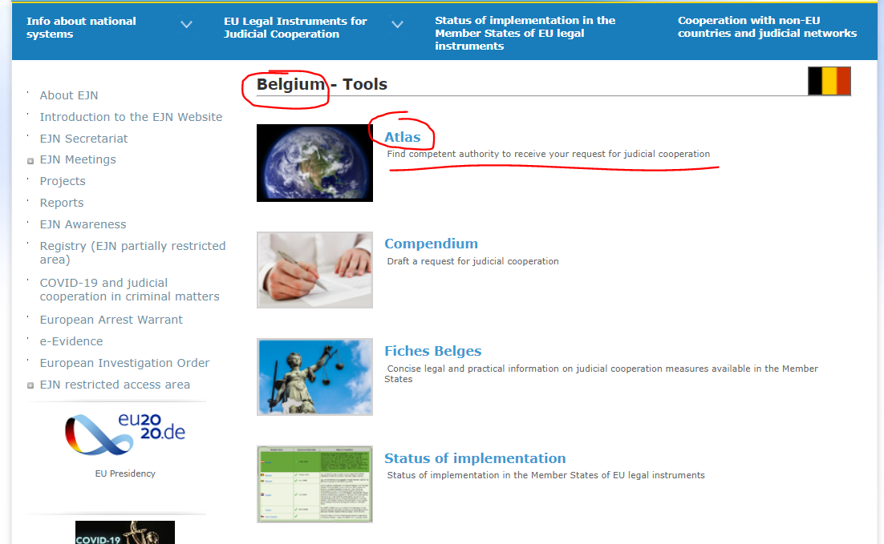

2. We select measure 601. Visit to and search homes. Then we select the section Next as shown below.

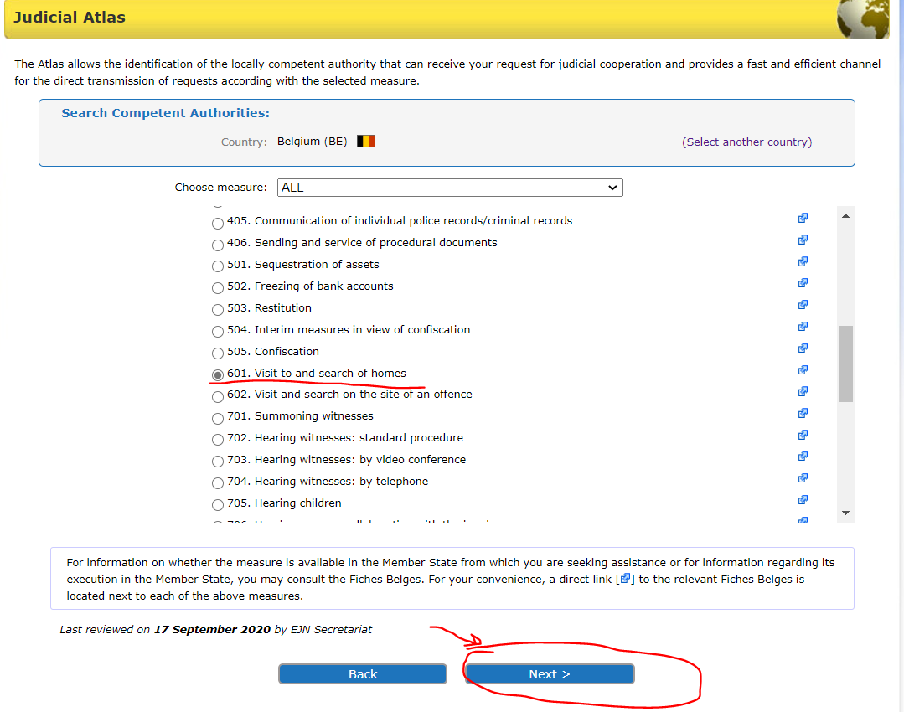

3. Here we have to select from 2 options. We will select that we know the location in Brussels (if we had not known the location we would have chosen not known and we would rely on the help provided by the competent authorities within the executing MS). Then we select the section Next as shown below.
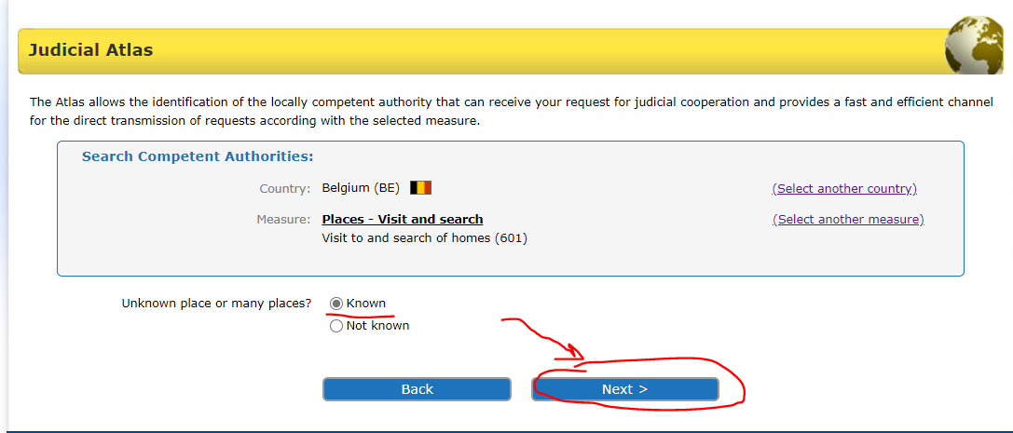

4. Here we have to select from 2 options – the 2000 Convention or Directive 2014/41 on EIO. In order for the Directive to be applicable we verify the status of implementation (on the EJN’s website) of the legal instrument. We know that only Denmark and Ireland are not bound by the Directive and the other MS have implemented the Directive. We will select Directive 2014/41 on EIO. Then we select the section Next as shown below.

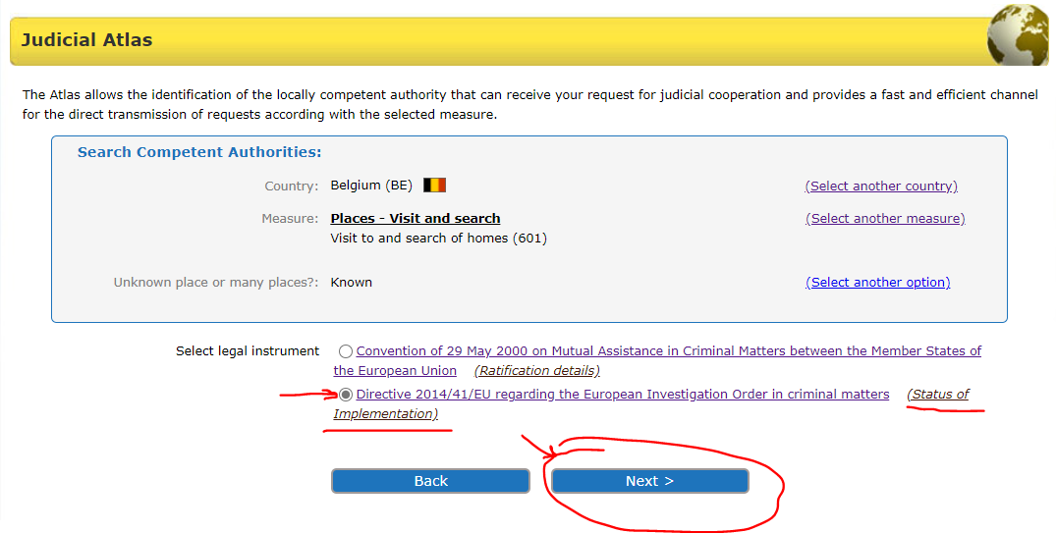

5.We introduce Brussels. Then we select the section Next as shown below.

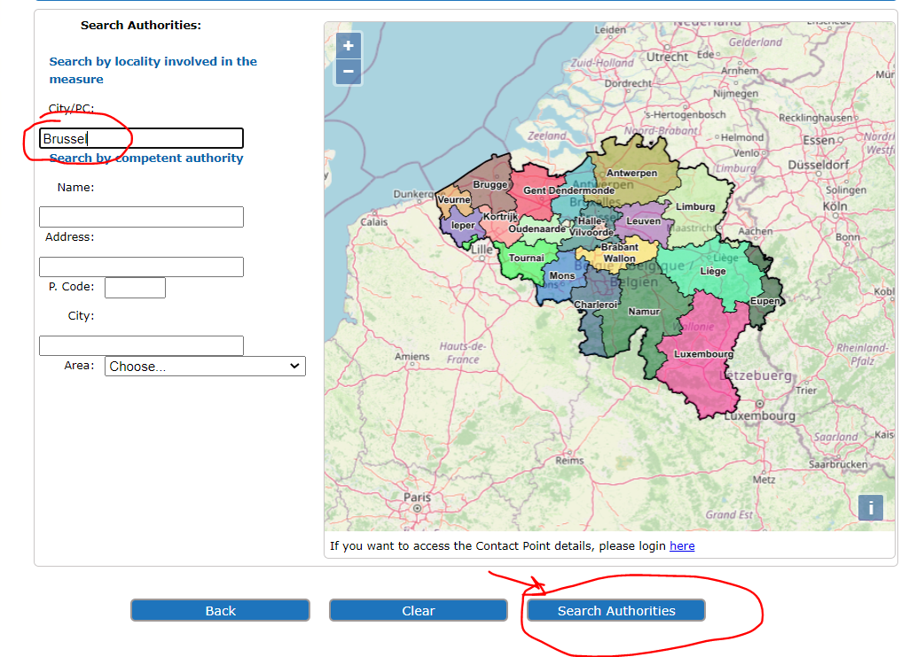

6. At the end we are provided with the results of our search as shown below.

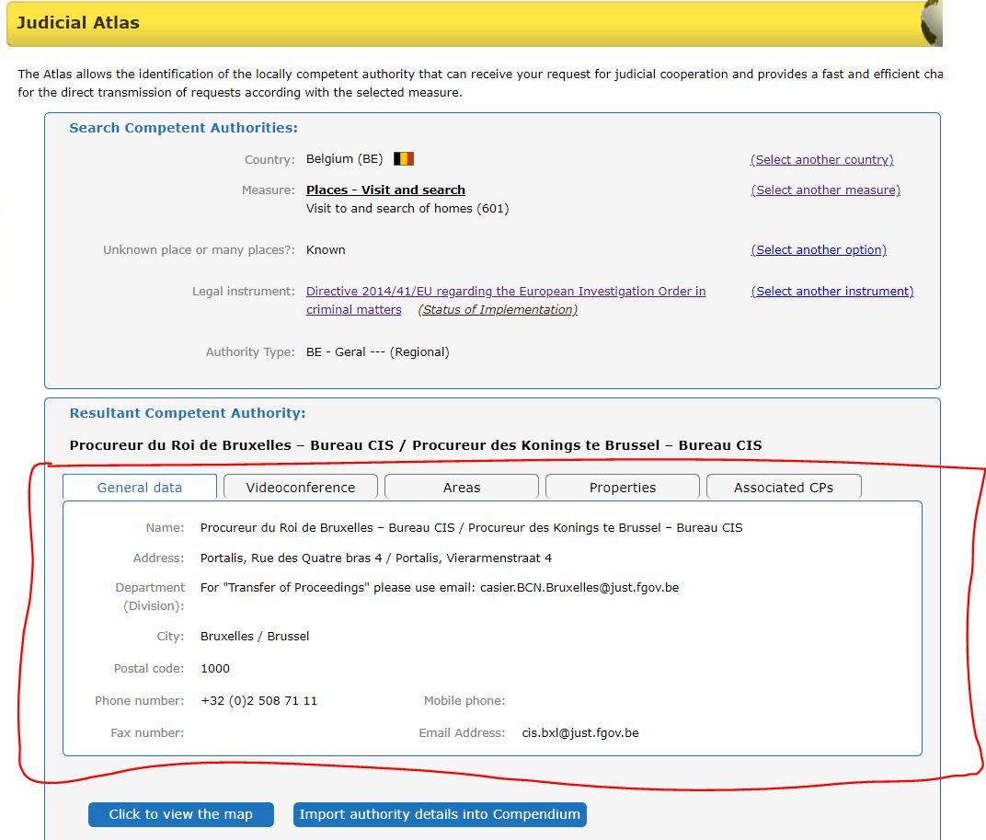
- A French competent issuing authority wants to hear, by videoconference, a witness residing in Vigo, Spain.

1. In order to identify the competent authority, we select Spain as the country selected (ES). Then we select the section Atlas as shown below.

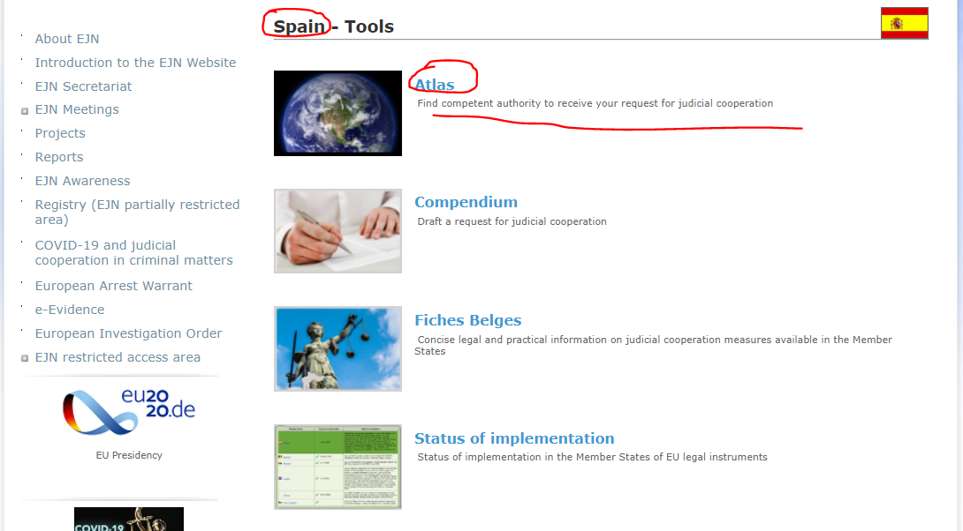

2. We select measure 703. Hearing witnesses: by video conference. Then we select the section Next as shown below.

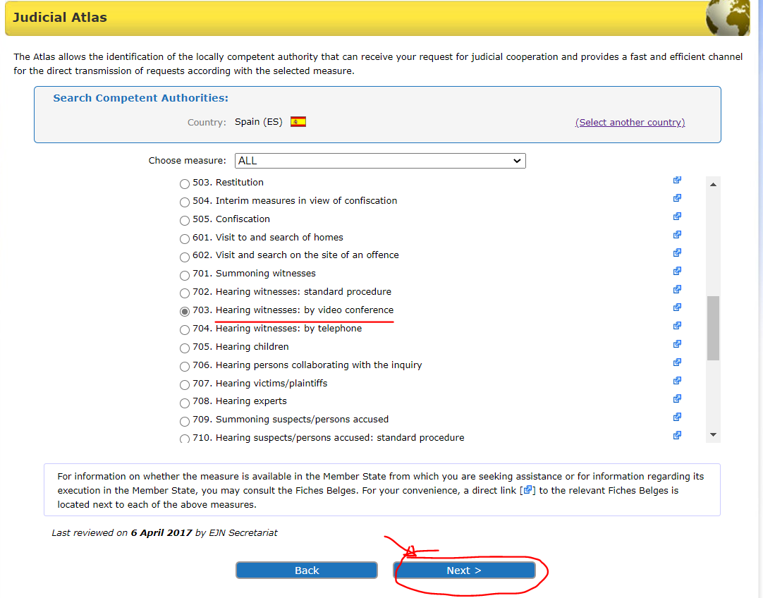
3. Here we have to select from 2 options –Directive 2014/41 on EIO or another legal instrument. In order for the Directive to be applicable we verify the status of implementation (on the EJN’s website) of the legal instrument. We know that only Denmark and Ireland are not bound by the Directive and the other MS have implemented the Directive. We will select Directive 2014/41 on EIO. Then we select the section Next as shown below.

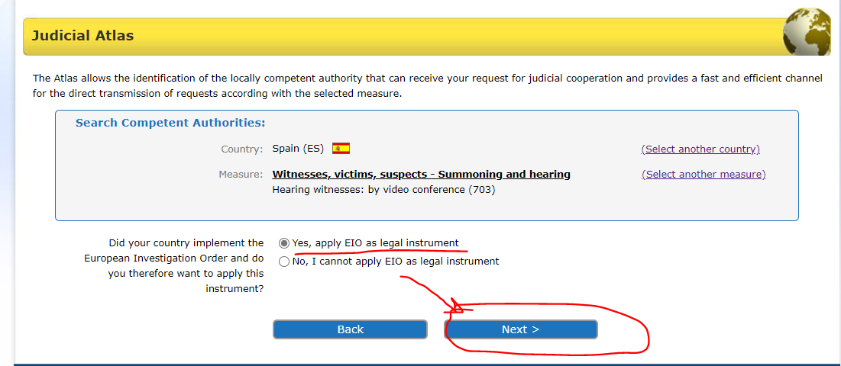

4.Here we have to select from 3 options concerning the offence involved. We select any other crime. Then we select the section Next as shown below.

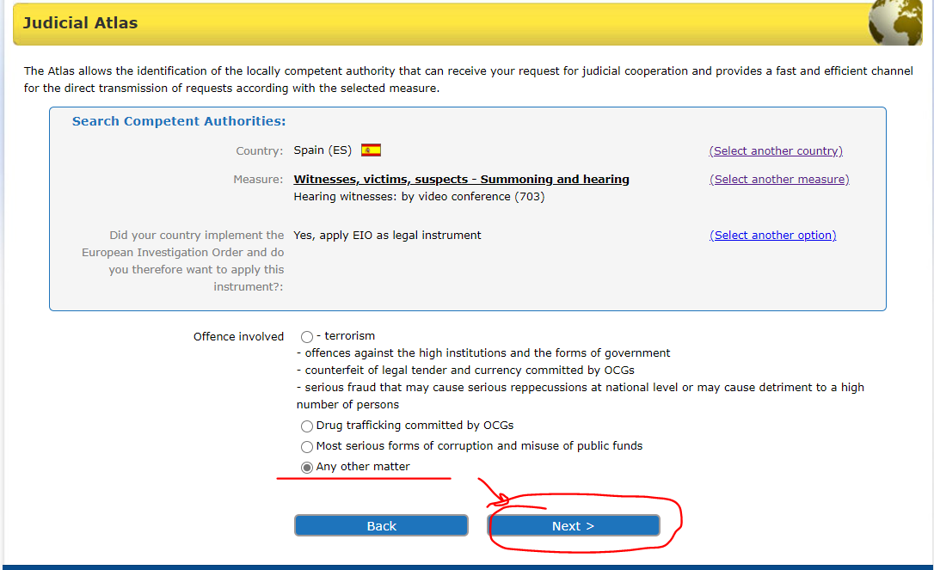

5. The next step is to select from 2 options. We will select that we know the location in Vigo, where the witness is residing. Then we select the section Next as shown below.

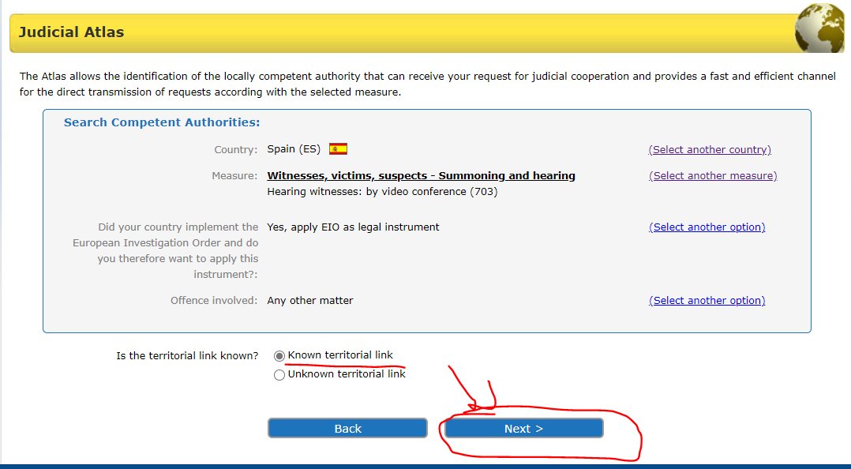

6.We introduce Vigo, Spain. Then we select the section Next as shown below.

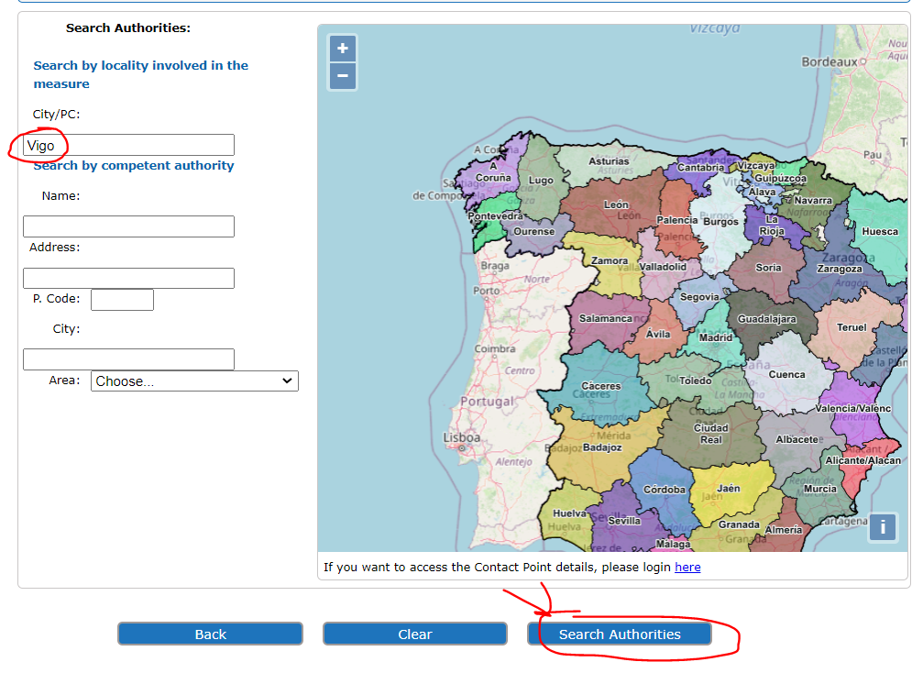

7. At the end we are provided with the results of our search as shown below.

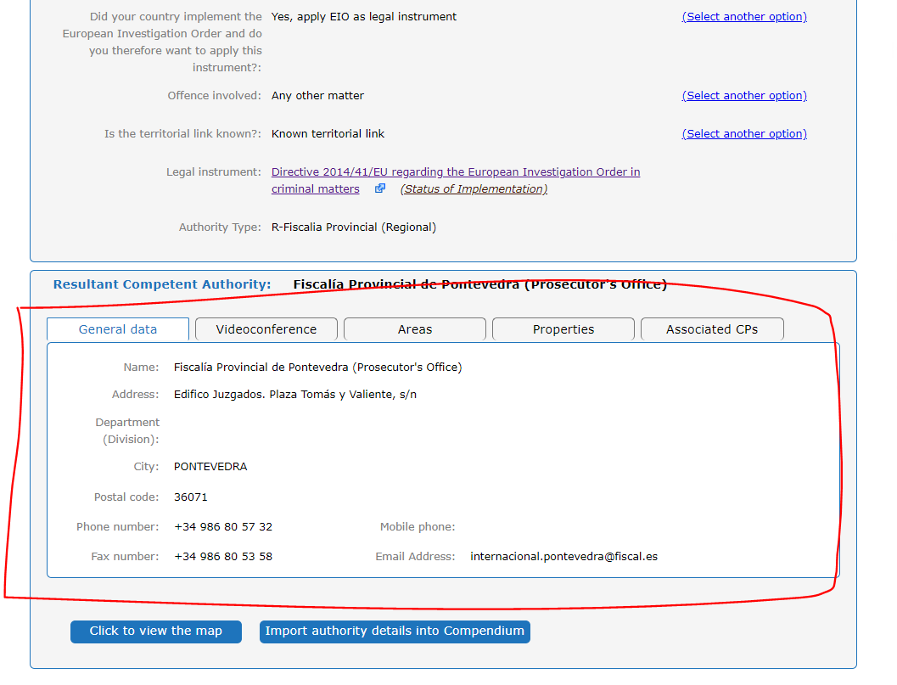

- A Spanish competent issuing authority wants to hear an expert living in Athens, Greece.

- In order to identify the competent authority, we select Greece as the country selected (GR). Then we select the section Atlas as shown below.

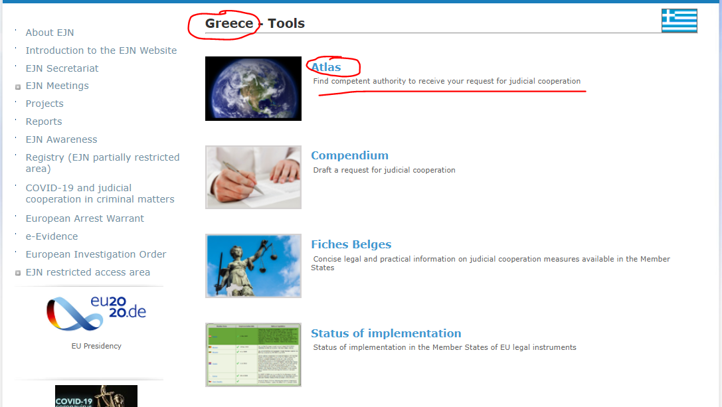
- We select measure 708. Hearing experts. Then we select the section Next as shown below.

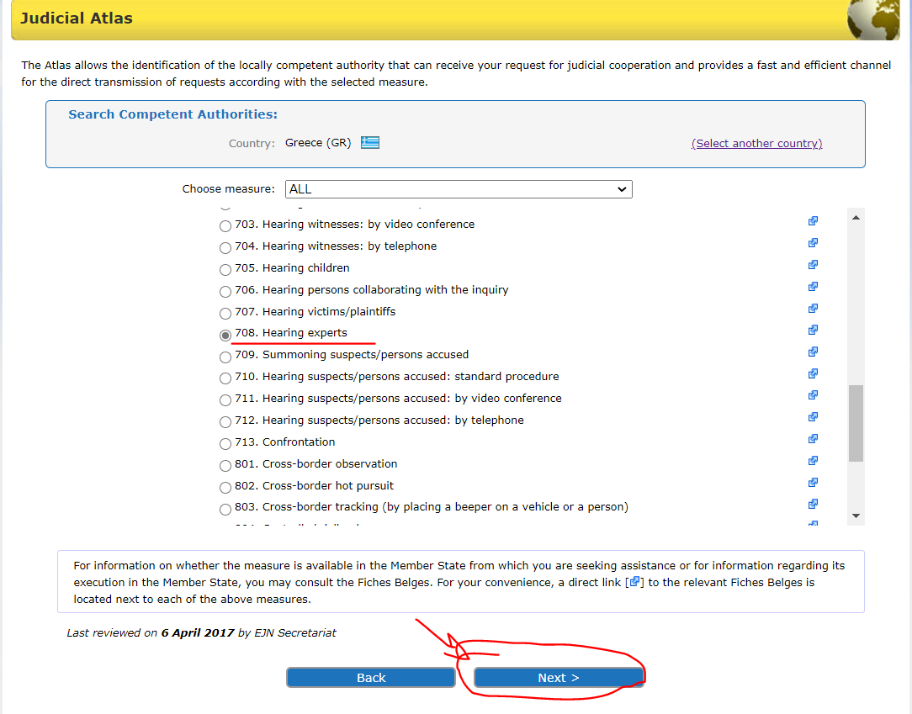

- The next step is to select from 2 options. We will select that we know the location - Athens, where the expert is residing. Then we select the section Next as shown below.

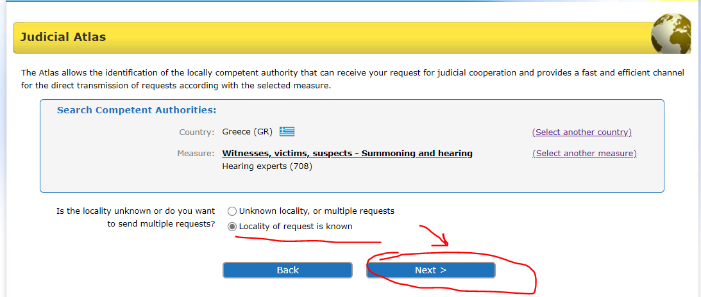

- Here we have to select from 2 options –Directive 2014/41 on EIO or the 1959 Convention (because in Greece the 2000 Convention in not in force, so not applicable). In order for the Directive to be applicable we verify the status of implementation (on the EJN’s website) of the legal instrument. We know that only Denmark and Ireland are not bound by the Directive and the other MS have implemented the Directive. We will select Directive 2014/41 on EIO. Then we select the section Next as shown below.

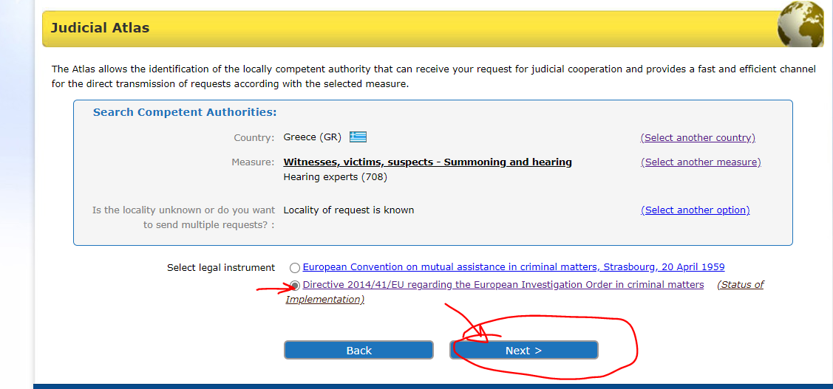

5.We introduce Athens. Then we select the section Next as shown below.

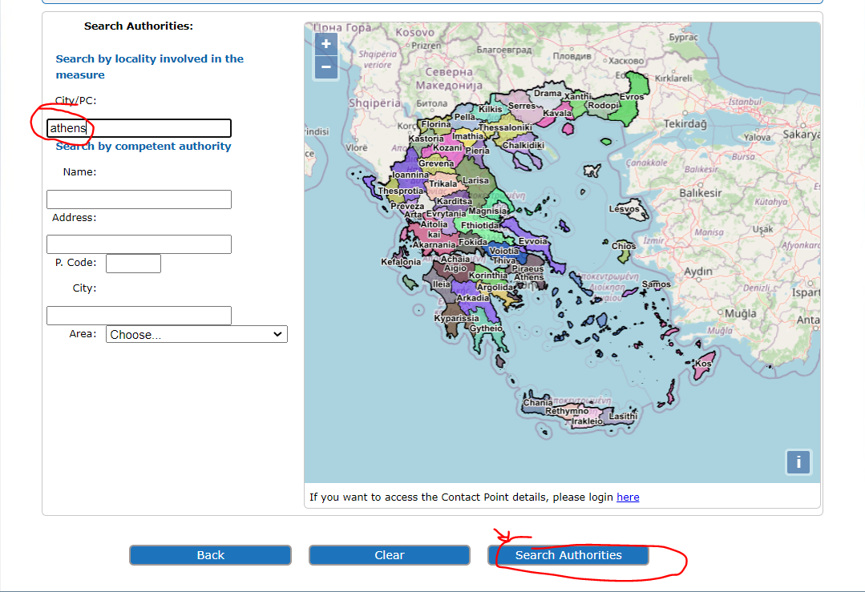

6. At the end we are provided with the result of our search as shown below.

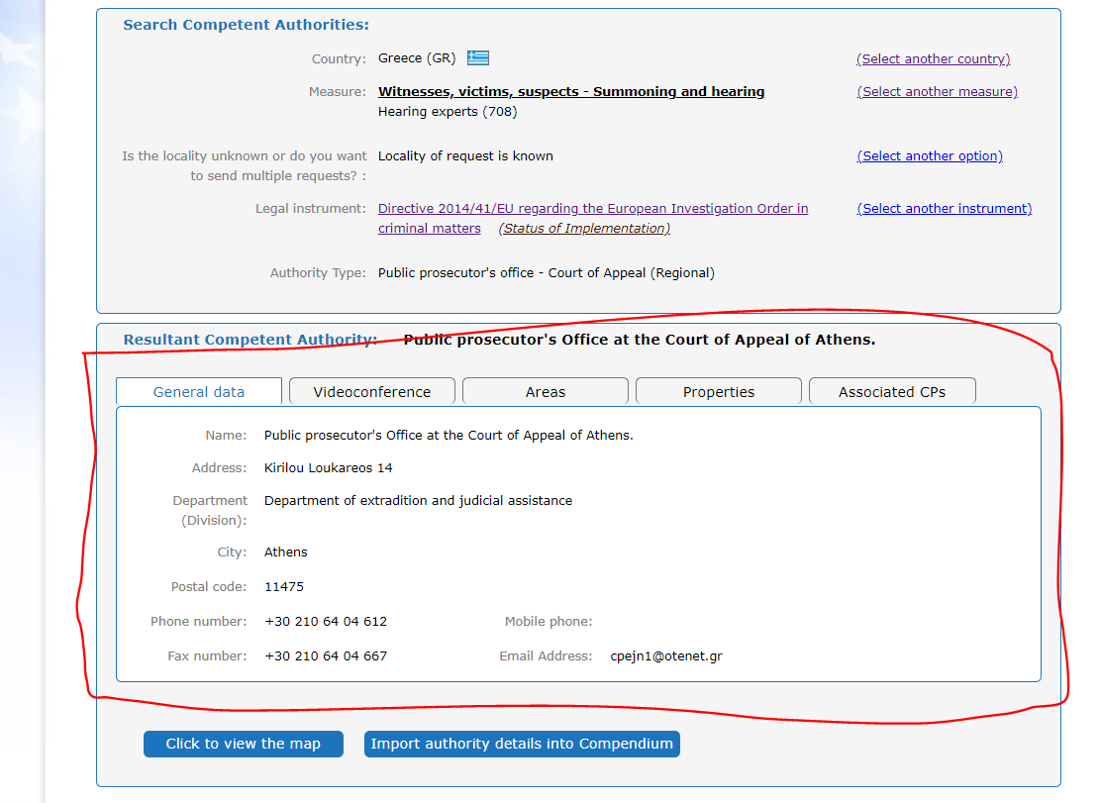

- A Romanian competent issuing authority wants to intercept the telecommunication of a suspect located in France without technical assistance.
- In order to identify the competent authority, we select France as the country selected (FR). Then we select the section Atlas as shown below.

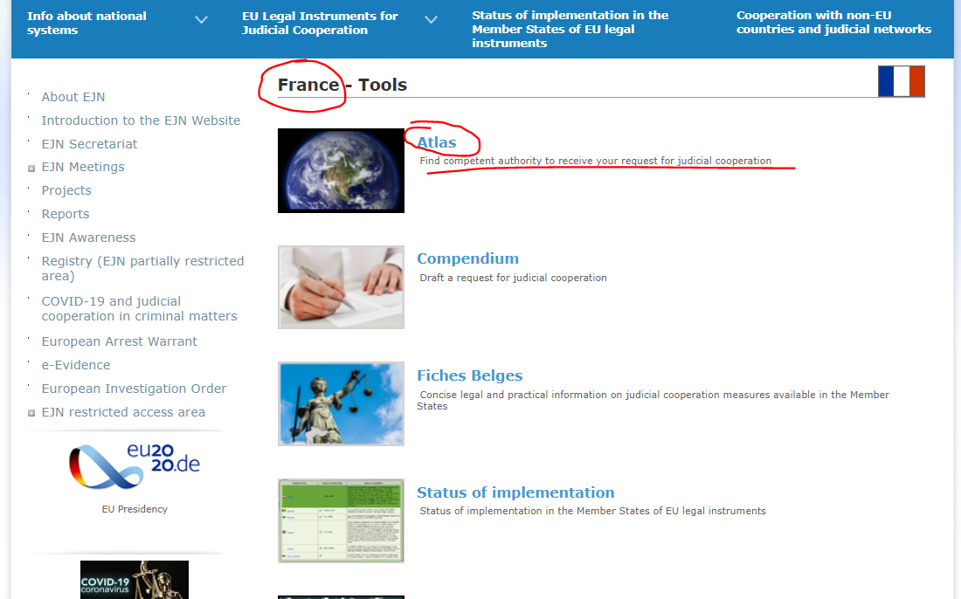
- We select measure 107. Interception of telecommunication without the technical assistance of another Member State. Then we select the section Next as shown below.

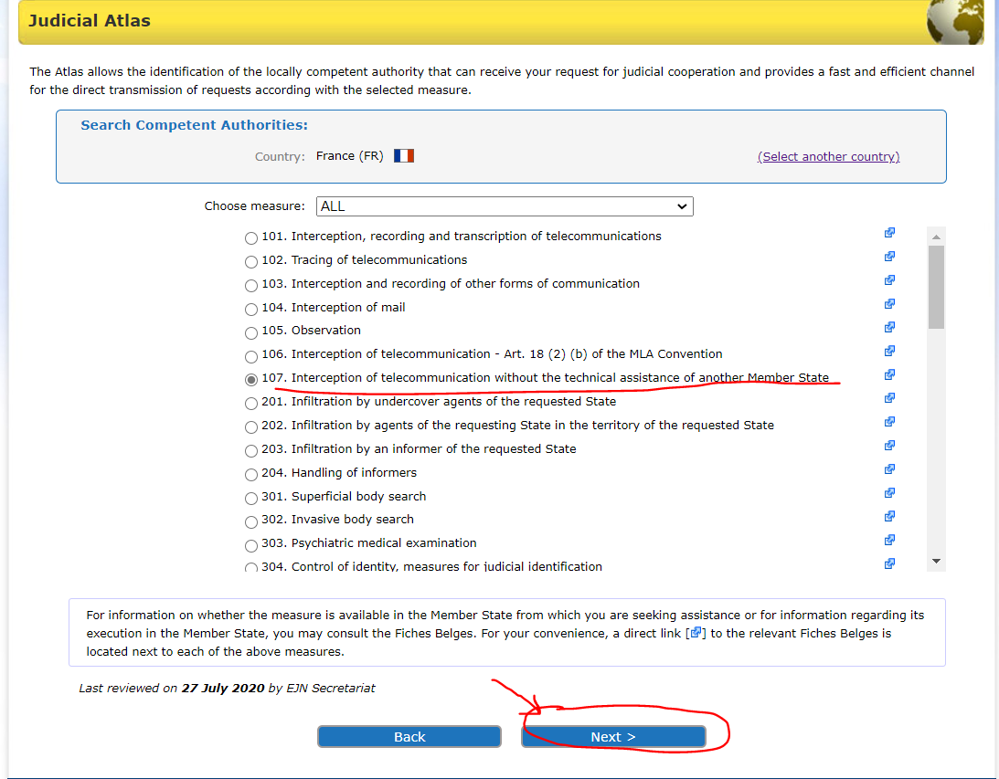

- Here we have to select from 2 options –Directive 2014/41 on EIO or the 1959 Convention. In order for the Directive to be applicable we verify the status of implementation (on the EJN’s website) of the legal instrument. We know that only Denmark and Ireland are not bound by the Directive and the other MS have implemented the Directive. We will select Directive 2014/41 on EIO. Then we select the section Next as shown below.

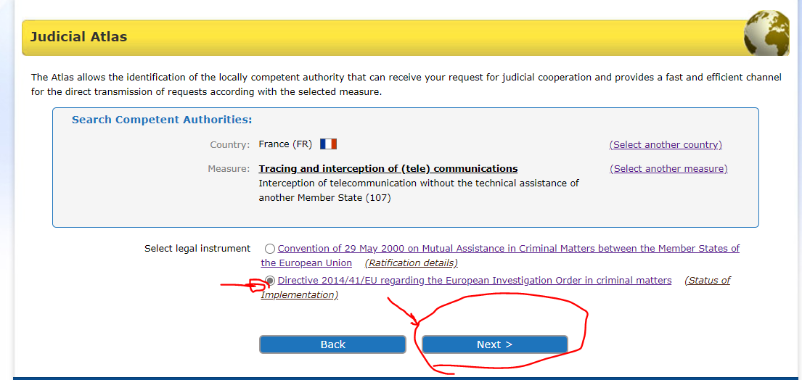

4. At the end we are provided with the results of our search as shown below.
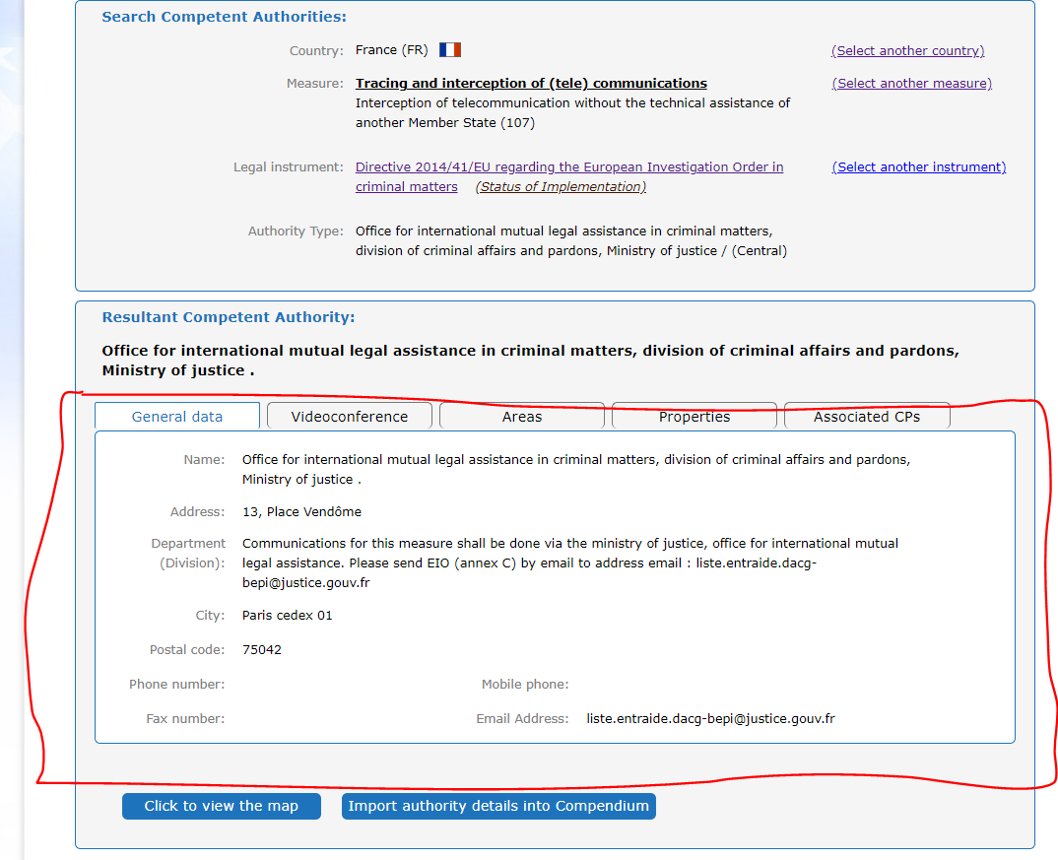
Solutions for points 1 and 2 from Case scenario 2:

- Find the German competent authority the Romanian judicial authority needs to address for the A.W.’s house search.

- In order to identify the competent authority, we select Germany as the country selected (DE). Then we select the section Atlas as shown below.

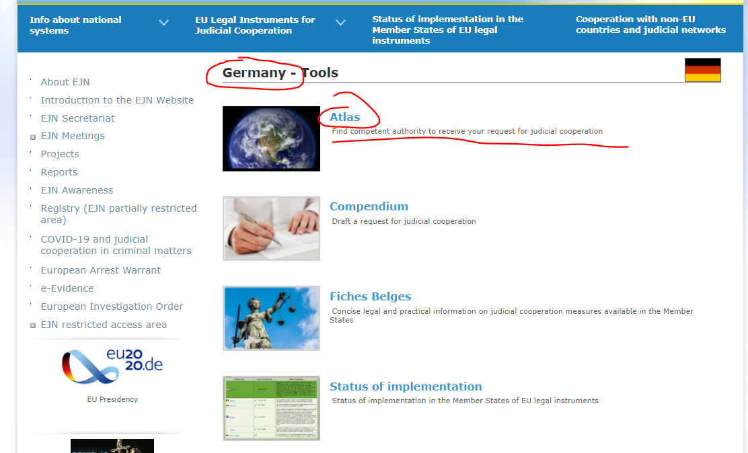

2. We select measure 601. Visit to and search homes. Then we select the section Next as shown below.

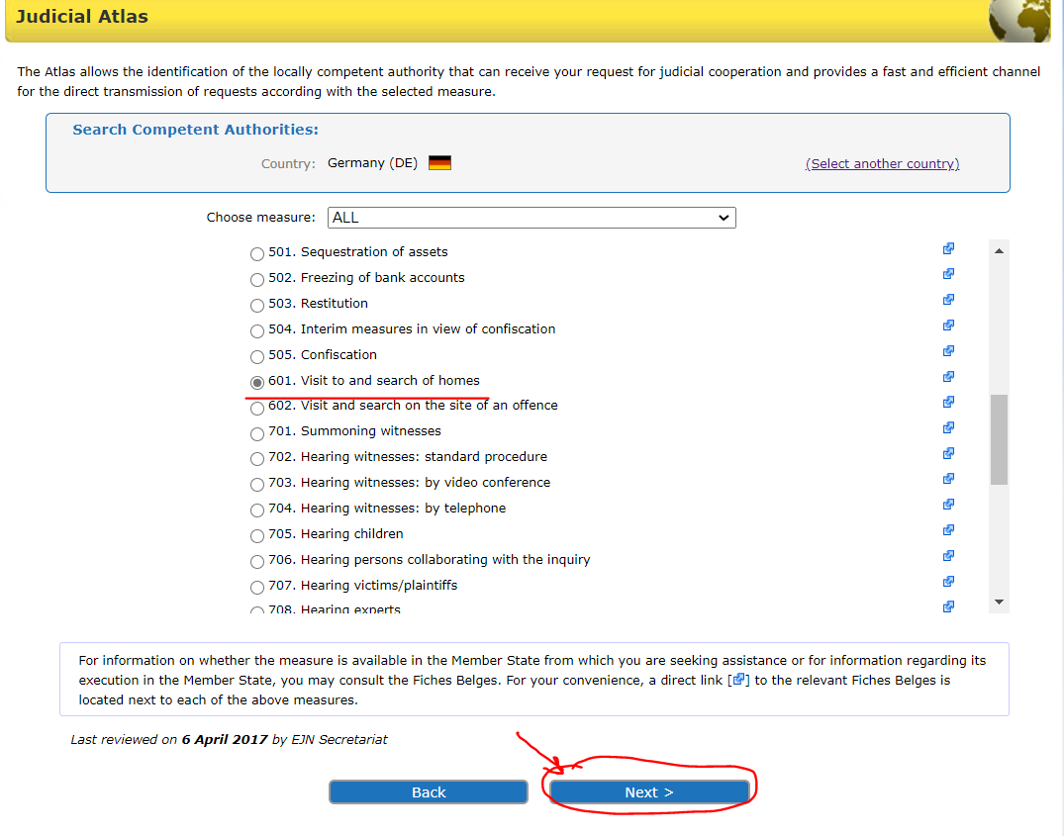

3. Here we have to select from 2 options. We will select that we know the location in Germany which is Stuttgart. Then we select the section Next as shown below.

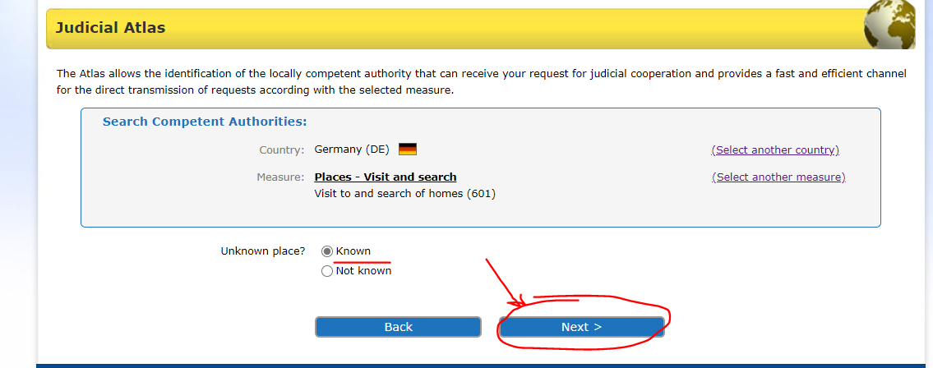

4. Here we have to select from 2 options – the 2000 Convention or Directive 2014/41 on EIO. In order for the Directive to be applicable we verify the status of implementation (on the EJN’s website) of the legal instrument. We know that only Denmark and Ireland are not bound by the Directive and the other MS have implemented the Directive. We will select Directive 2014/41 on EIO. Then we select the section Next as shown below.

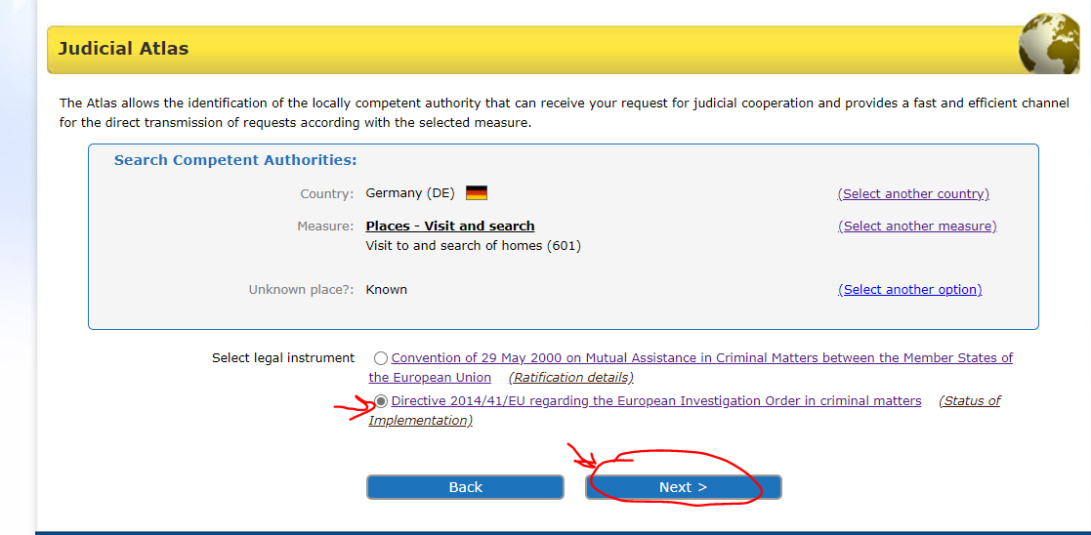

5.We introduce Stuttgart here. Then we select the section Next as shown below.

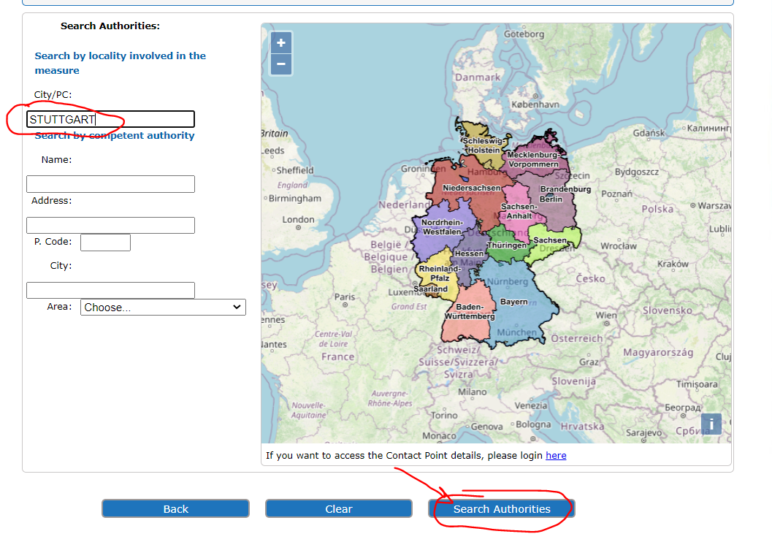
6. At the end we are provided with the results of our search as shown below.

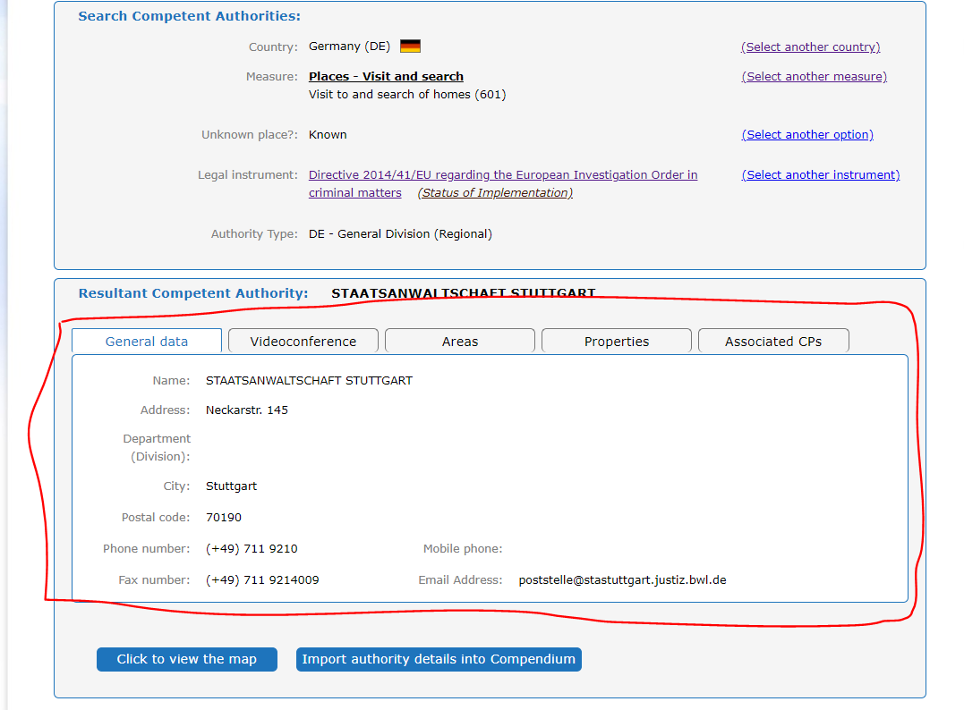
- Find the Austrian competent authority that will help the Romanian judicial authority to hear the witness by videoconference.

- In order to identify the competent authority, we select Austria as the country selected (AT). Then we select the section Atlas as shown below.

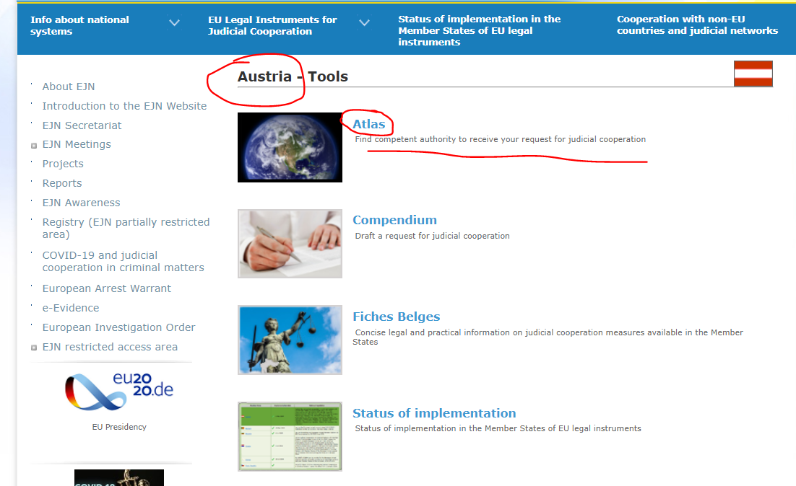

2. We select measure 703. Hearing witnesses: by video conference. Then we select the section Next as shown below.

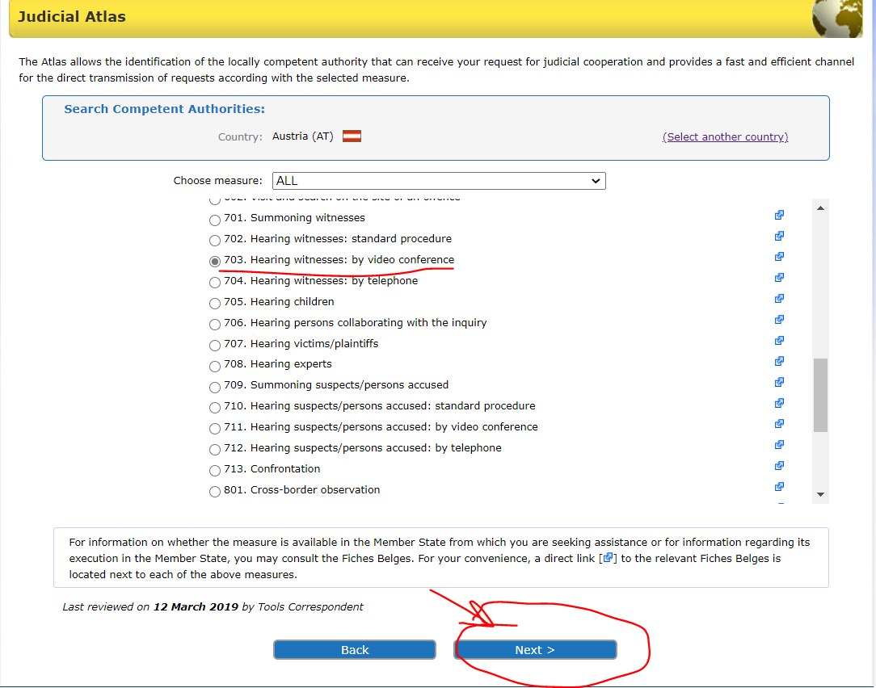

3. Here we have to choose whether the offence from our case is concerning corruption matters. In our case is not, so we select this option and then click on Next as shown below.

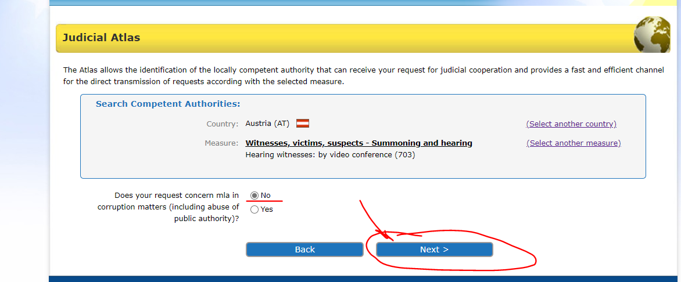

- Here we select that we know where the witness is residing in Austria and then click on Next as shown below.

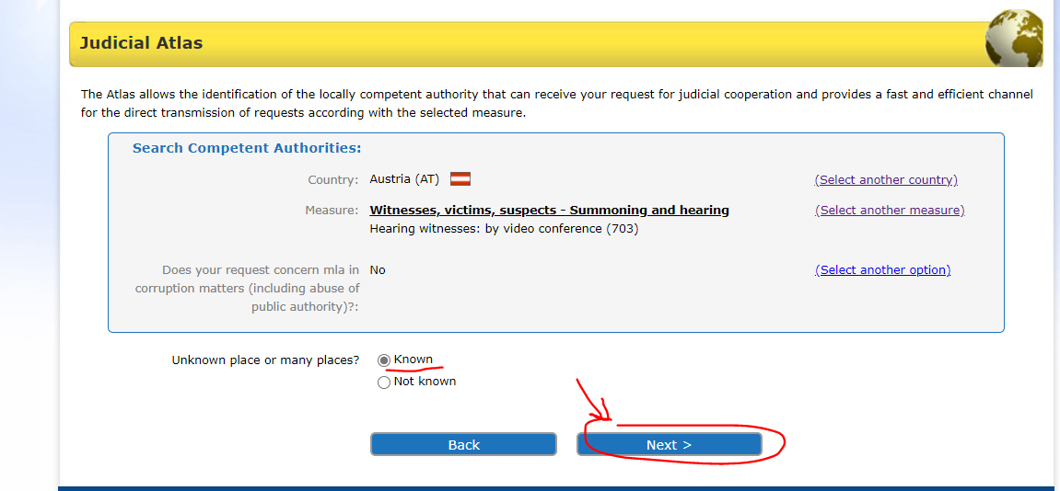

5. Here we have to select from multiple options for legal instruments. We know that Directive 2014/41 on EIO has replaced all the corresponding provisions from the 1959 Convention, 2000 Convention and the Schengen Agreement. In order for the Directive to be applicable we verify the status of implementation (on the EJN’s website) of the legal instrument. We know that only Denmark and Ireland are not bound by the Directive and the other MS have implemented the Directive. We will select Directive 2014/41 on EIO. Then we select the section Next as shown below.

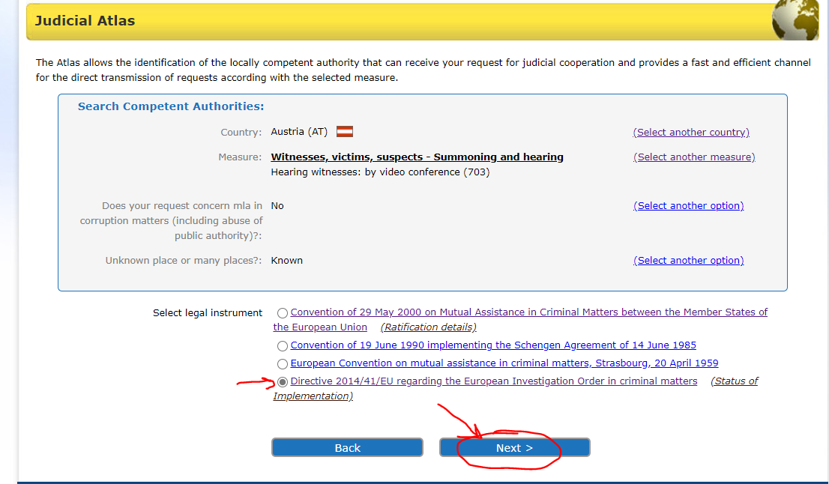

6.We introduce Vienna. Then we select the section Next as shown below.

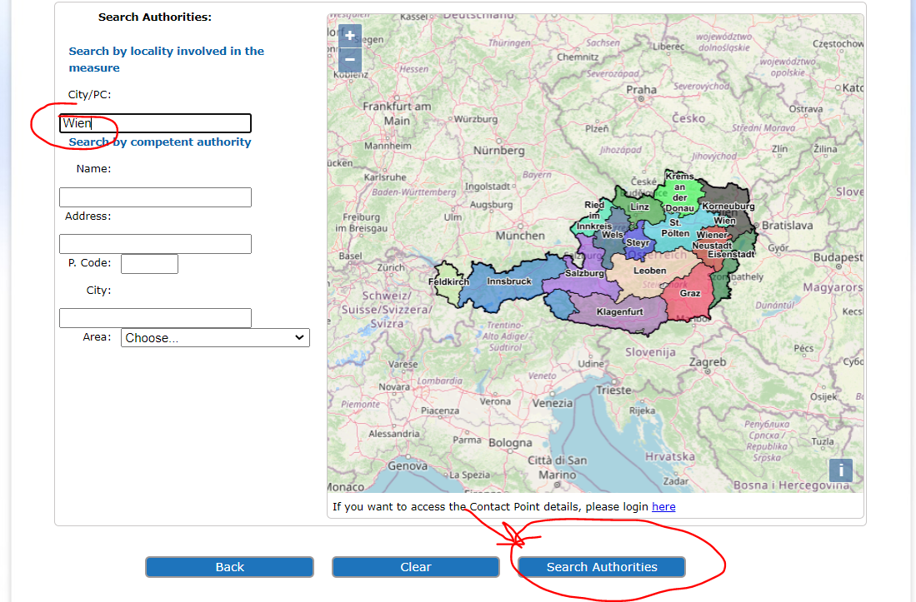

7. At the end we are provided with the results of our search as shown below.

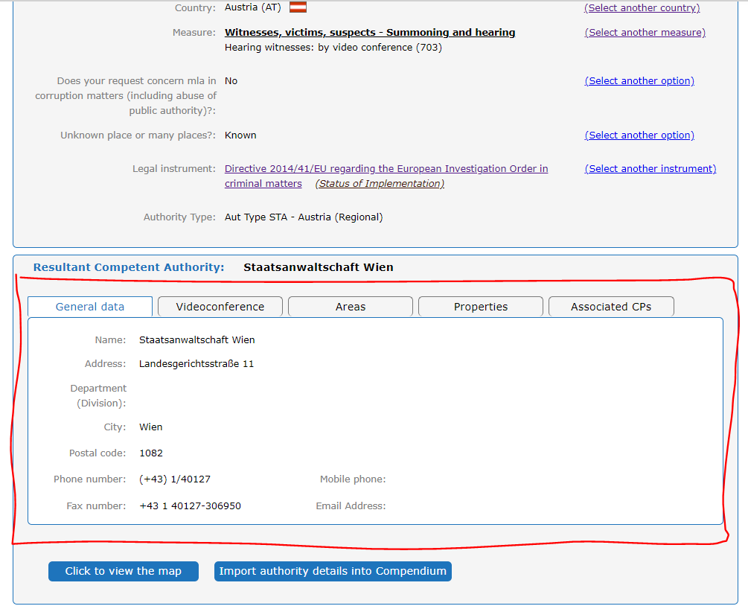

OJ L 130, 1.5.2014, p. 1–36
OJ C 197, 12.7.2000, p. 3–23
OJ L 162, 20.6.2002, p. 1–3
OJ L 196, 2.8.2003, p. 45–55
OJ L 303, 28.11.2018, p. 1–38

