Mutual recognition II
Council Framework Decision 2009/829/JHA of 23 October 2009 on the application, between Member States of the European Union, of the principle of mutual recognition to decisions on supervision measures as an alternative to provisional detention
Set of Case studies – a Guide for trainers

Written by:
Daniel Constantin Motoi
Judge,
Court of First Instance, 4th District, Bucharest Tribunal, Bucharest

Table of contents

A. Case studies 1
I. Introductory scenario; Questions 1
II. Exercises 2
III. Case scenario; Questions 2

B. Additional notes for the trainers regarding the cases 4

C. Methodological approach 5
I. General idea and core topics 5
II. Working groups and structure of the seminar 6
III. Additional material 6

D. Solutions 7

Annex 22

Mutual recognition II.
A. I. Introductory scenario
Supposing an offender has committed an offence in your country and the competent authority dealing with the case (depending on the provisions of the national law – prosecutor, investigating judge, judge, etc.) wants to take/to request a decision on supervision measures as an alternative to the provisional detention during the investigative phase (even though, for example, the conditions for taking the provisional detention are also met).
Questions:
- Are there any alternative measures to provisional detention provided in your legal system for such cases? Please indicate and briefly describe them.
- If such alternative measures exist in your legal system, do they apply under the same conditions to an offender who is lawfully resident in another MS and has committed an offence and your judicial authorities have competence to investigate it? Are there any special provisions regarding an offender who is lawfully resident in another MS? Please indicate and briefly describe them.
- If the competent authority in your country imposes supervision measures to the offender, is it possible, according to your national law, to ask the transfer of the supervision so the offender lawfully resident in another MS to be supervised in his country by the competent authority whilst waiting for his trial in your country? What is the legal instrument applicable in this case?

A. II. Exercises:
Find the following executing competent authorities and the languages to be used in the Certificate (for general criminal cases):
1. A German competent authority wants to transfer the supervision of the sentenced person A.N. who is lawfully and ordinarily residing in Brussels, Belgium.
Competent authority:
Language:

2. A French competent authority wants to transfer the supervision of the accused person B.C. who is lawfully and ordinarily residing in Vigo, Spain.
Competent authority:
Language:

3. A Spanish competent authority wants to transfer the supervision of the accused person M.M. who is lawfully and ordinarily residing in Vienna, Austria.
Competent authority:
Language:

A. III. Case scenario:
A.W., an Austrian citizen, resident in Vienna, Austria was on a two-week vacation in Brasov, Romania to visit some Romanian friends. On 6 January 2020 A.W. and his friends went to a bar in Brasov. At one point, A.W. had a discussion with a person from another group and the two started to threaten each other. A.W. got nervous and went to the victim A.B. and hit them on the head with a bottle. A.B. fell down unconscious and in that moment A.W. ran from the bar. A.B. was taken to a local hospital where he remained for two weeks for medical care.
The forensic document issued stated that A.B. suffered injuries that will necessitate 100 days of medical care.
According to the Romanian criminal law the facts constitutes the offence of bodily injury provided for in article 194 of the Romanian Criminal Code (the maximum penalty is 7 years of imprisonment).

On 10 January charges were pressed against A.W. by the Prosecutor’s Office attached to the Brasov Court of First Instance.
A.W. admitted committing the offence but he considered that he was provoked by the victim A.B. and his friends and that it was an uncontrolled reaction.
Taking into consideration the severity of the offence and the fact that A.W. appears to be lawfully residing in Austria, the Romanian prosecutor dealing with the case wants to impose a provisional measure, respectively a 60-day judicial control against offender A.W. in which he must observe the following obligations:
a) to report to the Prosecutor’s Office attached to the Brasov Court of First Instance or to the judge whenever he is called.
b) to inform the designated authority in charge of the supervision whenever he changes the place where he is staying.
c) to report to the designated police station according to the plan of supervision agreed or whenever he is called.
d) to not get closer than 200 metres to the victim A.B.
Questions:
- Can the supervision of the obligations imposed on A.W. be executed in Austria?
- What are the criteria for forwarding a decision on supervision measures to another MS? Is it necessary to have the prior consent of A.W. in our case?
- Is it mandatory for the competent authority to forward a decision on supervision measures to the competent authorities in another MS?
- Find the competent authorities from the two countries involved in the possible transfer of the supervision of the obligations imposed to the offender A.W.
- How will the issuing competent authority and the executing competent authority proceed in this case?
- What challenges may face the issuing and the executing competent authorities and how can they be overcome?
- What are the benefits in this case if such transfer of supervision is successful?

Part B. Additional notes for the trainer regarding the cases
A. III. Case scenario:
- The case scenario will be discussed according to the national provisions of the country where the seminar is taking place (except for Ireland).
- If the seminar is taking place in Austria, the issuing and executing MS will be switched, with the convicted person lawfully residing in Bucharest, Romania and visiting Austria).
Part C. Methodological approach
- General idea and core topics
The idea of this training material is to make the court staff from the Member States familiar with the legal instrument for judicial cooperation available at European level with a view to monitoring the supervision measures.
Court staff are often involved in administrative tasks ranging from filling in the form requested by the legal instrument, identifying the competent authority to send it to, translation of the form, to requesting or sending additional information regarding judicial cooperation.
For these reasons, the following main aspects will be covered within the seminars:
1. Scope of application of the Council Framework Decision 2009/829/JHA on the application, between Member States of the European Union, of the principle of mutual recognition to decisions on supervision measures as an alternative to provisional detention.
2. Familiarisation with the general structure of the Council Framework Decision 2009/829/JHA.
3. Identification of some of the challenges the issuing and executing competent authorities may be facing when requesting the transfer of the supervision measures.
4. Highlighting the benefits of the transfer of the decision on supervision measures.
5. Understanding some practical issues that may arise before and after the transfer of supervision.
6. Administrative details: How should an issuing authority proceed in a certain situation? Which language is to be used? Where can the issuing authority find the competent authority from the executing Member State which the request needs to be addressed to?
- Working groups and structure of the seminar
The seminar will start with the Introductory case which is designed to make participants aware of Council Framework Decision 2009/829/JHA on the application, between Member States of the European Union, of the principle of mutual recognition to decisions on supervision measures as an alternative to provisional detention. Solving the introductory case and answering the questions should take approx. 15-20 minutes.
After the Introductory case, the trainer will provide the participants with a brief presentation (Power point) highlighting the important features of the Council Framework Decision 2009/829 – objectives, definitions, criteria, grounds for-recognition, time limits, adaptation, governing law, subsequent decisions, obligations and information (approx. 15-20 min).
A 10-minute break is recommended at this point.
Solving the exercises from point A.II should take around 15 minutes as they are meant to help the participants in understanding the mechanism for finding a competent authority and the language to be used in the Certificate.
The Case scenario is the opportunity to understand Council Framework Decision 2009/829/JHA. The participants will work in groups of 5-6 and will have a laptop connected to internet in order to solve the questions. Solving the Case scenario and answering the questions should take approx. 2 hours.
Any remaining questions should be discussed at the end of the seminar (for approx. 5-10 minutes).
The organisers should try to create groups of participants with an approximate same level of experience in working with the CFD 2009/829 when solving the case scenarios.

- Additional material
All participants will be provided with a copy of the Council Framework Decision including the Forms in the Annexes I and II. Also, the participants must bring or have access to their national provisions implementing the CFD.

Part D. Solutions
A. I. Introductory scenario:
Q1: Are there any alternative measures to provisional detention provided in your legal system for such cases that can be taken? Please indicate and briefly describe them.
In order to answer this question, the participants will indicate and briefly describe the alternative measures to provisional detention regulated in their legal system.
Q2: If such alternative measures exist in your legal system, do they apply with the same conditions to an offender who is lawfully resident in another MS and has committed an offence and your judicial authorities have competence to investigate it? Are there any special provisions regarding an offender who is lawfully resident in another MS? Please indicate and briefly describe them.
After indicating the alternative measures, now the participants will have to indicate if these measures can apply under the same conditions to an offender who is lawfully resident in another MS. Here the participants will provide their national provisions in this respect (indicating if special provisions are put in place regarding an offender who is lawfully resident in another MS).
Q3: If the competent authority in your country imposes supervision measures to the offender, is it possible according to your national law request ask the transfer of the supervision so the offender lawfully resident in another MS to be supervised in his country by the competent authority whilst waiting for his trial in your country? What is the legal instrument applicable in this case?
In this situation Council Framework Decision 2009/829/JHA of 23 October 2009 on the application of the principle of mutual recognition to decisions on supervision measures as an alternative to provisional detention (European Supervision Order) which had to be implemented by 1 December 2012 is applicable.
The abovementioned decision has been implemented by almost all European Union Member States except for Ireland, who is currently implementing the Council Framework Decision although the implementation period has elapsed.
The status of the implementation of the Council Framework Decision 2009/829/JHA of 23 October 2009 is available on the EJN website – www.ejn-crimjust.europa.eu (in the section dedicated to the CFD 2009/829/JHA)

Taking into account that the principle of mutual recognition should also apply to pre-trial orders, this legal instrument is enabling a person resident in one Member State, but subject to criminal proceedings in a second Member State, to be supervised by the authorities in the State in which he/she is resident whilst awaiting trial and ensures that he/she is not treated any differently from a person subject to criminal proceedings who is so resident.
The Framework Decision has as its main objectives the promotion, where appropriate, of the use of non-custodial measures as an alternative to provisional detention, even where, according to the law of the Member State concerned, a provisional detention could not be imposed ab initio and to ensure the due course of justice and, in particular, that the person concerned will be available to stand trial.
The measures provided for in the CFD should also aim at enhancing the right to liberty and the presumption of innocence in the European Union and at ensuring cooperation between Member States when a person is subject to obligations or supervision pending a court decision.
Still, the CFD does not confer any right on a person to the use, in the course of criminal proceedings, of a non-custodial measure as an alternative to custody. This is a matter governed by the law and procedures of the Member State where the criminal proceedings are taking place (article 2 para 2 of the CFD).

At this point the participants should be able to identify the national provisions implementing the CFD 2009/829/JHA, as communicated in its notification to the General Secretariat of the Council of the European Union.
The information regarding the implementation of the CFD for each MS is available on the EJN website as above indicated.

A. II. Exercises:
Find the following executing competent authorities and the languages to be used in the Certificate (for general criminal cases):

In order to find the competent authorities, we will use the Atlas available on the EJN website – www.ejn-crimjust.europa.eu, select the executing MS as the executing countries and 905. Execution of a Supervision Measure.
Regarding the languages for the Certificate, we will use the section – Supervision Measures – Notifications for each of the MS available on EJN’s website.
If not notified anything in relation to article 24 of the CFD, then the official language(s) of the MS will be used.
The results should be as follows:
1. A German competent authority wants to transfer the supervision of the sentenced person A.N. who is lawfully and ordinarily residing in Brussels, Belgium.
Name: Parket van de procureur des Konings te Brussel (Bureau CIS)- Parquet du procureur du Roi de Bruxelles (Bureau CIS)
Address: Portalis, Rue des Quatre bras, 4
Department (Division):
City: Bruxelles
Postal code: 1000
Phone number: +32 (0)2 508 70 80
Mobile phone:
Fax number: +32 (0)2 519 82 96
Email Address: cis.bxl@just.fgov.be

According to article 24 of the CFD the languages accepted by the Belgian authorities are: Dutch, French, German and English.

2. A French competent authority wants to transfer the supervision of the sentenced person B.C. who is lawfully and ordinarily residing in Vigo, Spain.

Name: Oficina Decanato of Vigo (para su reparto a los Juzgados de Instruccion)
Address: Lalín, 4
Department (Division):
City: Vigo
Postal code: 36209
Phone number: +34986817168
Mobile phone:

According to article 24 of the CFD the language accepted by the Spanish authorities is Spanish.

3. A Spanish competent authority wants to transfer the supervision of the sentenced person M.M. who is lawfully and ordinarily residing in Vienna, Austria.

Name: Staatsanwaltschaft Vienna
Address: Landesgerichtsstraße 11
Department (Division):
City: Vienna
Postal code: 1082
Phone number: +43 1 40127 0
Mobile phone:
Fax number: +43 1 40127 306950
Email:

A translation into German is to be attached to the certificate. Certificates in other languages are accepted on the basis of reciprocity, that is to say on condition that the issuing State also accepts certificates in German as an executing State.

A. III. Case scenario:
Q1: Can the supervision of the obligations imposed to A.W. be executed in Austria?
In our case, the Romanian competent authorities may request to transfer the supervision of the obligations which are to be imposed on A.W. to the Austrian competent authorities and the legal instrument applicable is the Council Framework Decision 2009/829/JHA of 23 October 2009 on the application of the principle of mutual recognition to decisions on supervision measures as an alternative to provisional detention (European Supervision Order) which had to be implemented by 1 December 2012.
The abovementioned CFD has been implemented by two MS (the Austrian national law implementing the CFD entered into force on 1 August 2013 and the Romanian national law implementing the CFD entered into force on 26 December 2013).
The Romanian competent authorities will apply the provisions from the national law implementing the CFD in order to forward the decision on supervision measure to the competent authorities of the other MS.
Q2: Which are the criteria for forwarding a decision on supervision measures to another MS? Is it necessary the prior consent of A.W. in our case?
- Article 9 para 1 of the CFD provides that a decision on supervision measures may be forwarded to the competent authority of the Member State in which the person is lawfully and ordinarily residing, in cases where the person, having been informed about the measures concerned, consents to return to that State.
From this paragraph we can see two conditions that have to be met before forwarding a decision to another MS: the suspected person is lawfully and ordinarily residing in another MS and, after being informed about the measures concerned, consents to return to the executing MS.
The CFD cannot be used against the will of the person concerned. The suspect must cooperate with the competent authorities where he is residing during the supervision period.
- As an exception, article 9 para 2 of the CFD provides that the competent authority in the issuing State may, upon request of the person, forward the decision on supervision measures to the competent authority of a Member State other than the Member State in which the person is lawfully and ordinarily residing, on condition that the latter authority has consented to such forwarding.
It is possible to forward the decision on supervision measures to another MS in which the person is lawfully and ordinarily residing only if there is the request of the suspected person and the other MS consent to such a forwarding if the conditions for such consent are met.
When implementing the Framework Decision, Member States shall determine under which conditions their competent authorities may consent to the forwarding of a decision on supervision measures in cases pursuant to paragraph 2.

For example, regarding article 9 para 2, Romania, as executing state, notified the General Secretariat of the Council of the European Union at the moment of implementing the CFD that it may recognise the supervision order not only when the person is a legal and ordinary resident in Romania, but also in case when one of his/her family members is a Romanian national or resident, or is going to engage in a professional activity, study or training in Romania.
For example, regarding article 9 para 2, Austria, as executing state, notified the General Secretariat of the Council of the European Union at the moment of implementing the CFD that it may recognise the supervision irrespective of whether the person concerned has their domicile or permanent residence in Austria if, because of specific circumstances, ties exist between the person concerned and Austria of such intensity that it can be assumed that monitoring in Austria will help facilitate the social rehabilitation and reintegration of the person concerned.

Q3: Is it mandatory for the competent authority to forward a decision on supervision measures to the competent authorities in another MS?
Article 9 para 1 of the CFD provides that a decision on supervision measures may be forwarded to the competent authority of the Member State in which the person is lawfully and ordinarily residing, in cases where the person, having been informed about the measures concerned, consents to return to that State.
The wording used by the CFD “may” be forwarded could induce the idea that it could be an arbitrary decision of the issuing competent authority whether to forward such a decision on supervision measures to another MS in which the person is lawfully and ordinarily residing. It should be like this in practice.
This paragraph must be read in conjunction with article 22 of the CFD in which it is provided that the competent authorities of the issuing State and of the executing State shall consult each other during the preparation, or, at least, before forwarding a decision on supervision measures together with the certificate.
So, the decision whether to forward a decision on supervision measures must be an informed decision, taken on the information received from the competent authorities of the executing State.
For example, the competent authority of the executing State can communicate:
- information on the risk that the person concerned might pose to victims and to the general public in the executing MS,
- information allowing verification of the identity and place of residence of the person concerned,
- other information needed to facilitate the smooth and efficient monitoring of the supervision measures

Q4: Find the competent authorities from the two countries involved in the possible transfer of the supervision of the obligations imposed to the offender A.W.
According to articles 6 and 7 of the CFD each MS can, according to national law, designate the competent authorities as requested by the legal instrument.
The competent authorities can be judicial or non-judicial (with the exception of the provisions where it is mandatory to designate a judicial competent authority – e.g. article 18 para 1 c) of the CFD).
Each Member State may designate a central authority or, where its legal system so provides, more than one central authority to assist its competent authorities.
A Member State may, if it is necessary as a result of the organisation of its internal judicial system, make its central authority(ies) responsible for the administrative transmission and receipt of decisions on supervision measures, together with the certificates referred to in Article 10, as well as for all other official correspondence relating thereto. As a consequence, all communications, consultations, exchanges of information, enquiries and notifications between competent authorities may be dealt with, where appropriate, with the assistance of the central authority(ies) of the Member State concerned (article 7 para 4 of the CFD).
The competent authorities can be found here (notifications from each of the MS when implementing the CFD).

- The Romanian competent authority to forward the decision on supervision measures, this is according to the national legislation implementing the CFD 2009/829/JHA the judicial authority that took the decision on supervision measure (in our case, the prosecutor from the Prosecutor’s Office attached to the Brasov Court of First Instance).
- The Austrian competent authorities for incoming requests to monitor supervision measures are the Regional Courts. The certificate must be submitted together with the necessary documents from the Regional Court within whose jurisdiction the person concerned has their domicile or permanent residence or, in cases pursuant to Article 9(2), the Regional Court within whose jurisdiction specific ties exist with the person concerned.
The information regarding the competent authorities as issuing or executing competent authorities can be consulted on the EJN’s website – www.ejn-crimjust.europa.eu (information provided for each MS):
Romania – information is found here.
Austria – information is found here.
In order to see the Austrian competent authority we will use the Atlas available on the EJN’s website – www.ejn-crimjust.europa.eu, select Austria as the executing country and 905. Execution of a Supervision Measure (see Annex 3).

The result should be as follows:
Name: Staatsanwaltschaft Vienna
Address: Landesgerichtsstraße 11
Department (Division):
City: Vienna
Postal code: 1082
Phone number: +43 1 40127 0
Mobile phone:
Fax number: +43 1 40127 306950
Email Address:
And the link to the result is found here.
Q5: How will the issuing competent authority and the executing competent authority proceed in this case?
- Issuing competent authority:
- If possible, enter into prior consultation with the competent authority of the executing MS according to article 22 of the CFD before deciding to forward the decision on supervision measure and gather valuable information from the executing authority regarding the possibility of supervision of the suspected person.
- Take the consent of the suspect according to article 9 of the CFD in case of forwarding the decision on supervision measures to the MS in which he/ she is lawfully residing.
- Verify the lawful and ordinary residence of the suspected person in accordance with article 9 para 1 or the cases in which the executing MS, other than the one in which the suspected person lawfully and ordinarily resides, consents to such a forward (article 9 para 2-4 of the CFD).
- Identify the competent authority from the executing MS to send the Certificate and the decision on supervision measures (article 10 para 6 CFD) to.
- Fill in the Certificate provided in Annex I of the CFD and send it directly to the competent authority from the executing MS along with the decision on supervision measure (which must be enforceable according to the national law of the issuing MS – see article 4 a) of the CFD).
- Keep monitoring the supervision measures until informed by the authorities from the executing MS on the decision to recognize the decision on supervision measures (article 11 para 1 of the CFD)
- Executing competent authority:
- After receiving a decision on supervision measures, from an executing authority which it has no competence to recognize, forwards the decision together with the certificate to the competent authority and informs the competent authority in the issuing State to which authority it has forwarded this decision.
- Take a decision within 20 working days of receipt of decision on supervision measures (the limit can be extended by another 20 working days if a legal remedy has been introduced against the decision regarding the recognition).
- If it is not possible, in exceptional circumstances, to comply with the time limits it shall immediately inform the competent authority in the issuing State, by any means, giving reasons for the delay and indicating how long it expects to take to issue a final decision.
- Postpone the decision on recognition of the decision on supervision measures where the certificate received is incomplete or obviously does not correspond to the decision on supervision measures, until such reasonable time limit set for the certificate to be completed or corrected.
- Inform the competent authority in the issuing State of the final decision to recognize the decision on supervision measures and take all necessary measures for the monitoring of the supervision measures.
Q6: Which challenges may be facing the issuing and the executing competent authorities and how can they be overcome?
- Issuing competent authority
- Not aware of the Council Framework Decision 2009/829
Although the CFD 2009/829 has been in force as of 1.12.2012, the legal instrument is still not very often used at European level (most of the time it is used only on regional level or between MS with a tradition for cooperation with supervision procedures). One of the reasons for this is the lack of awareness among competent authorities, legal practitioners and suspected persons.
- Raising awareness among the competent authorities both as issuing and executing authorities about the legal instrument.
- Make information available for suspected person and lawyers (e.g. websites, training).
- Not knowing the other judicial system
The competent judicial authorities from the issuing MS are usually reluctant when it comes to requesting the transfer of the decision on supervision measures. Not knowing the other judicial system is one of the challenges for the issuing authority of the MS.
If having doubts about the other judicial system involved, the issuing competent authority has a lot of sources to inform from.
- In the section dedicated to the CFD 2009/928, EJN’s website provides valuable information on the judicial system of all MS (e.g. national legislation, notifications, declarations, reports, etc.).
Also, it must be kept in mind that all MS (except Ireland – with the process of implementation ongoing) have implemented the CFD, which means that the probations measures provided in article 8 para 1 of the CFD are available and can be monitored in all MS (except when a MS has notified or declared it will not apply when transferring the supervisions of sentence).
Article 8 para 2 of the CFD states that each Member State shall notify the General Secretariat of the Council when implementing this Framework Decision, which supervision measures, apart from those referred to in paragraph 1, it is prepared to monitor.
- Not trusting the other judicial system
Often issuing competent authorities have other doubts, such as they do not trust the other judicial system, and do not initiate a request for transfer of a decision on supervision measures, especially since there is no obligation explicitly provided in the CFD.
- Gather information from the executing authority regarding the possibility of supervision of the suspected person in the other MS by consulting the competent executing authority during the preparation, or, at least, before forwarding a decision on supervision measures together with the certificate (article 22 of the CFD)

- Difficult to establish the criteria provided in article 9 of the CFD
Normally, information about the lawful and ordinary residence of the suspected person is available to the competent authority of the issuing MS in the case file, in order to ascertain where to address according to article 10 of the CFD.
For the other criteria and conditions provided in article 9 para 2 of the CFD, the issuing competent authority must gather information.
- Article 22 of the CFD provides that the competent authorities of the issuing State and of the executing State shall consult each other during the preparation, or, at least, before forwarding a decision on supervision measures together with the certificate information allowing verification of the identity and place of residence of the person concerned or other information that is needed to assess the conditions provided in article 9 para 2-4.

- Not knowing where to send the Certificate and the decision on supervision measures
Finding the competent authority in the executing MS is not a difficult task especially as the Atlas from the EJN’s website helps legal practitioners identify the competent executing authority for the other MS (as seen at point 4 above).
- If the competent authority of the executing State is not known to the competent authority of the issuing State, the latter shall make all necessary inquiries, including via the contact points of the European Judicial Network created by Council Joint Action 98/428/JHA, in order to obtain the information from the executing State (article 10 para 7 of the CFD).
- When an authority of the executing State which receives a decision on supervision measures, together with the certificate, has no competence to recognize it and take the ensuing necessary measures for the supervision of the probation measure or alternative sanction, it shall, ex officio, forward it to the competent authority and shall without delay inform the competent authority of the issuing State accordingly by any means which leaves a written record (article 10 para 8 of the CFD).

- Time needed to take a decision on supervision measures
The issuing competent authorities finds itself in a situation in which has to decide to take a decision on supervision measures as an alternative to the provisional decision in a matter of hours after an offence has been committed. This will not give enough time to enter into consultation with the competent authorities from the other MS.
- If a decision on supervision measures needs to be taken quickly according to the national law, nothing impedes the issuing competent authority to take such a decision as in all similar domestic cases. After the decision has been taken, this decision on supervision measures can be later transferred to another MS and the supervision measures adapted according to article 13 of the CFD by consensus between the two MS involved.

- Executing competent authority
- Problems regarding the certificate received (incomplete, confusing information provided, boxes not ticked correctly or not ticked at all when they were mandatory, etc.)
These situations are provided as a ground for refusing recognition and supervision according to article 15 para 1 let. a) of the CFD by the competent authority of the executing MS.
- The competent authority from the executing MS may postpone the decision on recognition of the decision on supervision measures where the certificate is incomplete or obviously does not correspond to the decision on supervision measures, until such reasonable time limit set for the certificate to be completed or corrected.

- Problems in observing the time limits
If it not possible to observe the time limits provided in article 12 of the CFD, the competent authority of the executing State shall immediately inform the competent authority of the issuing State by any means, giving the reasons for the delay and indicating the estimated time needed for the final decision to be taken

- The reasons for not complying with the time limits provided in article 12 of the CFD must be exceptional circumstances and should be limited only to objective situations (e.g. additional information is needed from the issuing MS or from other competent authorities involved in the recognition process).

- Problems of adaptation of the supervision measures
If the nature of the supervision measures is incompatible with the law of the executing State, the competent authority in that Member State may adapt them in line with the types of supervision measures which apply, under the law of the executing State, to equivalent offences. The adapted supervision measure shall correspond as far as possible to that imposed in the issuing State (article 13 para 1 of the CFD).
- For example, the issuing authority has imposed an obligation on the suspected person not to enter certain defined areas, which in the legislation of the executing MS have a slightly different meaning. The adaptation should made according to the national of the executing MS, after informing the issuing MS according to article 20 f) of the CFD.
If the maximum length of time during which the supervision measures can be monitored in the executing State is below the one imposed in the decision on supervision measures, in case the law of the executing State provides such a maximum, the supervision period will be made by the executing MS in the time limits provided by national law. Then, the supervision will revert back to the issuing MS according to article 11 para 2 d) of the CFD.

- Impossible to monitor the suspected person
- The executing authority must inform the issuing State that it is impossible to monitor the supervision measures for the reason that, after transmission of the decision on supervision measures and the certificate to the executing State, the person cannot be found in the territory of the executing State, in which case there shall be no obligation of the executing State to monitor the supervision measures.

Q7: What are the benefits in this case if such transfer of supervision is successful?
- Better monitoring of the defendant’s movements and so ensuring the due course of justice and, in particular, that the person concerned will be available to stand trial
The suspected person will be monitored by the authorities from the executing MS in which he/she lawfully resides and so ensure the due course of justice and that the suspected person will be available to stand trial in the issuing MS.
- Improving the protection of victims and of general public
One of the objectives of the CFD is improving the protection of victims and of the general public. In most cases, the transfer of supervision measures to another MS means that the convicted person will be far away from the victim, who remains in the issuing MS.
Problems may arise when the victim lives in the executing MS, but even in these cases, in serious crimes or related gender-based crime obligations not to get closer to the victims are provided in the initial judgement and can be much more easily verified by the competent authorities in the executing MS.
Also, the protection of the general public is improved because the convicted person will have sufficient ties with the executing MS that will help him better rehabilitate and reintegrate into society.
- Better chances of applying a non-custodial sentence, if found guilty at the end of the trial
If the supervision of the suspected person goes well in the executing MS, the chances of applying a non-custodial penalty will increase for the suspected person (e.g. applying a suspended sentence and transfer of the supervision according to the CFD 2008/947/JHA).
- Strengthening mutual trust and cooperation between MS for future cases
The cooperation between MS in cases covered by the CFD will strengthen mutual trust for future cases. Successful cases will encourage even more MS to cooperate in order to better attain the objectives provided in article 2 of the CFD.

Annex. Step-by-step solutions

- A German competent authority wants to transfer the supervision of the accused person A.N. who is lawfully and ordinarily residing in Brussels, Belgium.

1. In order to identify the competent authority, we select Belgium as the country selected (BE). Then we select the section Atlas as shown below.

2. We select measure 905. Execution of a Supervision Measure. Then we select the section Next as shown below.

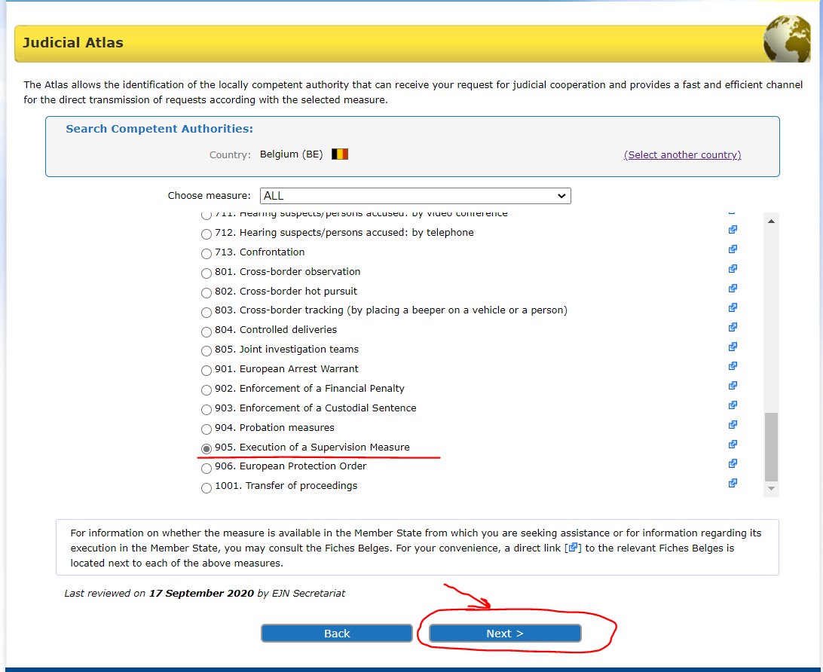

3. We introduce Brussels. Then we select the section Next as shown below.

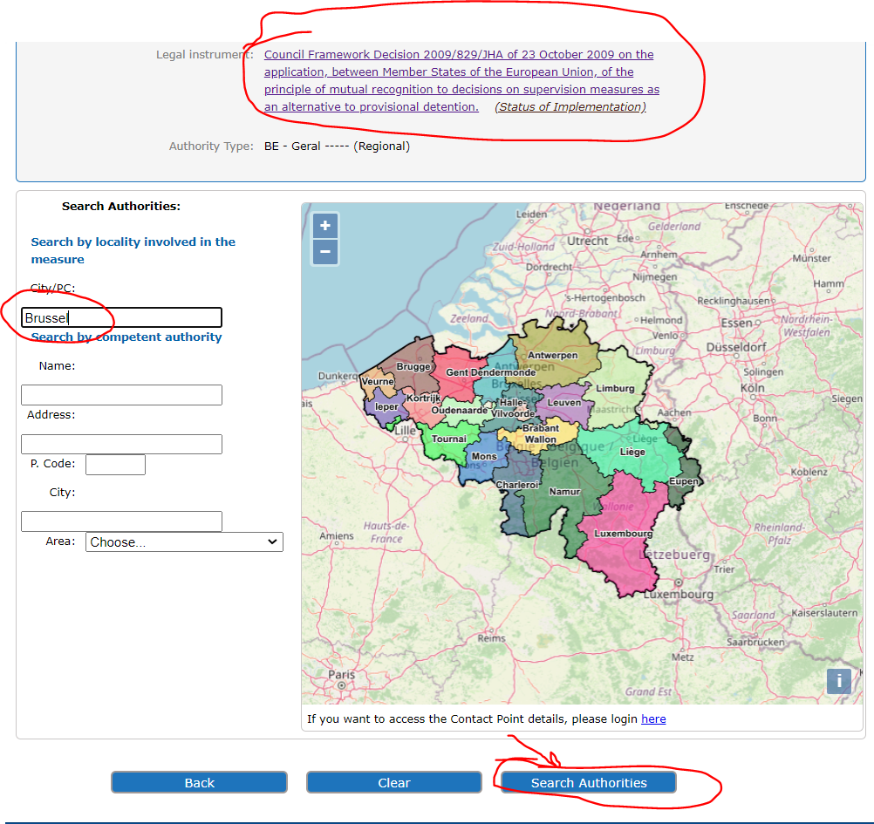

4. At the end we are provided with the result of our search as shown below.

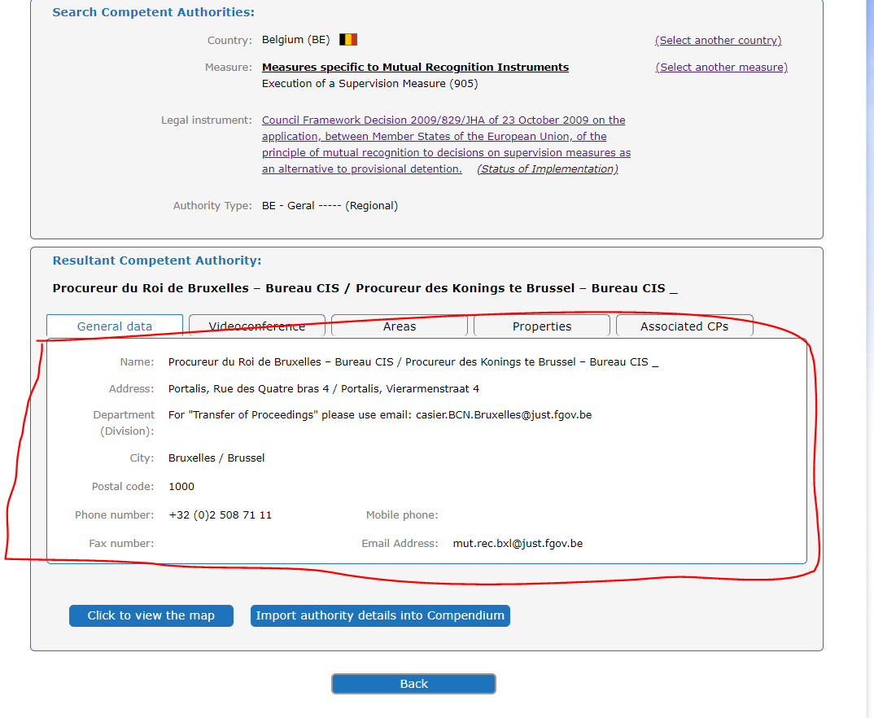

- A French competent authority wants to transfer the supervision of the accused person B.C. who is lawfully and ordinarily residing in Vigo, Spain.

1. In order to identify the competent authority, we select Spain as the country selected (ES). Then we select the section Atlas as shown below.

2. We select measure 905. Execution of a Supervision Measure. Then we select the section Next as shown below.
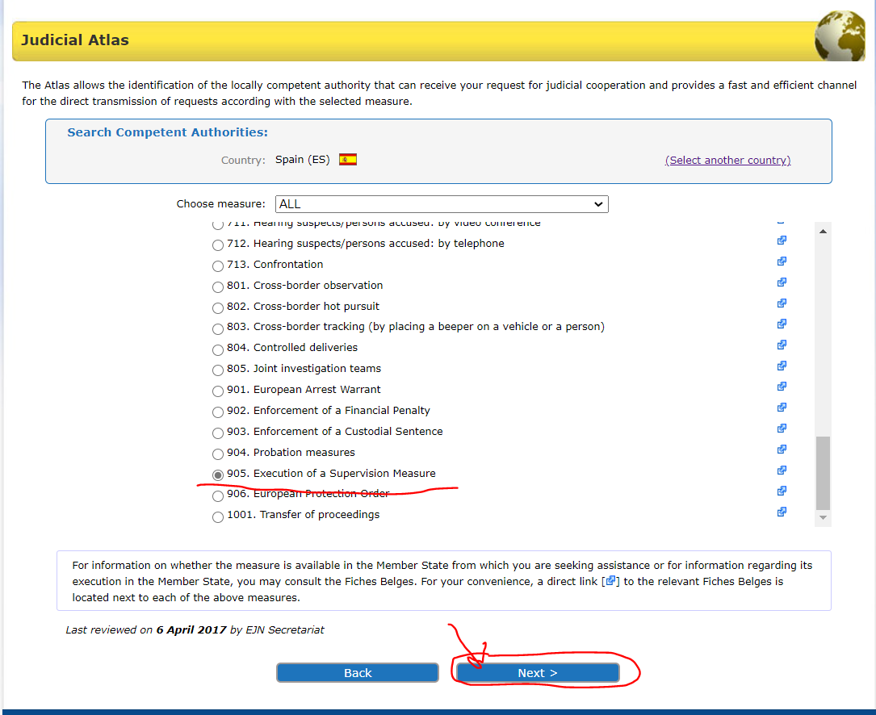
3. Here we have to select from 3 options. We will select the General regime as mentioned in the requirements of the exercise. Then we select the section Next as shown below.

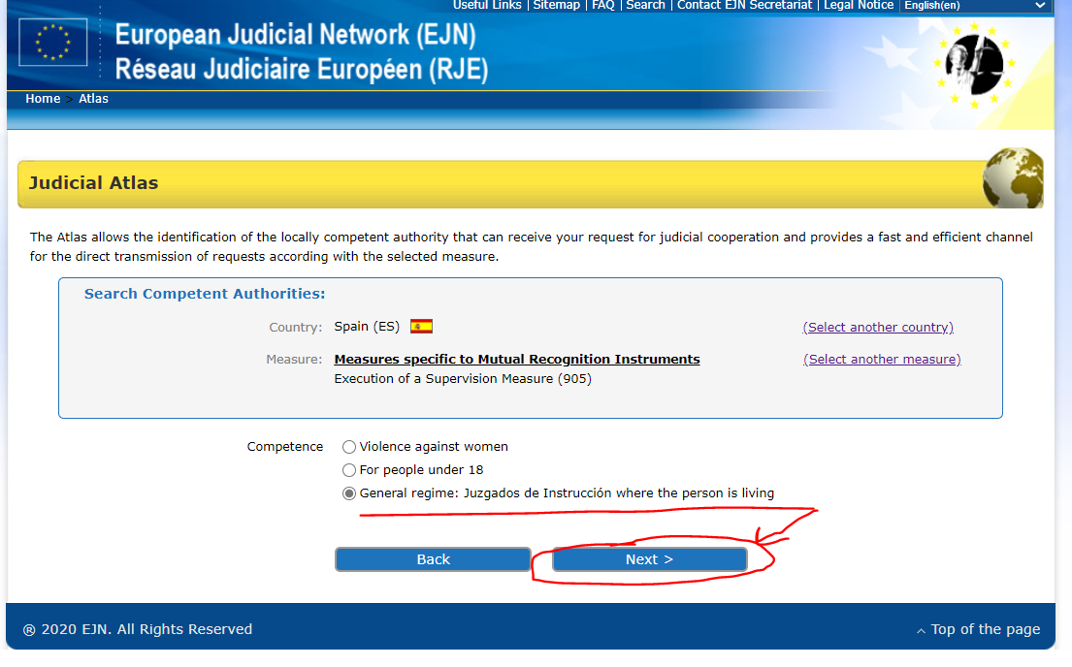

4. We introduce Vigo (Spain). Then we select the section Next as shown below.

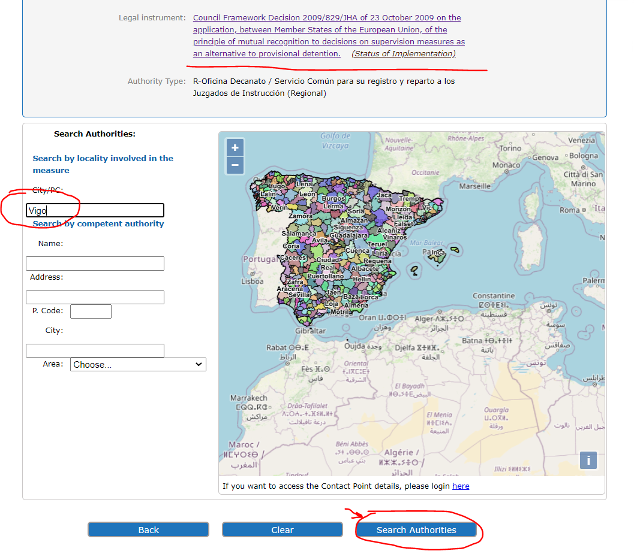

5. At the end we are provided with the result of our search like shown below.

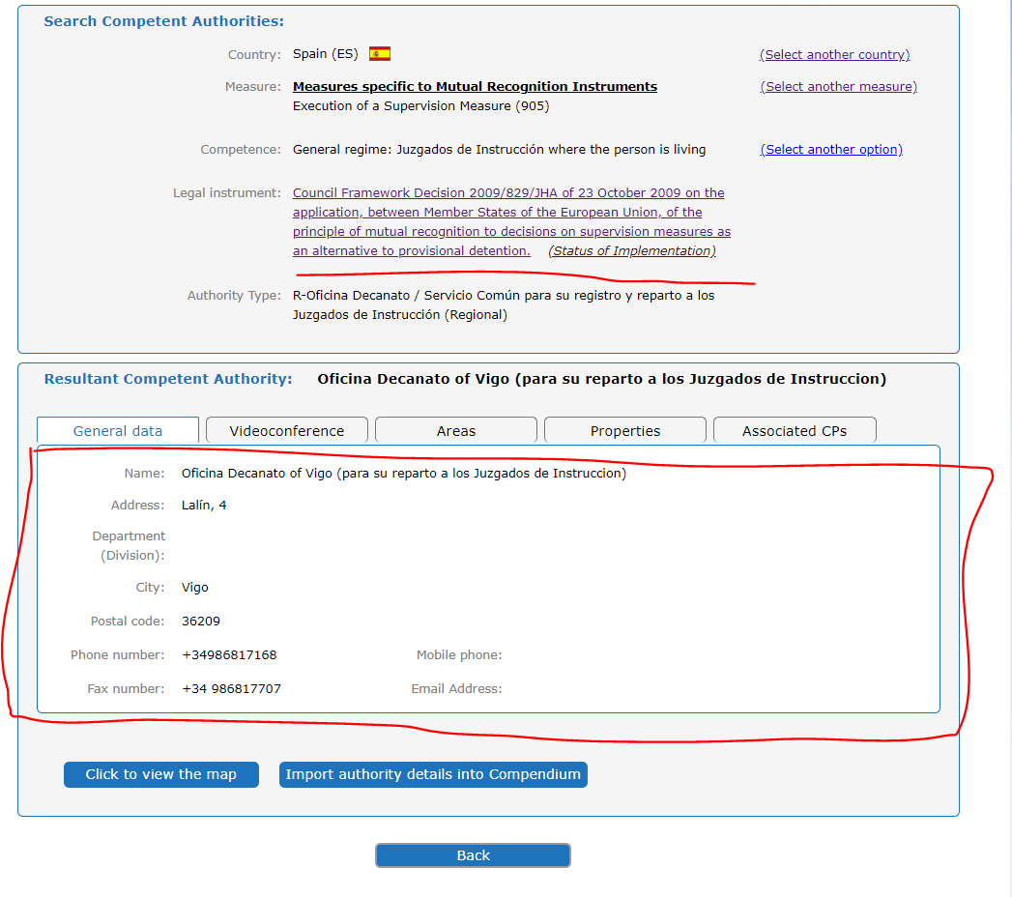

- A Spanish competent authority wants to transfer the supervision of the accused person M.M. who is lawfully and ordinarily residing in Vienna, Austria.

1. In order to identify the competent authority, we select Austria as the country selected (AT). Then we select the section Atlas as shown below.

2. We select measure 905. Execution of a Supervision Measure. Then we select the section Next as shown below.
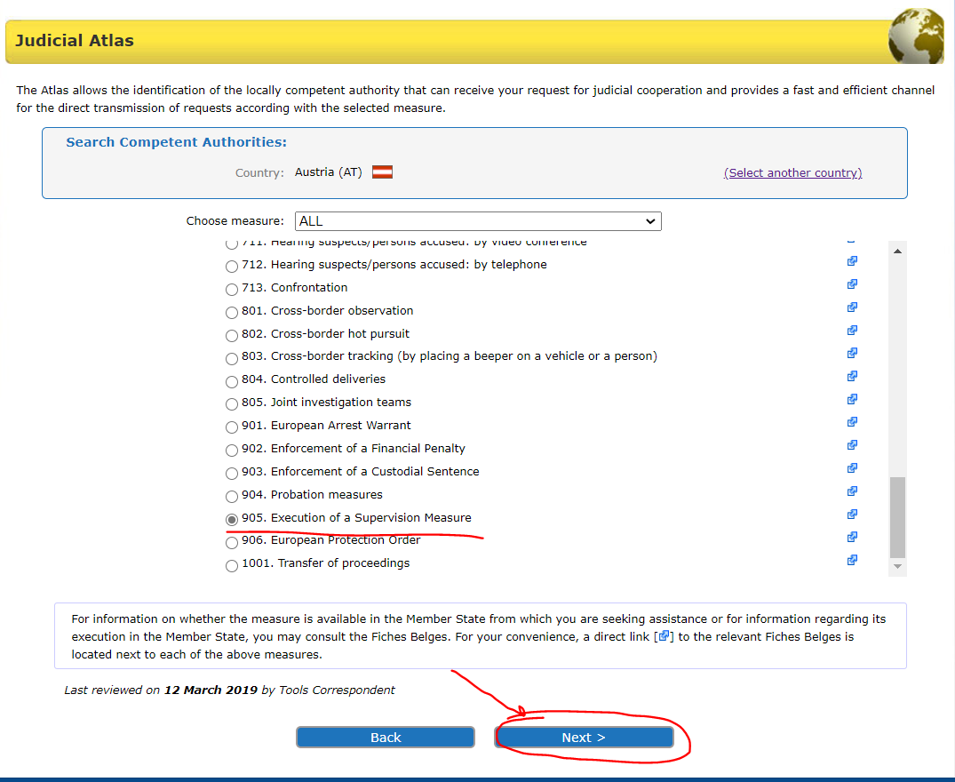

3. We introduce Vienna (Austria). Then we select the section Next as shown below.
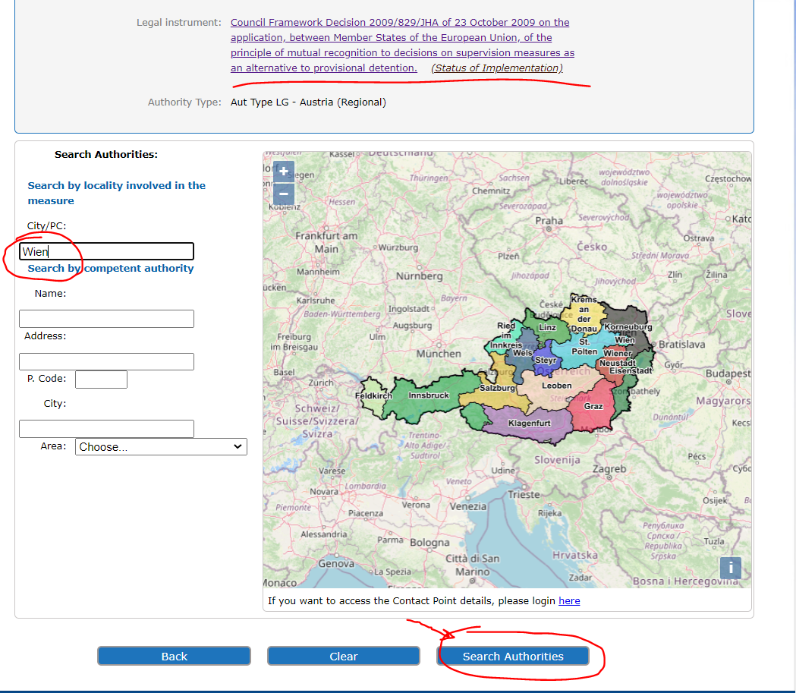

4. At the end we are provided with the result of our search like shown below.

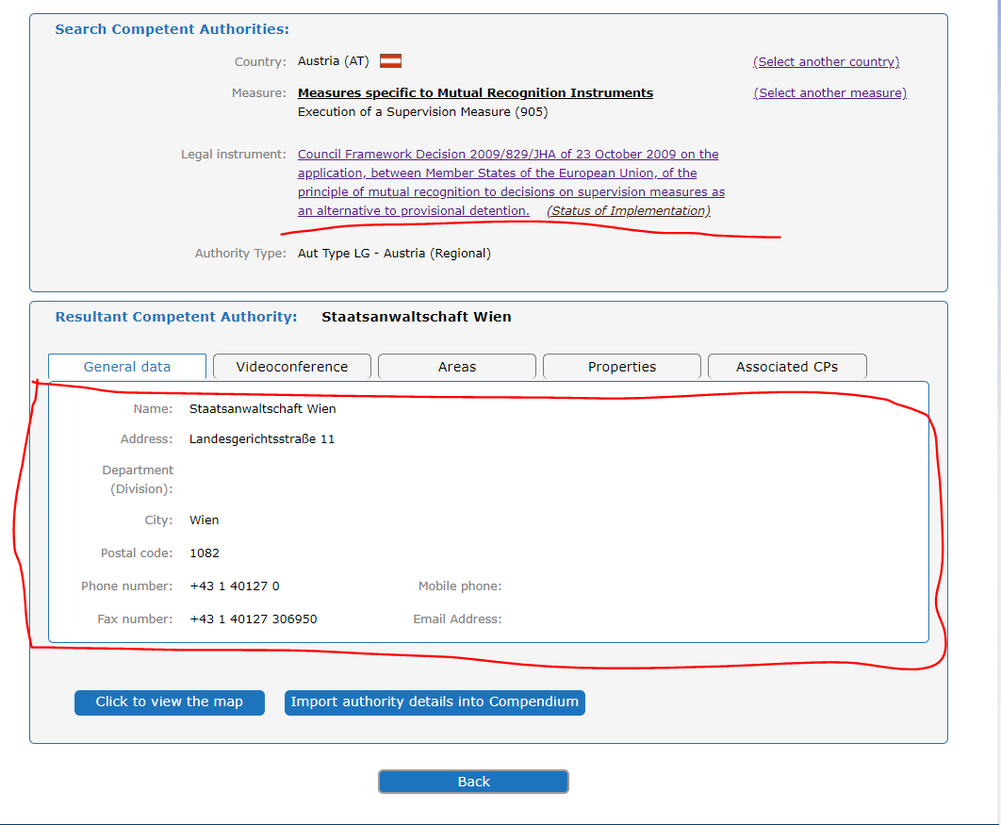

Solution to question 4 of the Case scenario.

The information regarding the competent authorities as issuing or executing competent authorities can be consulted on the EJN’s website – www.ejn-crimjust.europa.eu (information provided for each MS):

Romania – information provided below:
https://www.ejn-crimjust.europa.eu/ejn/libdocumentproperties.aspx?Id=1229

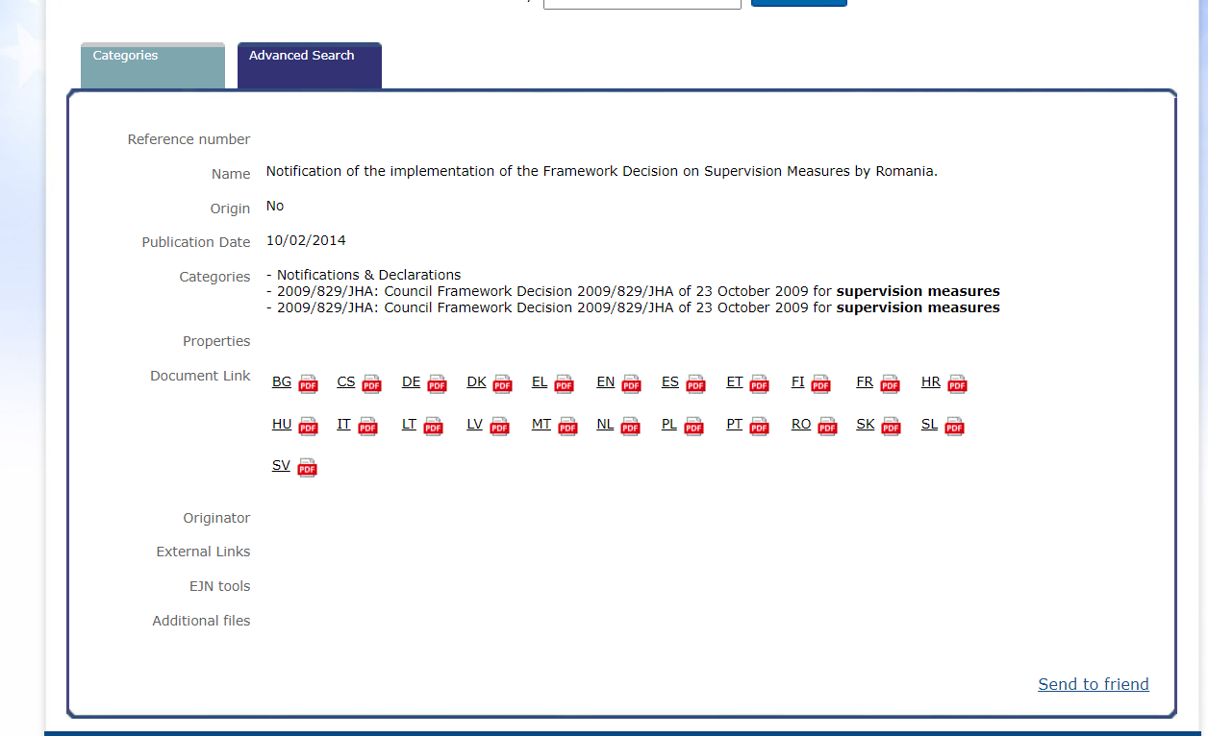

Austria – information provided below:
https://www.ejn-crimjust.europa.eu/ejn/libdocumentproperties.aspx?Id=1176
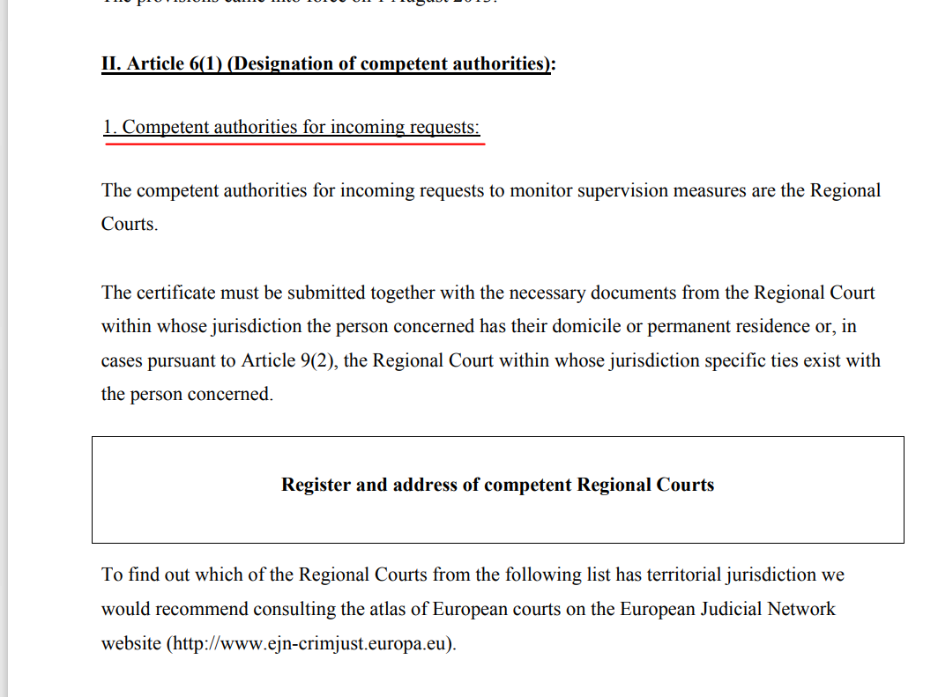

O.J. L 294, 11.11.2009

