Mutual recognition III
Council Framework Decision 2008/947/JHA of 27 November 2008
on the application of the principle of mutual recognition to judgements and probation decisions with a view to the supervision of probation measures and alternative sanctions
Set of Case studies – a Guide for trainers

Written by:
Daniel Constantin Motoi
Judge,
Court of First Instance, 4th District, Bucharest Tribunal, Bucharest

Table of contents

A. Case studies 1
I. Case scenario 1; Questions 1
II. Exercises 2
III. Case scenario 2; Questions 3

B. Additional notes for the trainers regarding the cases 4

C. Methodological approach 5
I. General idea and core topics 5
II. Working groups and structure of the seminar 6
III. Additional material 6

D. Solutions 7

Annex 27

Mutual recognition III.

A. I. Case scenario 1:
A German citizen M.H. (born on 23.05.1970) has been convicted by Bucharest Tribunal, Romania to 2 years of imprisonment for committing a computer-related crime. The penalty imposed has been suspended for a period of 4 years. During the probation period the German citizen has to observe the following obligations: the obligation for the sentenced person to inform a specific authority of any change of residence or working place, the obligation for the sentenced person to inform a specific authority of any change of residence or working place, the obligation to carry out community service and the obligation to cooperate with a probation officer or with a representative of a social service having responsibilities in respect of sentenced persons.
After the decision became final, the German citizen wants to return to his country, where he is lawfully and ordinarily residing (Hamburg, Germany). He requested at the Bucharest Probation Service to be supervised in Germany where his family is and where he is currently employed.
Questions:
- Can the Romanian authorities ask for the transfer of supervision of the obligations imposed on the convicted person to the competent German authorities? Which legal instrument is applicable in this case?
- What are the necessary criteria for forwarding the judgement to another Member State? Is the German citizen entitled to request such a transfer of supervision? Is his consent required in this phase?
- Find the competent authorities involved in the possible transfer of the convicted person (the competent Romanian and German authorities).
- How will the issuing competent authority and the executing competent authority proceed in this case?
- Which challenges might the issuing competent authority face when requesting the transfer of the supervision and how can they be overcome?
- Which challenges might the executing competent authority face during the recognition process and how can they be overcome?
- What are the benefits in this case if the transfer of the supervision is granted by the competent German authorities?

A. II. Exercises:
Find the following executing competent authorities and the languages to be used in the Certificate (general criminal cases):
1. A competent German authority wants to transfer the supervision of the sentenced person A.N. who is lawfully and ordinarily residing in Brussels, Belgium.
Competent authority:
Language:
2. A French competent authority wants to transfer the supervision of the sentenced person B.C. who is lawfully and ordinarily residing in Vigo, Spain.
Competent authority:
Language:
3. A Spanish competent authority wants to transfer the supervision of the sentenced person M.M. who is lawfully and ordinarily residing in Vienna, Austria.
Competent authority:
Language:
- III. Case scenario 2 (continuation of case scenario 1):
Supposing that the competent German authorities have granted the transfer of supervision of the suspended sentence (from case scenario 1) and the supervision began on 01.01.2020. During the supervision period, the German citizen has breached one of the obligations imposed. Now, the German authorities must decide how to proceed.

Questions:
- Which law is applicable during the supervision period?
- How will the German authorities proceed regarding the breaching of one of the obligations imposed to the convicted person?
- What will happen if the convicted person is facing new criminal proceedings in the issuing MS?
- What will happen if he absconds or no longer has a lawful and ordinary residence in the executing State?

Part B. Additional notes for the trainers regarding the cases
A. I. Case scenario 1:
- The country of conviction will be changed with the country where the seminar is taking place.
- In the seminar is taking place in Germany, the countries from case scenarios 1 and 2 will be swapped and the convicted person will this time be a Romanian citizen, lawfully and ordinarily residing in Bucharest, Romania).
Part C. Methodological approach
- General idea and core topics
The idea of this training material is to make the court staff from the Member States familiar with the legal instrument for judicial cooperation available at European level with a view to the supervision of probation measures and alternative sanctions.
Court staff are often involved in administrative tasks ranging from filling in the form requested by the legal instrument, identifying the competent authority where to send it, translation of the form, to requesting or sending additional information regarding judicial cooperation.
For these reasons, the following main aspects will be covered within the seminars:
1. Scope of application of the Council Framework Decision 2008/947/JHA of 27 November 2008 on the application of the principle of mutual recognition to judgements and probation decisions with a view to the supervision of probation measures and alternative sanctions.
2. Familiarisation with the general structure of the Council Framework Decision 2008/947/JHA.
3. Identifying some challenges the issuing competent authority may face when requesting the transfer of supervision and how to overcome them.
4. Identifying some of the challenges the executing competent authority may face during the recognition process and how to overcome them.
4. Highlighting the benefits of the transfer of supervision.
5. Understanding some practical issues that may arise before and after the transfer of supervision.
6. Administrative details: How should an issuing authority proceed in a situation? Which language is to be used? Where can the issuing authority find the competent authority from the executing Member State which the request needs to be addressed to?

- Working groups and structure of the seminar
The trainer will provide the participants with a brief presentation (Power point) highlighting the important features of Council Framework Decision 2008/947/JHA of 27 November 2008 on the application of the principle of mutual recognition to judgements and probation decisions with a view to the supervision of probation measures and alternative sanctions – scope, definitions, competent authorities, types of probation measures, criteria for forwarding a judgement, grounds for refusing, time limits, adaptation, governing law, subsequent decisions, obligations for the MS (approx. 15-20 min).
Case scenario 1 is the opportunity to understand Council Framework Decision 2008/947/JHA of 27 November 2008 on the application of the principle of mutual recognition to judgements and probation decisions with a view to the supervision of probation measures and alternative sanctions as an instrument for transfer of the supervision of sentenced persons between different MS that have implemented the CFD. The participants will work in groups of 4-5 and will have a laptop connected to the internet/group in order to solve the questions. Solving Case scenario 1 and answering the questions should take approx. 1 hour and 40 minutes.
A 10-minute break is recommended at this point.
Solving the exercises from point A.II should take around 10 minutes as they are meant to help the participants in understanding the mechanism for finding a competent authority and the language to be used in the Certificate.
Case scenario 2 will allow the participants to go deeper into understanding the application of some of the provisions of the CFD. The participants will work in groups of 4-5 and will have a laptop connected to internet/group in order to solve the questions. Solving Case scenario 2 should take approx. 40-45 minutes.
Any remaining questions should finally be discussed at the end of the seminar (for approx. 5-10 minutes).
The organisers should try to form groups of participants with an approximately similar level of experience in working with CFD 2008/947 when solving the case scenarios.

- Additional material
All participants will be provided with a copy of Council Framework Decision 2008/947/JHA of 27 November 2008 on the application of the principle of mutual recognition to judgements and probation decisions with a view to the supervision of probation measures and alternative sanctions comprising the Forms in the Annex I and II. Also, the participants must bring with them or have access to their national provisions for implementing the CFD.
Part D. Solutions
A. I. Case scenario 1:
Q1: Can the Romanian authorities ask for the transfer of supervision of the obligations imposed on the convicted person to the competent German authorities? Which legal instrument is applicable in this case?
In our case the Romanian authorities may request the transfer the supervision of the obligations imposed to the sentenced person to the competent German authorities and the legal instrument applicable is Council Framework Decision 2008/947/JHA of 27 November 2008 on the application of the principle of mutual recognition to judgements and probation decisions with a view to the supervision of probation measures and alternative sanctions.
The abovementioned decision has been implemented by almost all the European Union Member States except for the United Kingdom. Ireland is currently implementing the Council Framework Decision although the implementation period has elapsed (the CFD had to be implemented by 6 December 2011).
The status of the implementation of the Council Framework Decision 2008/947/JHA of 27 November 2008 is available on the EJN website – www.ejn-crimjust.europa.eu (in the section dedicated to CFD 2008/947/JHA):
The Framework Decision applies to the recognition of judgements and, where applicable, probation decisions and to the transfer of responsibility for the supervision of probation measures and alternative sanctions (article 1 para 2 CFD).
The Framework Decision does not apply to:
(a) the execution of judgements in criminal matters imposing custodial sentences or measures involving deprivation of liberty which fall within the scope of Framework Decision 2008/909/JHA,
(b) recognition and execution of financial penalties and confiscation orders which fall within the scope of Council Framework Decision 2005/214/JHA of 24 February 2005 on the application of the principle of mutual recognition to financial penalties and Council Framework Decision 2006/783/JHA of 6 October 2006 on the application of the principle of mutual recognition to confiscation orders (article 1 para 3).
Q2: What are the necessary criteria for forwarding the judgement to another Member State? Is the German citizen entitled to request such a transfer of supervision? Is his consent required in this phase?
The criteria for forwarding a judgement and, where applicable, a probation decision, are provided in article 5 of the Council Framework Decision.
Article 5 para 1 states that the competent authority of the issuing State may forward a judgement and, where applicable, a probation decision to the competent authority of the Member State in which the sentenced person is lawfully and ordinarily residing, in cases where the sentenced person has returned or wants to return to that State.
Article 1 para 1 also states that the Framework Decision aims at facilitating the social rehabilitation of sentenced persons, improving the protection of victims and of the general public, and facilitating the application of suitable probation measures and alternative sanctions, in case of offenders who do not live in the State of conviction.
As can be seen in our case, the German citizen is entitled to request the transfer of the supervision of the suspended sentence because he is lawfully and ordinarily residing in Germany and he wants to return to his home country where he has his family and where he has a job.
In our case, the perspective of facilitating the social rehabilitation of the convicted person is clear and the Romanian competent authorities need to ask the competent German executing authorities for the recognition and supervision of the obligations imposed.
According to article 5 of the CFD, the consent of the sentenced person is always required, unless the person has returned to the executing State, when his consent is implied.
Para 2 of the same article states that the competent authority of the issuing State may, upon request of the sentenced person, forward the judgement and, where applicable, the probation decision to a competent authority of a Member State other than the Member State in which the sentenced person is lawfully and ordinarily residing, on condition that this latter authority has consented to such forwarding. Member States shall determine under which conditions their competent authorities may consent to the forwarding of a judgement and, where applicable, a probation decision under this paragraph.

Q3: Find the competent authorities involved in the possible transfer of the convicted person (the competent Romanian and German authorities).
Regarding the competent Romanian authorities to ask for the transfer of the supervision, these are according to the national legislation implementing the CFD 2008/947/JHA the district courts (in our case, Bucharest Tribunal as the court that rendered the suspended sentence).
The information regarding the competent authorities as issuing authorities can be consulted on the EJN website – www.ejn-crimjust.europa.eu in the Complementary information provided by the Council Secretariat available at the following link (information provided for each MS).
In order to see the competent German authorities we will use the Atlas available on the EJN website – www.ejn-crimjust.europa.eu, select Germany as the executing country and 904. Probation Measures.
The result should be as follows:
Name: STAATSANWALTSCHAFT HAMBURG
Address: Gorch-fock-wall 15
Department (Division):
City: Hamburg
Postal code: 20355
Phone number: (+49) 40 428280
Mobile phone:
Fax number: (+49) 40 428433968
Email Address: Poststelle-Staatsanwaltschaft@sta.justiz.hamburg.de
And the result of the search can be found here:
Q4: How will the issuing competent authority and the executing competent authority proceed in this case?
- Issuing competent authority
With a view to facilitating the social rehabilitation of the sentenced person and having the consent of the sentenced person, the competent Romanian authority will check the criteria set out in article 5 para 1 of the CFD.
The competent Romanian authority will fill in the Certificate set out in Annex I to CFD 2008/947 and will send it along with the judgement directly to the competent executing authority identified in point 3 above.
According to article 21 of the CFD, the judgement and the Certificate must be translated into German.
- Executing competent authority
After receiving the judgement and the Certificate from the Romanian authorities, the competent German authority will have to take a decision whether to recognize and supervise the obligations imposed according to article 6 of the CFD.
Remember that the grounds for refusing recognition and supervision are limited and expressly mentioned in article 11 of the CFD.
The time limits for taking such a decision are mentioned in article 12 of the CFD.
The executing authorities will have to inform the issuing authority as provided in article 18 of the CFD regarding:
- the transmission of the judgement and, where applicable, the probation decision, together with the certificate referred to in Article 6(1) to the competent authority responsible for its recognition and for taking the ensuing measures for the supervision of the probation measures or alternative sanctions in accordance with Article 6(7), where it has no competence according to the national law,
- the final decision to recognise the judgement and, where applicable, the probation decision and to assume responsibility for supervising the probation measures or alternative sanctions,
- any decision not to recognise the judgement and, where applicable, the probation decision and to assume responsibility for supervising the probation measures or alternative sanctions in accordance with Article 11, together with the reasons for the decision,
- any decision to adapt the probation measures or alternative sanctions in accordance with Article 9, together with the reasons for the decision.
As mentioned in article 15 of the CFD, where and whenever it is felt appropriate, competent authorities of the issuing State and of the executing State may consult each other with a view to facilitating the smooth and efficient application of the Framework Decision.
Q5: Which challenges might the issuing competent authority face when requesting the transfer of the supervision and how can they be overcome?
- Not aware of the legal instrument
Although CFD 2008/947 has been in force since 6.12.2011, the legal instrument is still not very often used at European level (most of the time it is used only on regional level or between MS with a tradition for cooperation with supervision procedures).
One the reasons for this is the lack of awareness among legal practitioners and sentenced persons (especially as they do not have a lawyer in this phase of the trial – the execution of the judgement).
Because in some countries the probation offices are separate from the competent courts, most of the time the courts competent for requesting the transfer of supervision are not aware of the situation after a sentence is being enforced, because the probation offices only come back to the courts when there are problems regarding the interpretation of the sentence or if the convicted person does not comply with the supervision measures or with the obligations imposed on him.
- These situations can be overcome if for example, after the sentence has become final and enforceable, the court that rendered the judgement and the probation offices let the sentenced person (especially those lawfully and ordinarily residing in another Member State) know about the possibility to request the transfer of supervision and the conditions that have to be met in order to ask for and to be granted such a transfer. Also, relevant information available on the courts’ and probation offices’ websites could be of use for the sentenced person.
- Not knowing the other judicial system in the executing MS
The competent judicial authorities from the issuing MS are usually reluctant when it comes to asking for the transfer of supervision of the judgement. Not knowing the other judicial system is one of the challenges for the issuing authority.
If there are doubts about the other judicial system involved, the issuing competent authority has a lot of sources to locate the information.
- For example, in the section dedicated to CFD 2008/947, EJN website provides valuable information on the judicial system of all MS (e.g. national legislation, notifications, declarations, reports, etc.).
Also, it must be kept in mind that all MS (except Ireland – with the process of implementation ongoing) have implemented the CFD, which means that the probation measures and alternative sanctions provided in article 4 para 1 of the CFD are available and can be supervised in all MS (except when an MS has notified or declared it will not apply when transferring the supervisions of sentence). Article 4 para 2 of the CFD states that each Member State shall notify the General Secretariat of the Council when implementing this Framework Decision, which probation measures and alternative sanctions, apart from those referred to in paragraph 1, it is prepared to supervise.

- Not trusting the other judicial system
Often issuing competent authorities have other doubts, such as they do not trust the other judicial system, and do not initiate a request for transfer, especially because there is no such obligation explicitly provided in the CFD.
- The competent judicial authorities always have to think of the objectives of the CFD which sometimes go beyond a subjective decision and which facilitate the social rehabilitation of sentenced persons, improving the protection of victims and of the general public, and facilitating the application of suitable probation measures and alternative sanctions, in case of offenders who do not live in the State of conviction.
- Preamble 8 of the CFD states that the aim of mutual recognition and supervision of suspended sentences, conditional sentences, alternative sanctions and decisions on conditional release is to enhance the prospects of the sentenced person’s being reintegrated into society, by enabling that person to preserve family, linguistic, cultural and other ties, but also to improve monitoring of compliance with probation measures and alternative sanctions, with a view to preventing recidivism, thus paying due regard to the protection of victims and the general public.
Also, the issuing competent authorities must remember that, in order to reach these objectives, some of the MS, other than the Member State in which the sentenced person is lawfully and ordinarily residing, have declared that they consent to a forwarding of the supervision (article 5 para 2 of the CFD).
- Difficult to establish the criteria provided in article 5 of the CFD
Normally, information about the lawful and ordinary residence of the sentenced person is available to the competent authority of the issuing MS in the case file, in order to ascertain where to address according to article 6 of the CFD.
Still, sometimes, when the sentenced person is not of the nationality of the MS where the transfer will be asked for, it is difficult to establish if the convicted person has the right of residence or residence under the law of the other MS.
It is sometimes difficult to assess, for example, when the convicted person is not of the nationality of the executing MS, that he has the right of residence or residence in the executing MS under the law of the other MS, or is one of the family members of a national citizen or a person who has the right of residence or right of residence in the executing MS.
Most of the time the convicted person provides additional information in this regard, and should always prove for example that they are to carry out a lucrative activity, studies, or vocational training on the territory of the executing MS.
- Article 15 of the CFD can perfectly apply in this phase, as competent authorities of the issuing State and of the executing State may consult each other where and whenever it is felt appropriate, with a view to facilitating the smooth and efficient application of the Framework Decision (in this case gathering information before asking the transfer of the supervision of the suspended sentence).
- Not knowing where to send the Certificate and the judgement
Finding the competent authority in the executing MS is not a difficult task, especially as the Atlas from the EJN website helps legal practitioners identify the competent executing authority for the other MS (as seen at point 3 above).
Also, if the competent authority of the executing State is not known to the competent authority of the issuing State, the latter shall make all necessary inquiries, including via the contact points of the European Judicial Network created by Council Joint Action 98/428/JHA, in order to obtain the information from the executing State (article 6 para 6 of the CFD).
Not to forget that, when an authority of the executing State which receives a judgement and, where applicable, a probation decision, together with the certificate, has no competence to recognise it and take the ensuing necessary measures for the supervision of the probation measure or alternative sanction, it shall, ex officio, forward it to the competent authority and shall without delay inform the competent authority of the issuing State accordingly by any means which leaves a written record (article 6 para 7 of the CFD).
- The process is taking too much time
When confronted with a situation of a possible transfer of supervision to another Member State, those in charge of supervision or the national competent authorities often think that the procedure will take too much time and be too complicated. If they think the national issuing competent authority will not agree with the request for transfer or that the executing competent authority will refuse the transfer of procedure, then the picture is complete.
Papers must be filled in by the probation officers who then must address the competent authority in the issuing MS. That is why we now have situations in which persons residing or working in another MS are supervised for example every 6 months in the MS in which the person was convicted. This kind of supervision is outside of the objectives mentioned in the CFD.
- People in charge of the supervision must be aware of the objectives of the CFD and always bear in mind the benefits, especially for the sentenced person, if supervision is transferred to another MS. They should also think that it is much easier to supervise a sentenced person in the country where they are lawfully and ordinarily residing or studying, etc. The grounds for refusing the transfer of supervision are limited and expressly provided in the CFD, which narrows the possibility of a discretionary decision in this regard by the executing competent authorities.
Q6: Which challenges might the executing competent authority face during the recognition process and how can they be overcome?
- Problems regarding the certificate received (incomplete, confusing information provided, boxes not ticked correctly or not ticked at all when they were mandatory, etc.)
Sometimes, the Certificate is not filled in correctly by the issuing authority, information is missing, is confusing, or manifestly does not correspond to the judgement or to the probation decision.
These situations are provided as a ground for refusing recognition and supervision according to article 11 para 1 let. a) of the CFD by the competent authority of the executing MS.
- Before deciding to refuse the recognition and supervision, the executing competent authority must enter into contact with the issuing authority according to article 15 of the CFD and ask the Certificate to be completed or corrected or additional information to be provided in a reasonable period by the issuing authority.
- Only if in this reasonable period the Certificate is not completed or corrected or additional information is not provided, then the executing MS can refuse recognition and supervision (the ground mentioned in article 11 para 1 a) of the CFD).
- Problems in understanding or applying the judgement rendered in the other MS
Sometimes, the executing competent authority may find it difficult to understand or apply the judgement rendered in the other MS.
- For this it is important to enter into contact and consult with the issuing competent authority according to article 15 of the CFD
- Problems in observing the time limits

According to article 12 of the CFD, the competent authority of the executing State shall decide as soon as possible, and within 60 days of receipt of the judgement and, where applicable, the probation decision, together with the certificate referred to in Article 6(1), whether or not to recognise the judgement and, where applicable, the probation decision and assume responsibility for supervising the probation measures or alternative sanctions.
If it is not possible to observe this time limit the competent authority of the executing State shall immediately inform the competent authority of the issuing State by any means, giving the reasons for the delay and indicating the estimated time needed for the final decision to be taken
- The reasons for not complying with the time limits provided in article 12 of the CFD must be exceptional circumstances and should be limited only to objective situations (e.g. additional information is needed from the issuing MS or from other competent authorities involved in the recognition process).
- Problems of adaptation of the probation measures or alternative sanctions
Maybe the biggest challenge for the competent authority of the executing State is adaptation of the probation measures or alternative sanctions because the two judicial systems involved are not always the same.
Problems can arise relating to the nature, to the duration of the probation measures or alternative sanctions or to the probation period.
- Where the duration of the probation measure, the alternative sanction or the probation exceeds the maximum duration provided for under the law of the executing State, the duration may be adapted and the duration of the adapted probation measure, alternative sanction or probation period shall not be below the maximum duration provided for equivalent offences under the law of the executing State. Also, the adapted probation measure, alternative sanction or probation period shall not be more severe or longer than the probation measure, alternative sanction or probation period which was originally imposed.
- For example, in our case the penalty imposed has been suspended for 4 years and if under the German legal the maximum is 3 years of suspension, then the period of suspension will be reduced to 3 years, according to the law of the executing State. If in Germany, for example, the maximum in the same case is 5 years, the executing authority will leave 4 years as imposed in Romania and not increase the duration to 5 years because in this case it will be longer then the initial period and will aggravate the situation of the convicted person.
- Also, for example, if an obligation to carry out community service has been imposed on the convicted person for a period of 1 year, the executing competent authority can reduce this period if national law provides for a period of maximum 6 months but cannot impose the obligation for a period of 2 years according to the national law, because in this case it will be longer then the initial period and will aggravate the situation of the convicted person.
- If the nature of the relevant probation measure or alternative sanction are incompatible with the law of the executing State, the competent authority of that State may adapt them in line with the nature and duration of the probation measures and alternative sanctions, or duration of the probation period, which apply, under the law of the executing State, to equivalent offences. The adapted probation measure, alternative sanction or duration of the probation period shall correspond as far as possible to that imposed in the issuing State (article 8 para 1 of the CFD).
- For example, in the executing State the obligation to carry out community service is not provided as an obligation in a suspended sentence and it is a penalty itself under the national law. In this case, the executing State will also assume supervision of this obligation, although not provided in national law, as in the law of the issuing State. Of course, the duration may be adapted to the maximum provided under the national law as mentioned in the example above.
Before making any adaptation, the executing competent authority shall communicate this to the issuing competent authority which may decide to withdraw the certificate referred to in Article 6(1) provided that supervision in the executing State has not yet begun. In such cases, the decision shall be taken and communicated as soon as possible and within ten days of the receipt of the information.
Problems related to costs (especially related to the therapeutic treatment)
Article 22 of the CFD provides that costs resulting from the application of this Framework Decision shall be borne by the executing State, except for costs arising exclusively within the territory of the issuing State.
In this situation, when an obligation to undergo therapeutic treatment or treatment for addiction has been imposed, the problem of potential costs can arise for the executing competent authority, especially in treatments with rather high costs.
- This can be a sensitive issue for the executing State, but taking into account the implementation of the CFD and the objectives provided in it as already mentioned above, the transfer of supervision should not be put in direct relation with the potential costs that can arise and the decision to recognise and execute should not be taken thinking about this issue.
Q7: Which are the benefits in this case if the transfer of supervision is granted by the competent German authorities?
- Better perspective for social rehabilitation in the executing MS
The CFD provides that the aim of mutual recognition and supervision of suspended sentences, conditional sentences, alternative sanctions and decisions on conditional release is to enhance the prospects of the sentenced person’s being reintegrated into society, by enabling that person to preserve family, linguistic, cultural and other ties, but also to improve monitoring of compliance with probation measures and alternative sanctions.
- Better chances not to re-offend for the convicted person
By preserving family, linguistic, cultural, and other ties with his country of origin the convicted person has better chances not to re-offend during the probation period.
It is proven that by preserving such ties the convicted person has better chances to not re-offend and reintegrate into society.
- Much easier to supervise the convicted person in the executing MS
By transferring the supervision to the executing MS, the monitoring of compliance with probation measures and alternative sanctions is improved. The convicted person has lawful and ordinary residence there, so he will be willing to cooperate in order to finish the supervision period.
- Improving the protection of victims and of general public
One of the objectives of the CFD is improving the protection of victims and of the general public. In most of the cases, the transfer of supervision to another MS means that the convicted person will be far away from his victim, who remains in the issuing MS.
Problems may arise when the victim lives in the executing MS, but even in these cases, in serious crimes or related gender base crime obligations not to get closer to the victims are provided in the initial judgement and can be much easier verified by the competent authorities in the executing MS.
Also, the protection of the general public is improved because the convicted person will have sufficient ties with the executing MS that will help him better rehabilitate and reintegrate in the society.
- Better ensuring that the convicted person will compensate financially for the prejudice caused by the offence
If the convicted person has a job or is likely to have one in the executing MS, then he will have the means to compensate financially for the prejudice caused by the offence as obliged in the judgement (for example compensate the victim or pay a sum to charity or to other entities mentioned in the judgement).
Also, the competent authorities from the executing MS have access and can verify the means of the convicted person and can ensure that the convicted person compensates financially for the prejudice caused by the offence as provided in the judgement (e.g. seize the amount needed to compensate for the prejudice cause by the offence or retain a monthly fee to cover for the damages caused).
- Strengthening mutual trust and cooperation between MS for future cases
The cooperation between MS in cases covered by the CFD will strengthen mutual trust for future cases. Successful cases will encourage even more MS to cooperate in order to better attain the objectives provided in article 1 of the CFD which are facilitating the social rehabilitation of sentenced persons, improving the protection of victims and of the general public, and facilitating the application of suitable probation measures and alternative sanctions, in case of offenders who do not live in the State of conviction

A. II. Exercises:
Find the following executing competent authorities and the languages to be used in the Certificate (general criminal cases) - see also Annex 2:
In order to find the competent authorities we will use the Atlas available on the EJN website – www.ejn-crimjust.europa.eu, select the executing MS as the executing countries and 904. Probation Measures.
Regarding the languages for the Certificate, we will use the section – Supervision Measures – Notifications for each of the MS. If not notified of anything in relation to article 21 of the CFD, then the official language(s) of the MS will be used.
The results should be as follows:
1. A competent German authority wants to transfer the supervision of the sentenced person A.N. who is lawfully and ordinarily residing in Brussels, Belgium.
Name: Parket van de procureur des Konings te Brussel (Bureau CIS)- Parquet du procureur du Roi de Bruxelles (Bureau CIS)
Address: Portalis, Rue des Quatre bras, 4
Department (Division):
City: Bruxelles
Postal code: 1000
Phone number: +32 (0)2 508 70 80
Mobile phone:
Fax number: +32 (0)2 519 82 96
Email Address: cis.bxl@just.fgov.be

According to article 21 of the CFD the languages accepted by the Belgian authorities are: Dutch, French, German and English.

2. A French competent authority wants to transfer the supervision of the sentenced person B.C. who is lawfully and ordinarily residing in Vigo, Spain.
Name: Servicio Común de Registro, (para el reparto entre los Juzgados Centrales de lo Penal)
Address: Goya 14
Department (Division):
City: Madrid
Postal code: 28071
Phone number: (+34) 91.400.62.13/26/25
Mobile phone:
Fax number: (+34) 91.400.72.34/35
Email Address: audiencianacional.scrrda@justicia.es

According to article 21 of the CFD the language accepted by the Spanish authorities is Spanish.
3. A Spanish competent authority wants to transfer the supervision of the sentenced person M.M. who is lawfully and ordinarily residing in Vienna, Austria.
Name: Staatsanwaltschaft Vienna
Address: Landesgerichtsstraße 11
Department (Division):
City: Vienna
Postal code: 1082
Phone number: +43 1 40127 0
Mobile phone:
Fax number: +43 1 40127 306950
Email:

According to article 21 of the CFD a translation into German is to be attached to the certificate. Certificates in other languages are accepted on the basis of reciprocity, that is to say on condition that the issuing State also accepts certificates in German as an executing State.

A. III. Case scenario 2:
Q1: Which is the law applicable during the supervision period?
Once the competent authority of the executing State has recognised the judgement and, where applicable, the probation decision forwarded to it and has informed the competent authority of the issuing State of such recognition, the issuing State shall no longer have competence in relation to the supervision of the probation measures or alternative sanctions imposed, nor to take subsequent measures referred to in Article 14(1).
According to article 13 of the CFD the supervision and application of probation measures and alternative sanctions shall be governed by the law of the executing State (German law in our case).
Q2: How will the German authorities proceed regarding the breaching of one of the obligations imposed to the convicted person?
The CFD provides in article 14 which jurisdiction is to take all subsequent decisions and governing law in case of non-compliance with a probation measure or alternative sanction or if the sentenced person commits a new criminal offence.
Article 14 para 3 corroborated with para 1 provides that each Member State may, at the time of adoption of this Framework Decision or at a later stage, declare that as an executing State it will refuse to assume the responsibility for revocation of the suspension of the execution of the judgement or the revocation of the decision on conditional release or imposition of a custodial sentence or measure involving deprivation of liberty in case of an alternative sanction or conditional sentence in cases or categories of cases to be specified by that Member State (especially in cases relating to an alternative sanction, where the judgement does not contain a custodial sentence or measure involving deprivation of liberty to be enforced in case of non-compliance with the obligations or instructions concerned; in cases relating to a conditional sentence or in cases where the judgement relates to acts which do not constitute an offence under the law of the executing State, whatever its constituent elements or however it is described).
Because in our case the convicted person has breached one of his obligations, the revocation of the suspension of the execution of the judgement is at stake.
The German authorities have to verify how Germany implemented article 14 para 3 of the CFD, respectively whether the German authorities have assumed the responsibility for the subsequent revocation like in our case.
- On the EJN website we find all the information concerning the notifications made my each of the MS with regard to some of the provisions from the CFD, including article 14 para 3 in our case.
With regard to Article 14(3) we see that:
The Federal Republic of Germany refuses to assume responsibility for subsequent decisions provided for in Article 14(1)(b) and (c) of the Framework Decision in the cases mentioned in Article 14(3)(a), (b) and (c) of the Framework Decision.
In our case, being a suspended sentence, the cases from article 14 para 3 a) and b) are not applicable, so the only thing that needs to be checked is the case from 14 para 3 c), respectively if the suspended judgement relates to acts which do not constitute an offence under German law, whatever its constituent elements or however it is described.
- If it is an offence under German law, then the competent German authorities can, according to the national provisions applicable in these kinds of situations, revoke the suspension of the execution of the judgement and impose a penalty (normally a custodial sentence).
In cases where it has the competence to take subsequent decisions the competent authority of the executing State shall without delay inform the competent authority of the issuing State, by any means which leaves a written record, of the decision on the revocation of the suspension of the execution of the judgement (Article 16 para 1 of the CFD).
- If it is not an offence under German law, then the competent German authorities will proceed according to article 14 para 4 of the CFD which states that when a Member State makes use of any of the possibilities referred to in paragraph 3, the competent authority of the executing State shall transfer jurisdiction back to the competent authority of the issuing State in case of non-compliance with a probation measure or alternative sanction if the competent authority of the executing State is of the view that a subsequent decision as referred to in paragraph 1(b) or (c) needs to be taken.
By using the wording - if the competent authority of the executing State is of the view …… - the abovementioned provision leaves the decision whether to request transfer back to the jurisdiction to the issuing MS in the hands of the competent authority of the executing State. This means that the executing competent authority will have to appreciate the breach according to national law (the same as in a domestic case).
If the competent authority of the issuing State has jurisdiction for the subsequent decisions mentioned in Article 14(1) pursuant to the application of Article 14(3), the competent authority of the executing State shall immediately notify it of any finding which is likely to result in revocation of the suspension of the execution of the judgement using the form provided in Annex II of the CFD (article 17 para 1 of the CFD).
- If, under the national law of the issuing State, the sentenced person must be given a judicial hearing before a decision is taken on the imposition of a sentence, this requirement may be met by following mutatis mutandis the procedure contained in instruments of international or European Union law that provide the possibility of using video links for hearing persons (article 17 para 4 of the CFD).
- In our case, the Romanian authorities can hear the convicted person by videoconference, using a European Investigation Order (EIO) as both MS have transposed Directive 2014/41/EU of the European Parliament and of the Council of 3 April 2014 regarding the European Investigation Order in criminal matters.
Q3: What will happen if the convicted person is facing new criminal proceedings in the issuing MS?
Article 20 para 2 of the CFD provides that if new criminal proceedings against the person concerned are taking place in the issuing State, the competent authority of the issuing State may request the competent authority of the executing State to transfer jurisdiction in respect of the supervision of the probation measures or alternative sanctions and in respect of all further decisions relating to the judgement back to the competent authority of the issuing State. In such a case, the competent authority of the executing State may transfer jurisdiction back to the competent authority of the issuing State.
As can be seen, the transfer back of the supervision is not mandatory (neither the request from the issuing MS nor the acceptance to transfer back the jurisdiction from the executing MS in such a case).

- For example, we can imagine a criminal case in which the judicial competent authorities from the issuing MS can go on with the criminal proceeding in the issuing MS (observing all the rights of the convicted person during the criminal investigation and during the trial, if it the case) and in the end impose a criminal fine or a conditional sentence, which doesn’t entail the revocation of the previous suspended sentence and doesn’t affect the supervision in the executing MS of the previous transferred sentence.
- Of course, the issuing MS can’t revoke the suspended transferred sentence in the MS as long as they haven’t asked the transfer, or the transfer was not granted by the competent authorities from the executing MS.
- If it imposes a custodial sentence without taking a decision regarding the transferred suspended sentence, then there is a problem of incompatibility between the custodial sentence and the suspended sentence in terms of executing both at the same time.

Q4: What will happen if he absconds or no longer has a lawful and ordinary residence in the executing State?
Article 20 para 1 of the CFD provides that if the sentenced person absconds or no longer has a lawful and ordinary residence in the executing State, the competent authority of the executing State may transfer the jurisdiction in respect of the supervision of the probation measures or alternative sanctions and in respect of all further decisions relating to the judgement back to the competent authority of the issuing State.
For example, if the supervised person absconds, there it can be a situation of not observing one of the obligations imposed in the supervised sentence. This situation can entail the revocation of the suspended sentence in accordance with article 14 para 1 b) of the CFD and with the national provisions.
The possibility to revoke the suspended sentence is granted to the competent authority of the executing MS only in cases in which the German authorities have assumed the responsibility for the revocation of the suspended sentence as provided in article 14 para 3 of the CFD.
If, for example, the German national authorities haven’t assumed the responsibility for the revocation of the suspended sentence, then, they may transfer to the competent authorities of the issuing MS the transfer back of the supervision.
The CFD stops here and doesn’t provide any further procedure to be followed by the two competent authorities involved. It remains to be regulated at national level and even the refusal of transfer back the supervision from the issuing MS can’t be ruled out in this situation.
Article 20 para 3 only provided that when, in application of article 20, jurisdiction is transferred back to the issuing State, the competent authority of that State shall resume jurisdiction. For the further supervision of the probation measures or alternative sanctions, the competent authority of the issuing State shall take account of the duration and degree of compliance with the probation measures or alternative sanctions in the executing State, as well as of any decisions taken by the executing State in accordance with Article 16(1).

If the sentenced person no longer has a lawful and ordinary residence in the executing State, for the executing MS the situation becomes the same with the one that was applicable to the issuing MS.
The CFD provides in article 20 the possibility to transfer the jurisdiction in respect of the supervision of the probation measures or alternative sanctions and in respect of all further decisions relating to the judgement back to the competent authority of the issuing State. Again, CFD doesn’t provide any further procedure to be followed by the two competent authorities involved.
If the transfer back to the issuing MS is granted and the sentenced person will have a lawful and ordinary residence in another MS, then, article 5 para 1 of the CFD will be again applicable.

Annex. Step-by-step solutions
- A competent German authority wants to transfer the supervision of the sentenced person A.N. who is lawfully and ordinarily residing in Brussels, Belgium.
1. In order to identify the competent authority, we select Belgium as the country selected (BE). Then we select the section Atlas as shown below.

2. We select measure 904. Probation measures. Then we select the section Next as shown below.

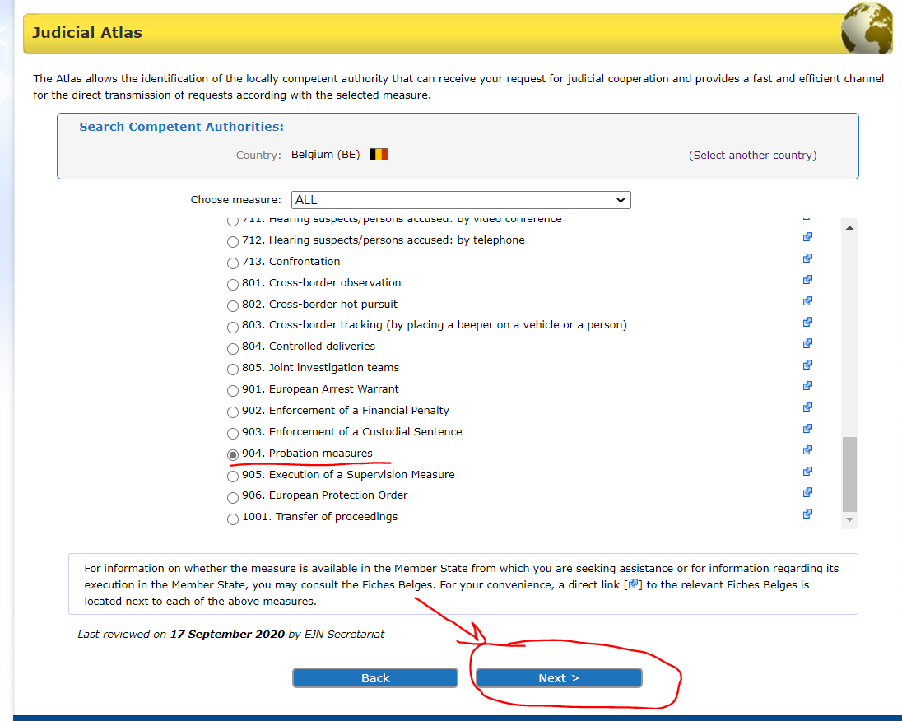

3. At this stage we have to select whether it is about giving consent according to article 5 para 2 of the CFD (forward the judgement and, where applicable, the probation decision to a competent authority of a Member State other than the Member State in which the sentenced person is lawfully and ordinarily residing, on condition that this latter authority has consented to such forwarding) or it is a request to recognise and supervise measures according article 5 para 1 of the CFD (the sentenced person is lawfully and ordinarily residing in that MS). It is the second option for our case. Then we select the section Next as shown below.

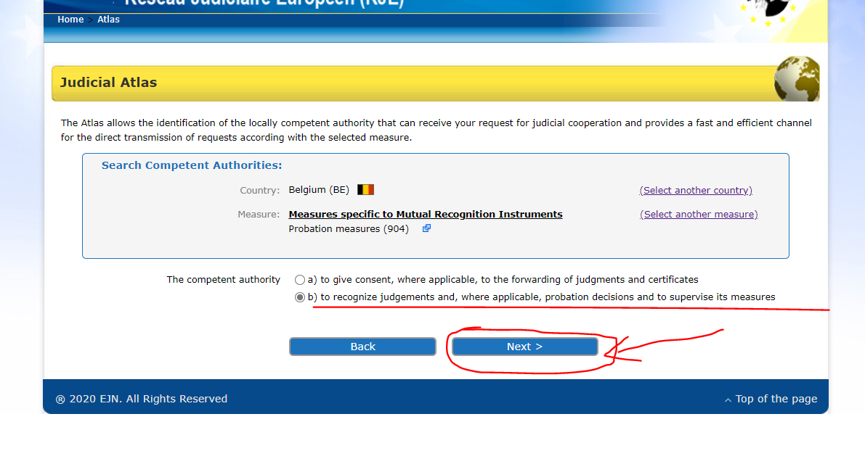
4. We introduce Brussels. Then we select the section Next as shown below.

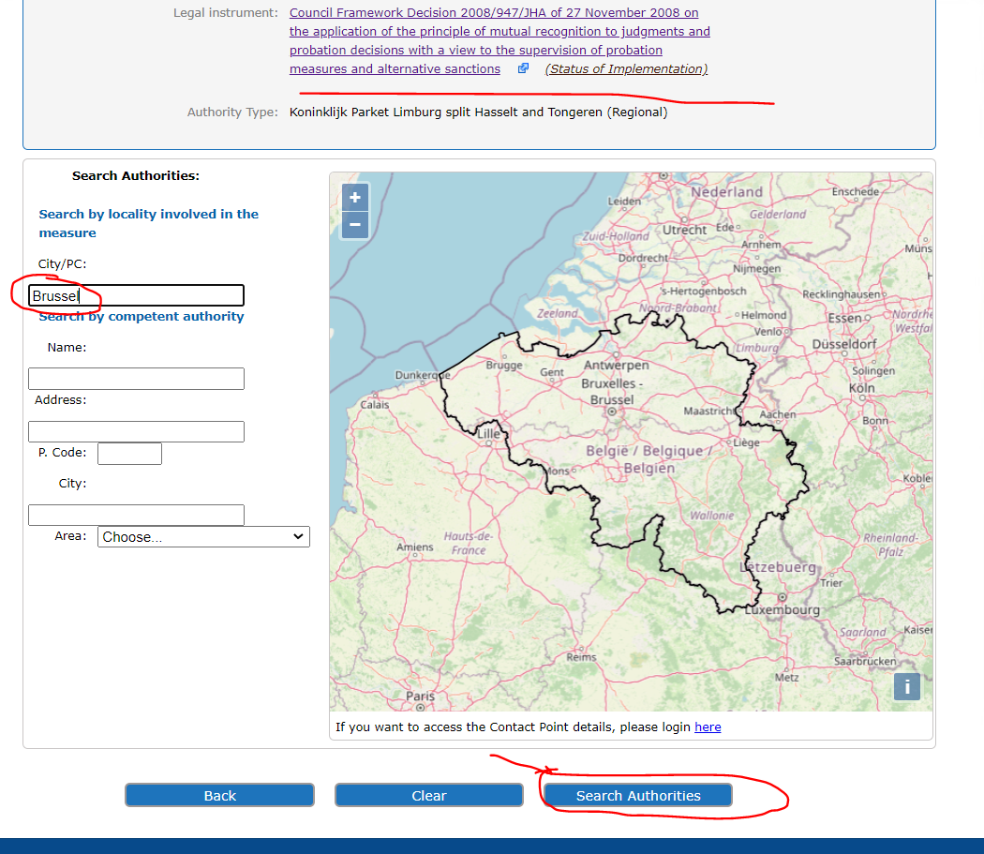
5. At the end we are provided with the result of our search as shown below.

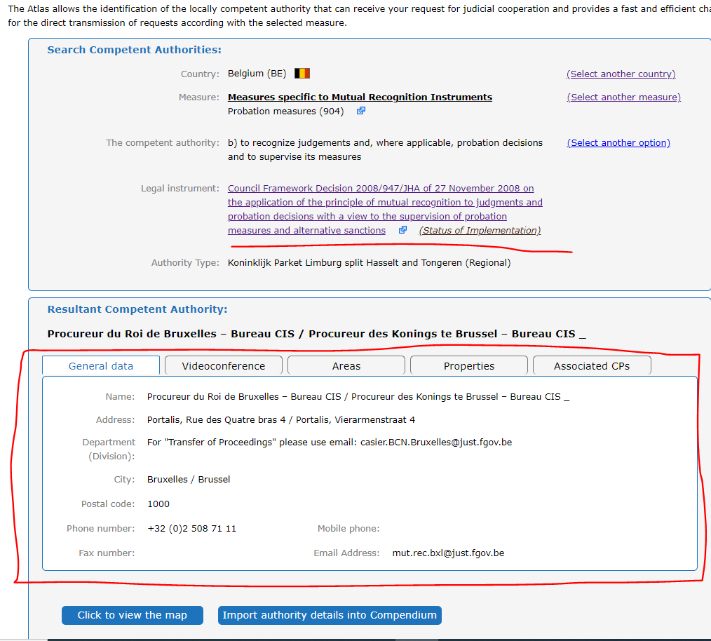
- A French competent authority wants to transfer the supervision of the sentenced person B.C. who is lawfully and ordinarily residing in Vigo, Spain.
1. In order to identify the competent authority, we select Spain as the country selected (ES). Then we select the section Atlas as shown below.

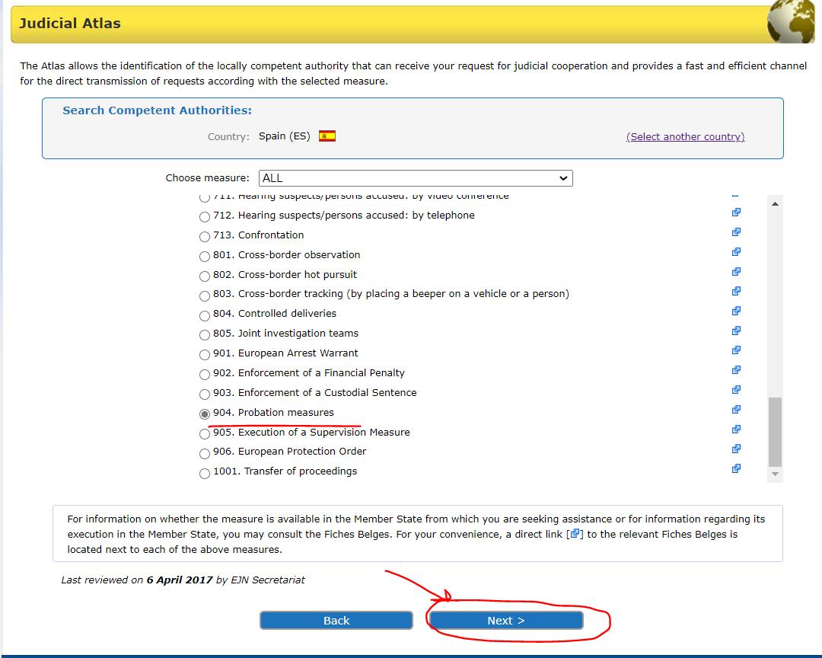
2. We select measure 904. Probation measures. Then we select the section Next as shown below.
3. Here we have to select from 2 options. We will select the General regime as mentioned in the requirements of the exercise. Then we select the section Next as shown below.

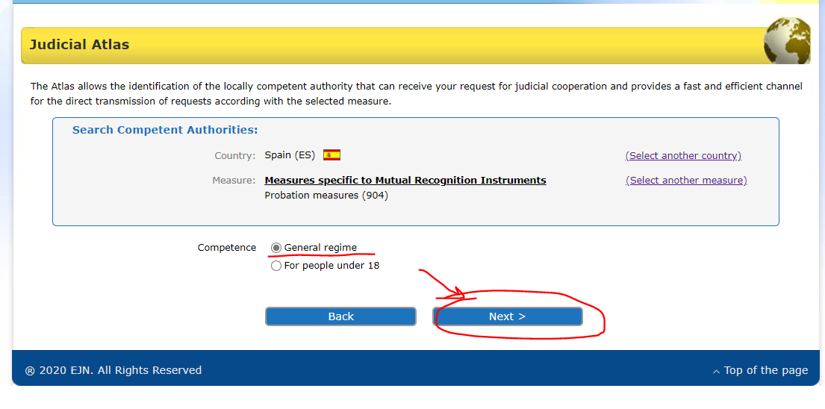
4. At the end we are provided with the result of our search as shown below.

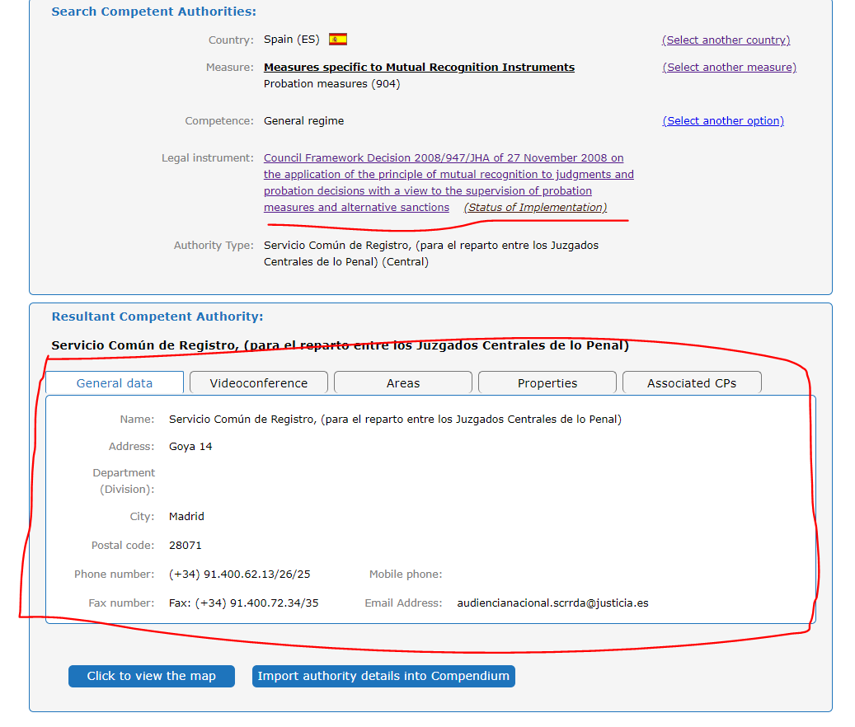

- A Spanish competent authority wants to transfer the supervision of the sentenced person M.M. who is lawfully and ordinarily residing in Vienna, Austria.

1. In order to identify the competent authority, we select Austria as the country selected (AT). Then we select the section Atlas as shown below.

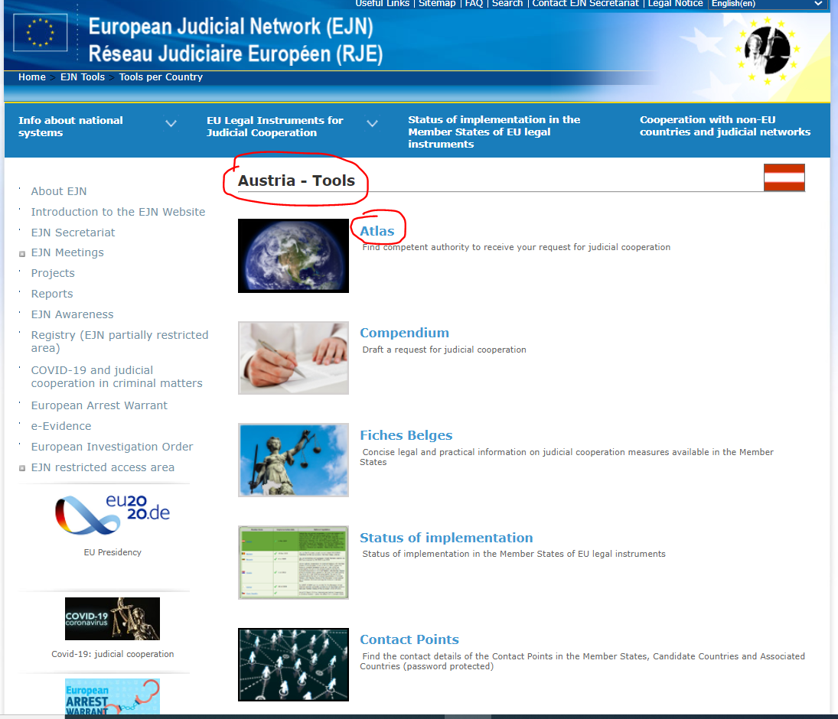

2. We select measure 904. Probation measure. Then we select the section Next as shown below.

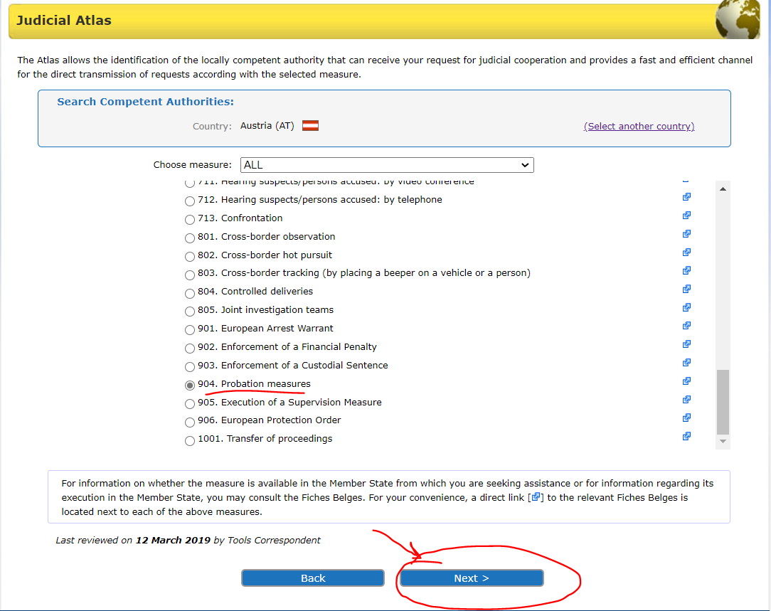

3. We introduce Vienna. Then we select the section Next as shown below.

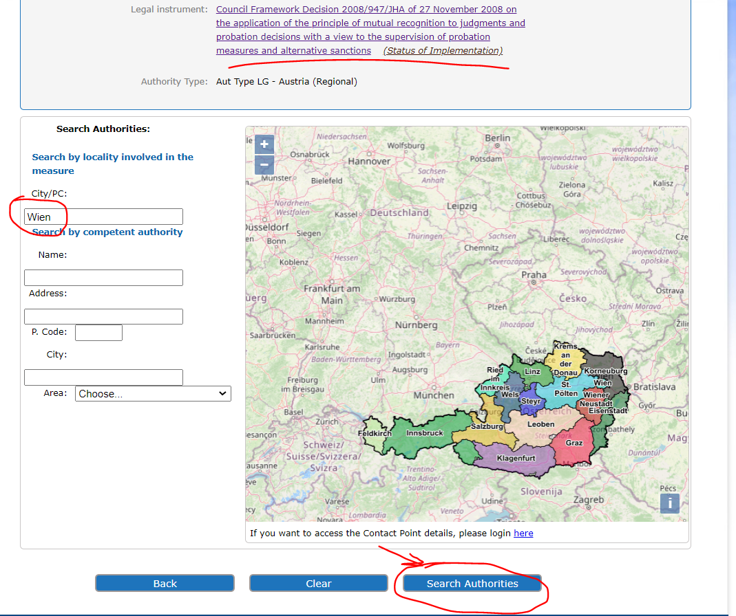
4. At the end we are provided with the result of our search as shown below.
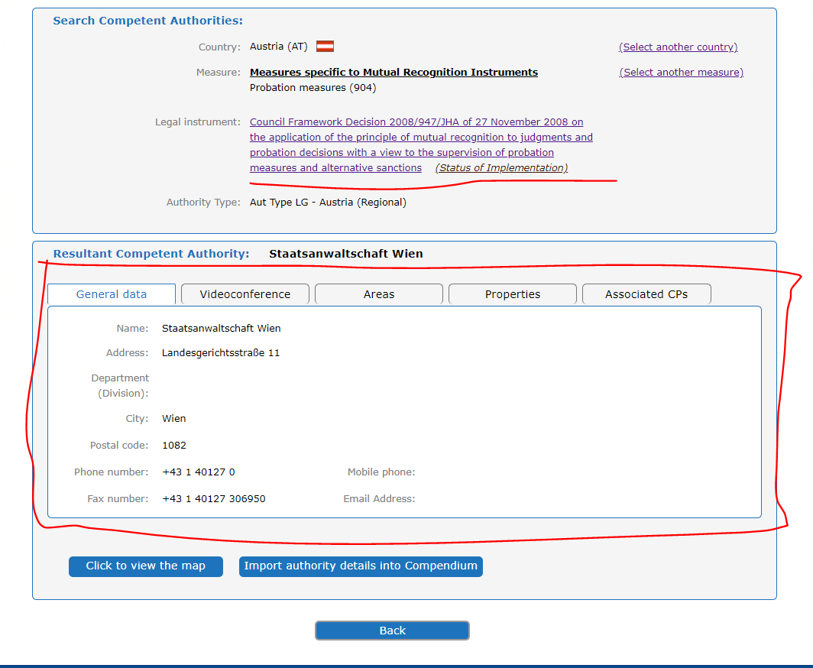
Solution to question 3 of Case scenario 1.
- Find the competent German authority with M.H. lawfully and ordinarily residing in Hamburg, Germany.
1. In order to identify the competent authority, we select Germany as the country selected (DE). Then we select the section Atlas as shown below.

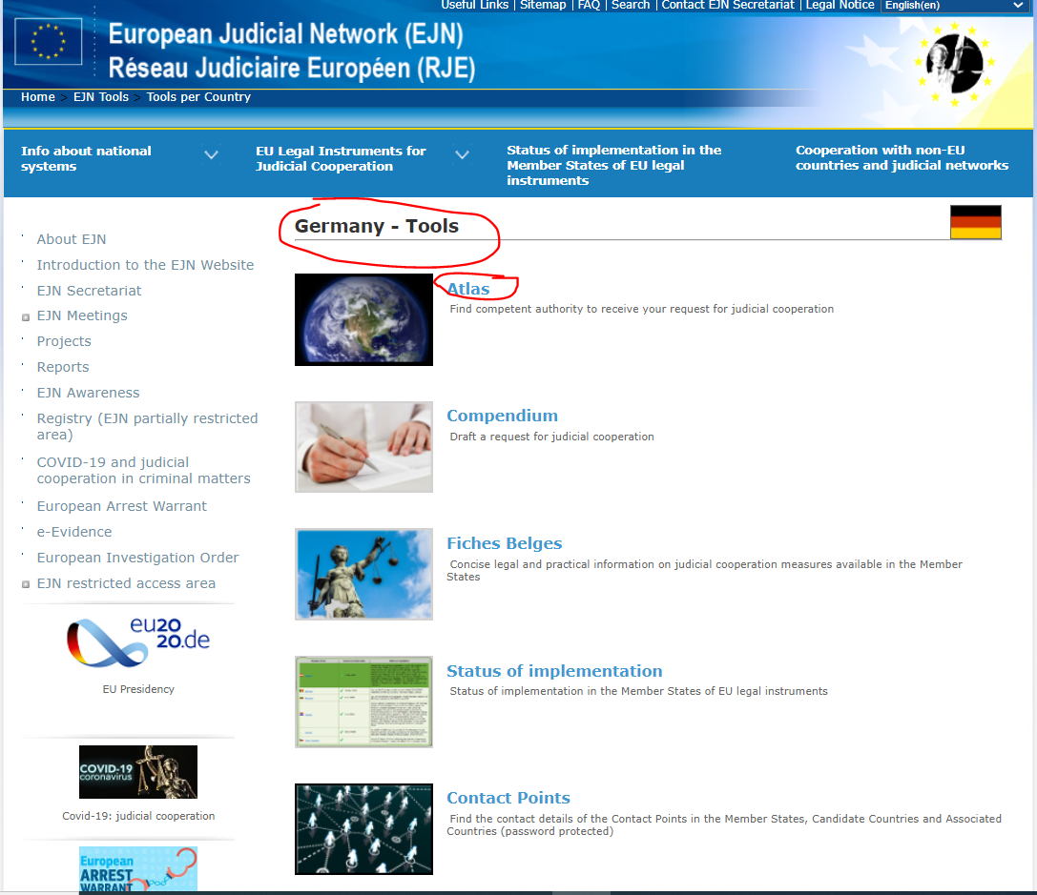

2. We select measure 904. Probation measures. Then we select the section Next as shown below.

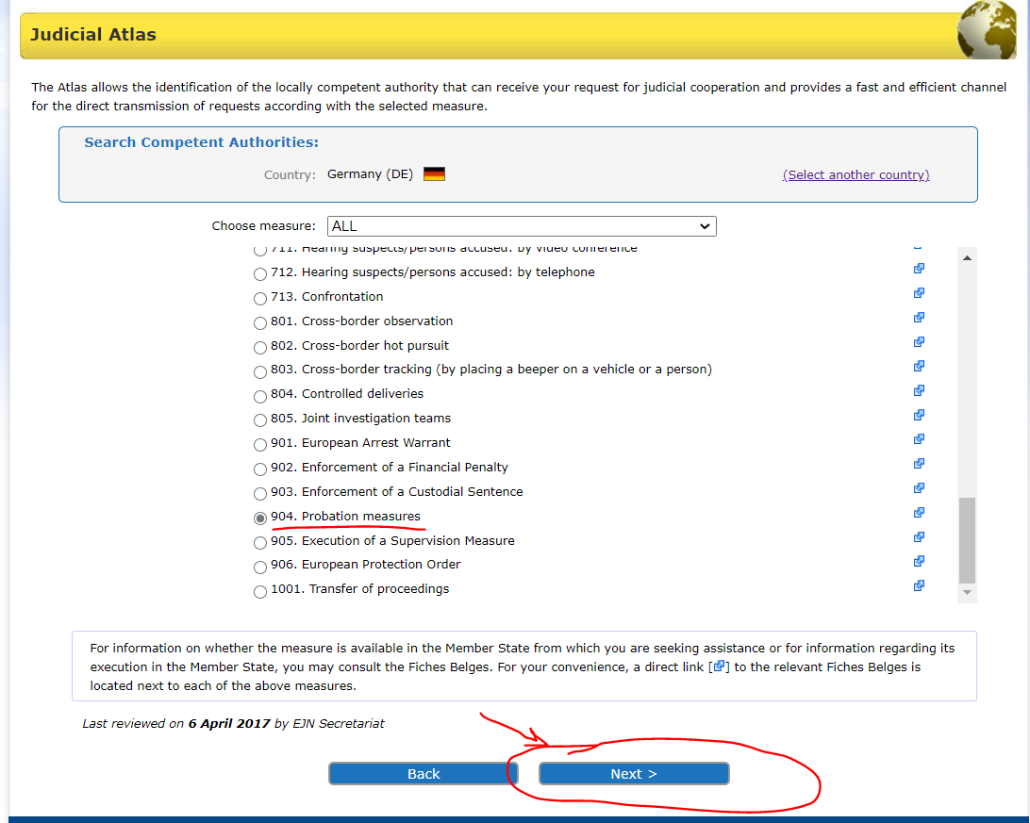

3. We introduce Hamburg. Then we select the section Next as shown below.

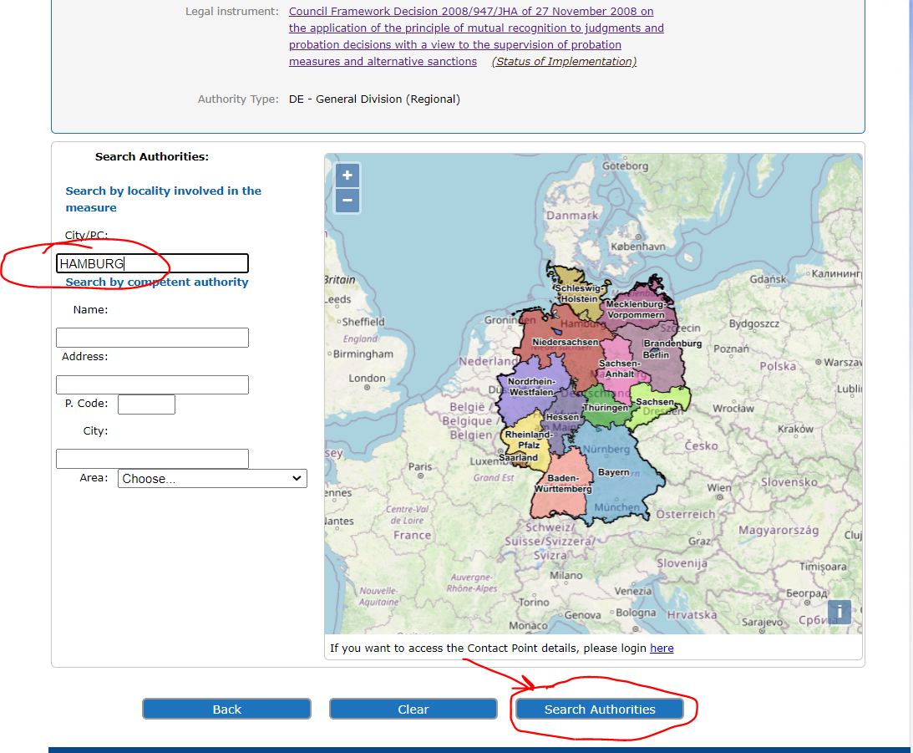

4. At the end we are provided with the result of our search as shown below.

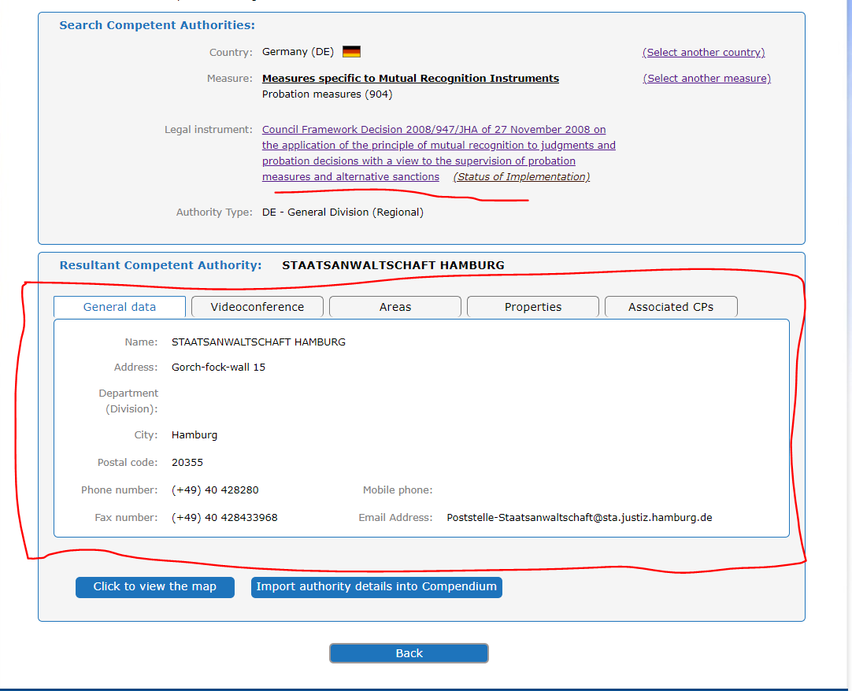

O.J. L 337, 16.12.2008
O.J. L 327, 05.12.2008
O.J. L 76, 22.03.2005
O.J. L 328, 24.11.2006

